Using myCAV for incorporated associations

Background

Consumer Affairs Victoria has developed a new online system for incorporated associations (IAs).

The system, called myCAV, is part of the Victorian Government’s Digital Strategy to ensure that Government services and information are accessible online to all Victorians.

All incorporated associations need to use myCAV to lodge annual statements, pay fees and notify us of any changes.

The tasks are the same as those you currently do for your association, except online.

About myCAV

myCAV is free to use. It reduces paper work and makes meeting your legal obligations easier.

You can use MyCAV to:

- apply to become an incorporated association
- access association information quickly and conveniently
- update and change association details instantly
- lodge annual statements
- keep track of records and transactions, all in the one place

Delegates can help

To use myCAV, secretaries of IAs must have a myCAV account, an email address, and access to the internet.

If you need help with the online system, a secretary can authorise up to 3 delegates to assist them. The secretary is still responsible for compliance with the law.

A delegate can be:
- another member of your association
- an accountant or solicitor
- a representative of a peak body
- a friend or a family member.

A delegate can do the same tasks as a secretary, except change the secretary. Only the current secretary can change the secretary.
This information shows the key steps on myCAV to:

- create a myCAV account
- link your account to your association
- use your myCAV home page
- lodge annual statements
- make payments
- change association name
- change rules
- change secretary details
- add and remove delegates
- change personal details
- reset your password
- find out more

Giving and receiving information by electronic needs

Using myCAV enables secretaries to give to Consumer Affairs Victoria and receive from Consumer Affairs Victoria any information required under the Associations Incorporation Reform Act 2012 by electronic needs.

How to create a new myCAV account

To create a myCAV account:  - Go to our website www.consumer.vic.gov.au and select Sign in at the top right hand corner to open the Sign in/Create myCAV account page.  - You will see this screen →  - Select the Create myCAV account button. | 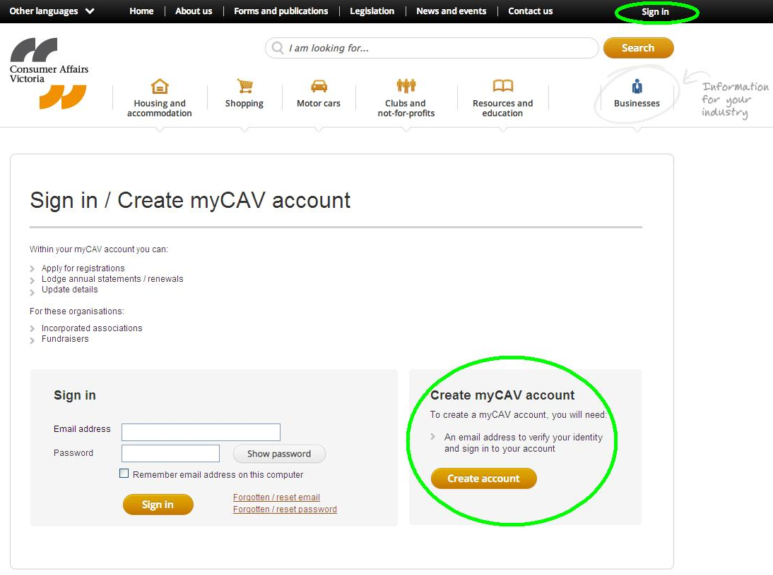
- Answer Yes or No (unsure) to the question Have you received a letter from Consumer Affairs Victoria?  - If you answer No, complete the information on the form and select the Create Account button.  - If you answer Yes, you will go to the registration number page. | 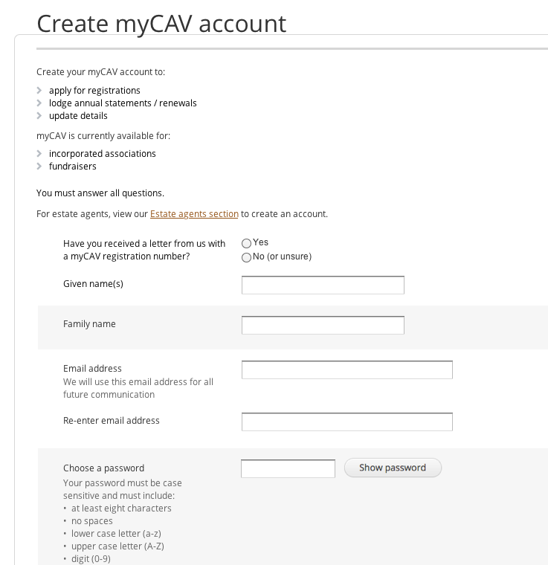
On the registration number page:  - Enter the myCAV registration number shown at the top of your letter and select Next. | 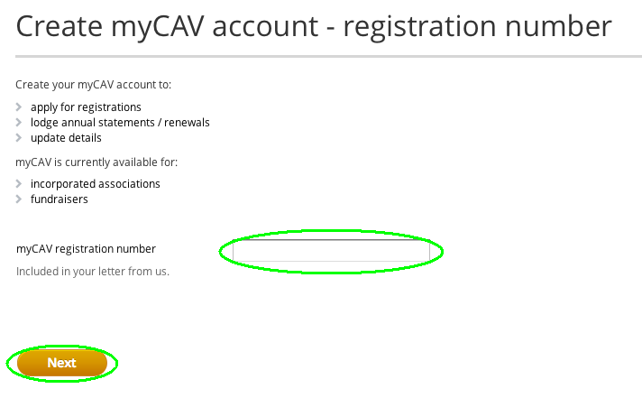
- Confirm if you are the person named. If Yes, select Next to continue. | 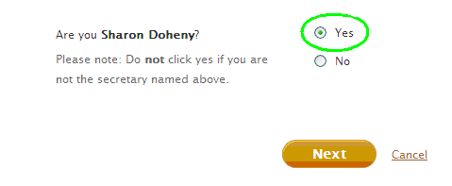
- Enter your email address and password.  - Select Show password to check your password.  - Then select the Create account button.  Note: Please remember your email and password and keep them safe.  The password must be at least 8 characters long and include at least one lower case letter, one upper case letter, a numerical digit and a special character. | 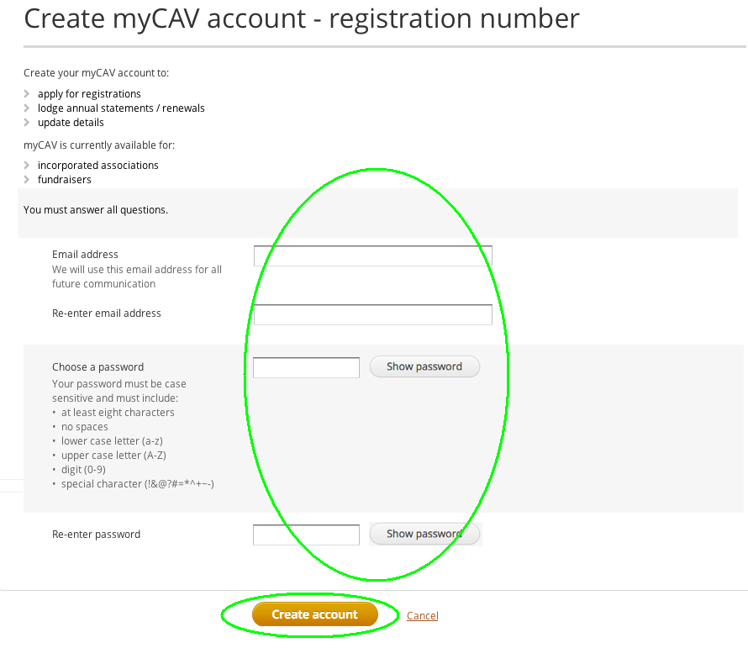
An instant message will advise you have successfully created your account.  Click on the sign in link in the message to complete your application. | 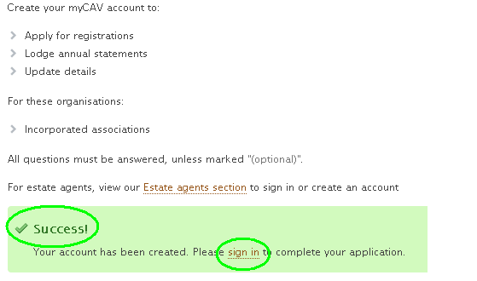
In the myCAV Sign in section enter your email address and password and select the Sign in button to go to your myCAV home page. | 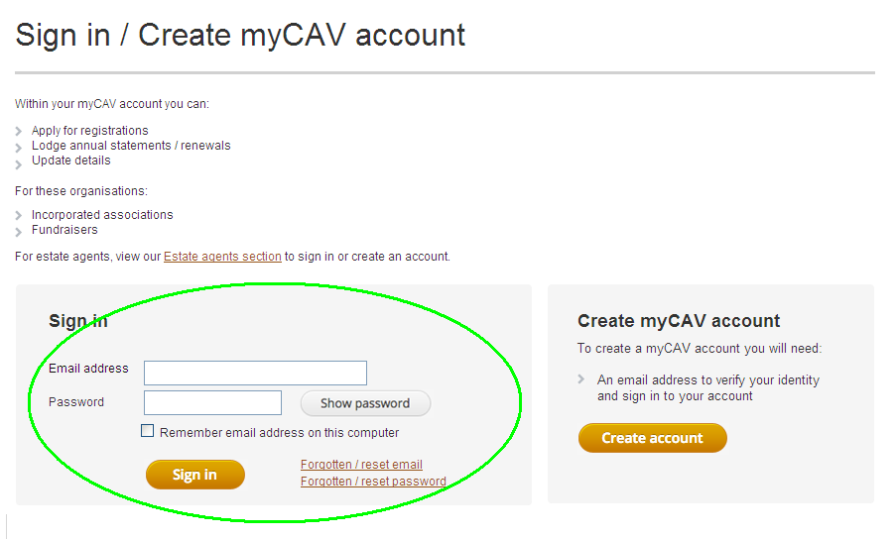
On your myCAV home page you can:  - View and change your association details using the Actions list.  - Download your certificate and rules.  - See recent transactions.  - Lodge your annual statement. | 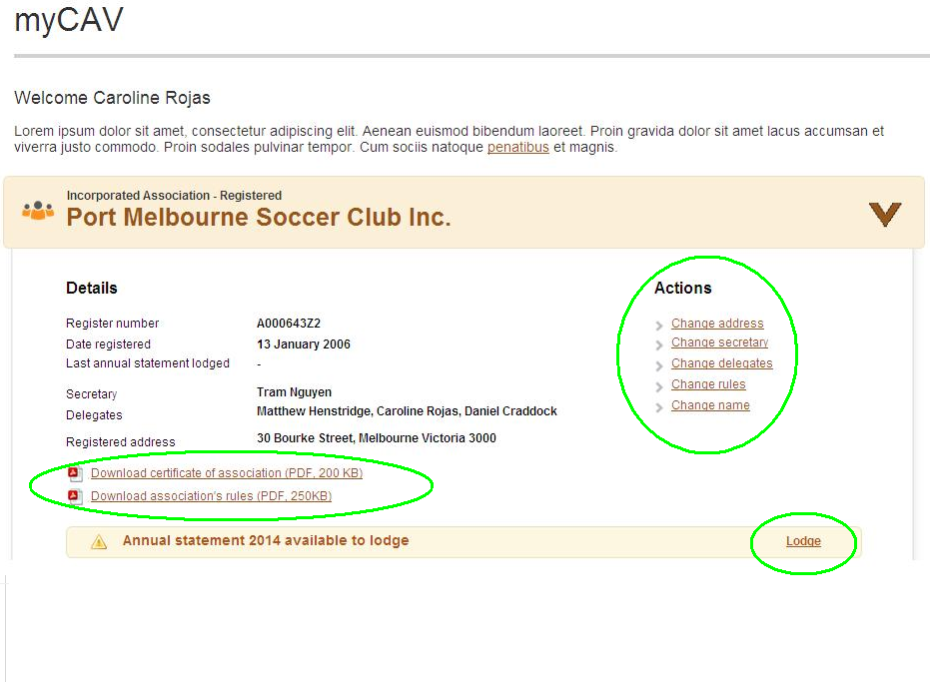
Note:  If you are not the person named, select No. A message will ask you to create a new myCAV account.  To do this select the link in the message, enter your name, email address and password and then the create account button.  Once you have created a myCAV account you can link it to your association. | 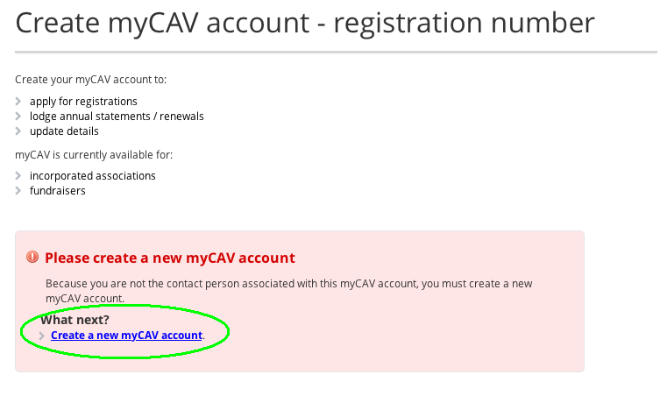
How to link your account to your association

Once you have created a new myCAV account you can link it to your association.  - Select your name at the top right of our website to open the drop down list.  - Select Link to an organisation from the list. | 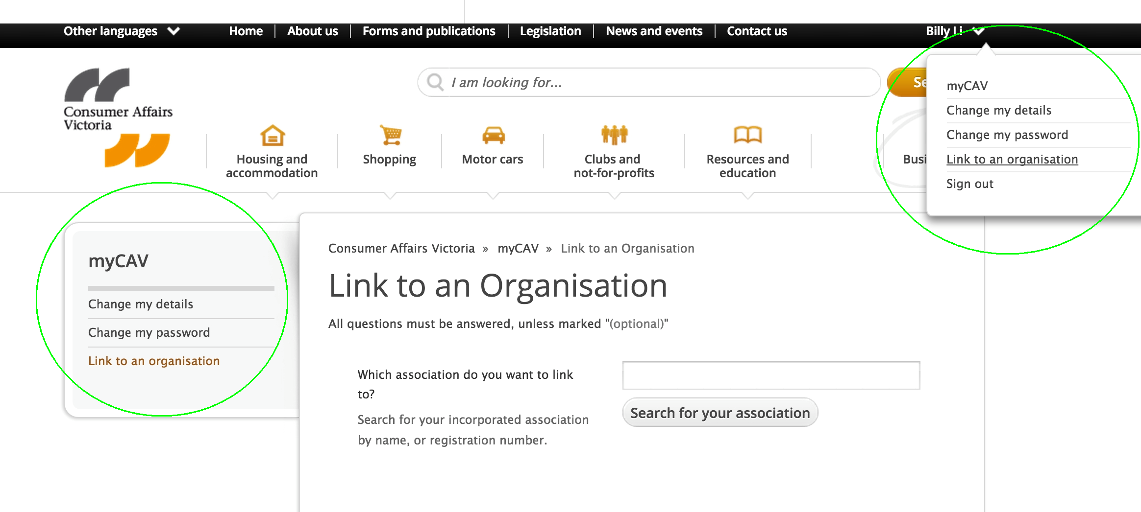
- Enter the name of the association you want to link to and select the Search for your association button  - When you see the name of your association, select the name.  - Tick OK when a box appears with the question Are you sure you want to link the association as secretary? | 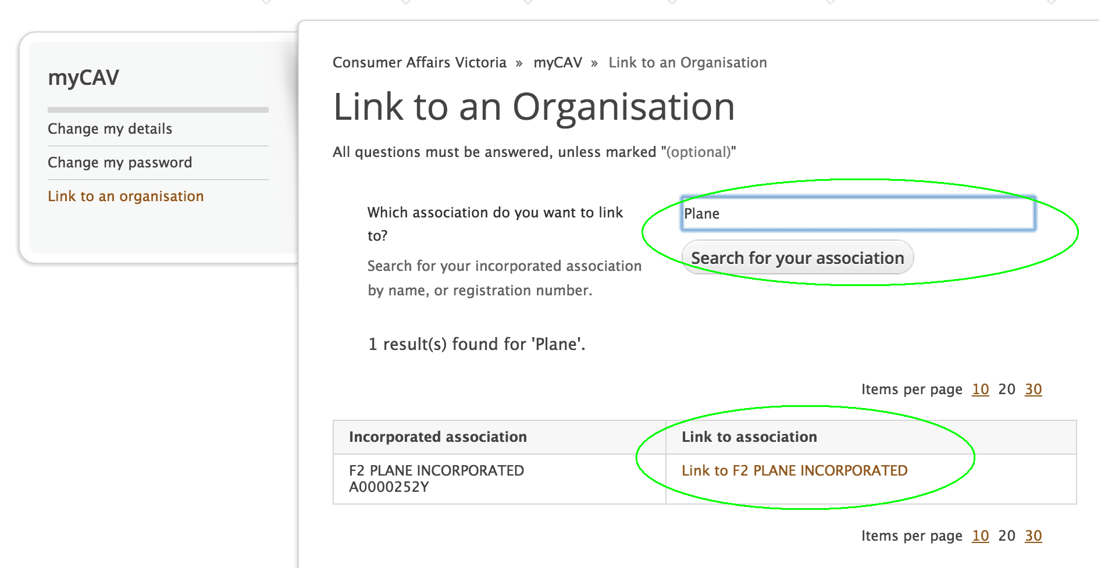
An instant message will let you know you if you have been successful in linking your account to your association.  To go to your myCAV home page, select the Return to myCAV link in the message. | 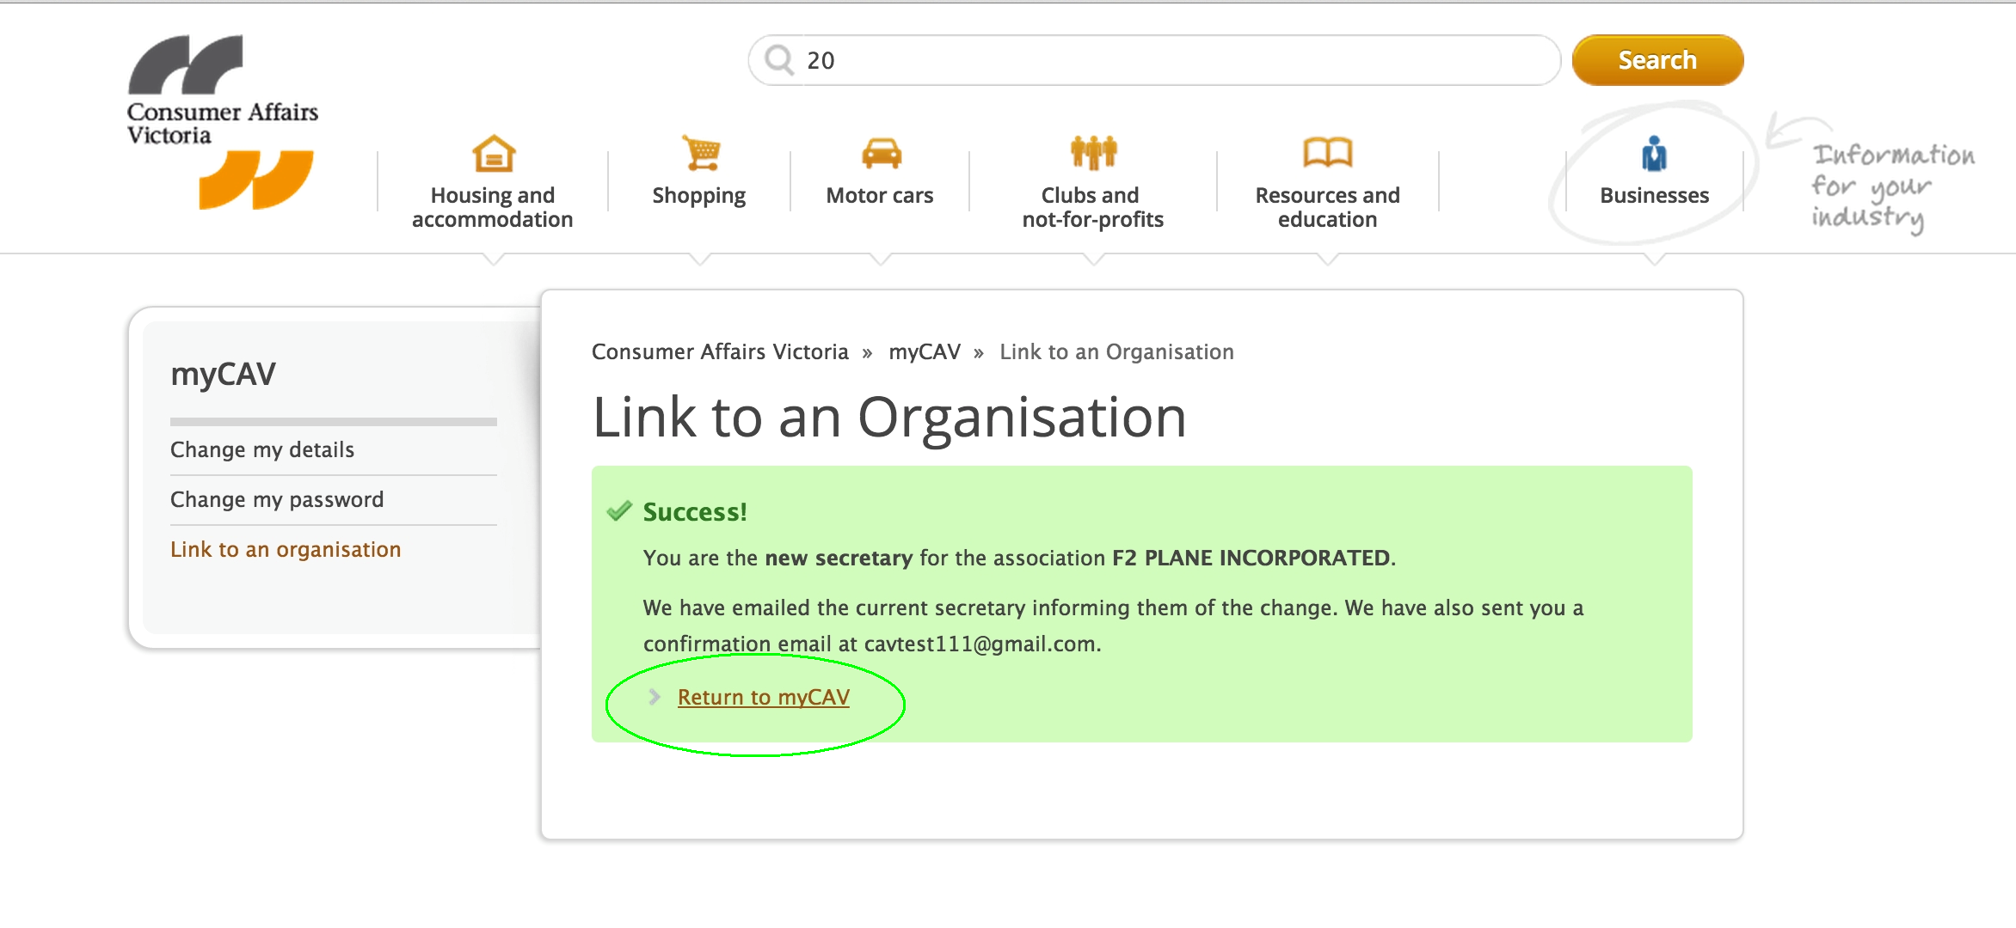
You will also receive an email letting you know you have been linked to your association.  When you select the link in the email you will go to the Sign in section on myCAV. | 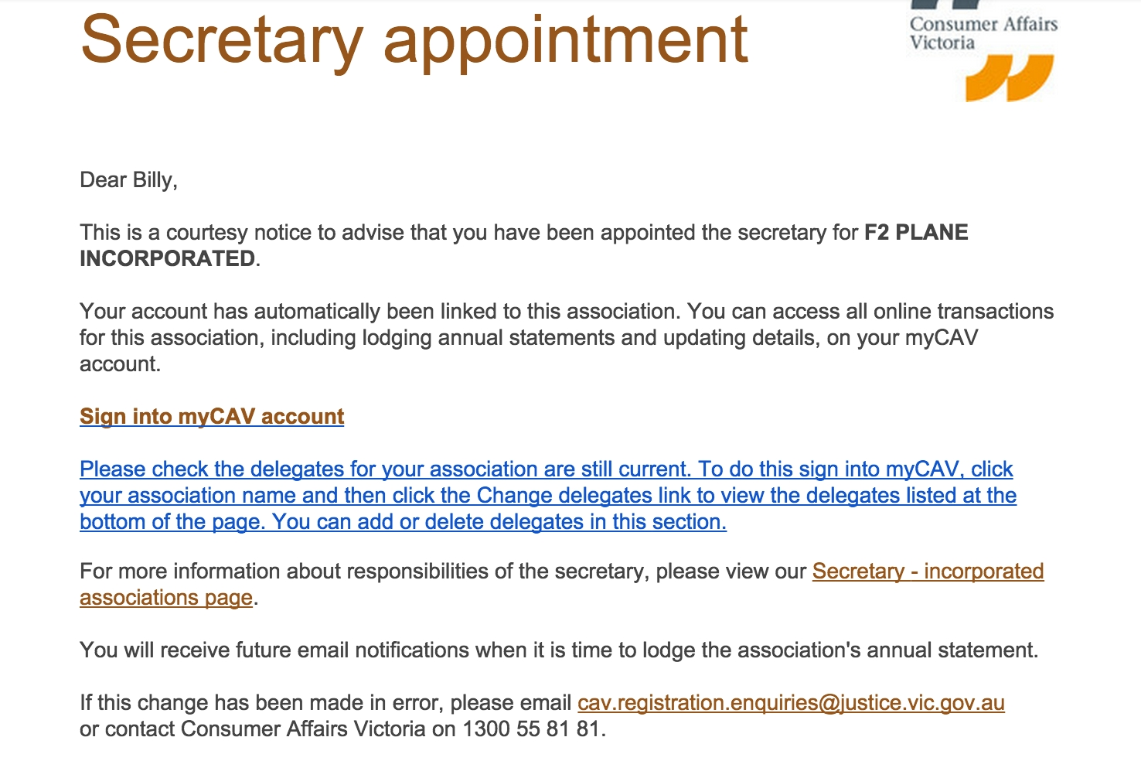
Once you have linked your myCAV account to your association, you can sign in to your myCAV home page at any time. | 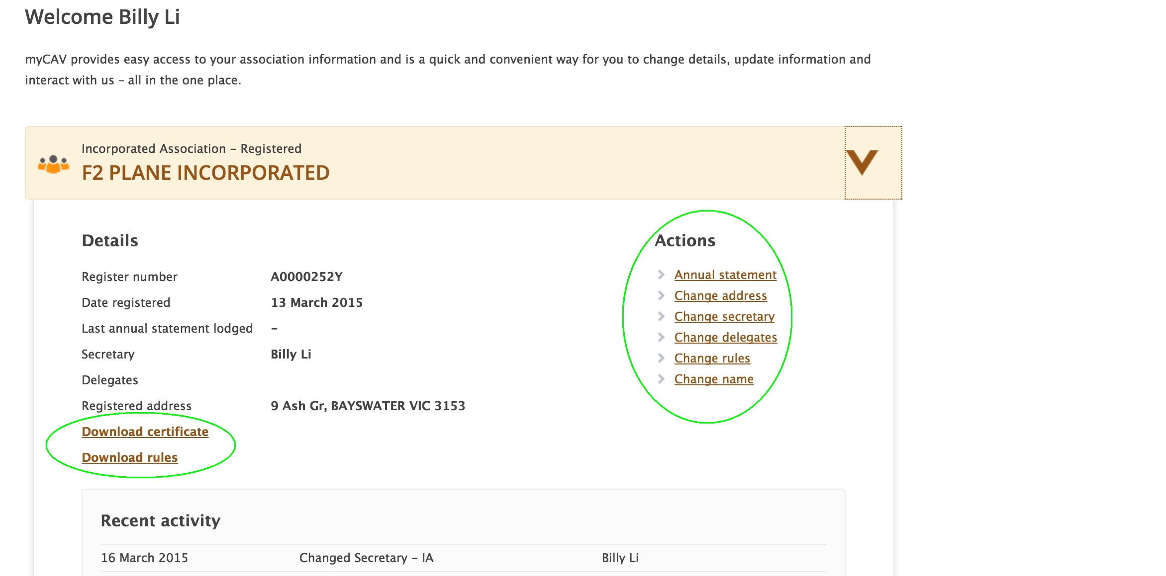
How to use your myCAV home page

Only the secretary or delegate can change association details on myCAV.  When a change is made an email is sent to the secretary advising of the change.  On your myCAV home page select the arrow next to your association’s name to:  - View your association details and recent activity.  - Download copies of your certificate and rules.  - Make changes to your association details by using the Actions List.  - Lodge your annual statement when it is due. | 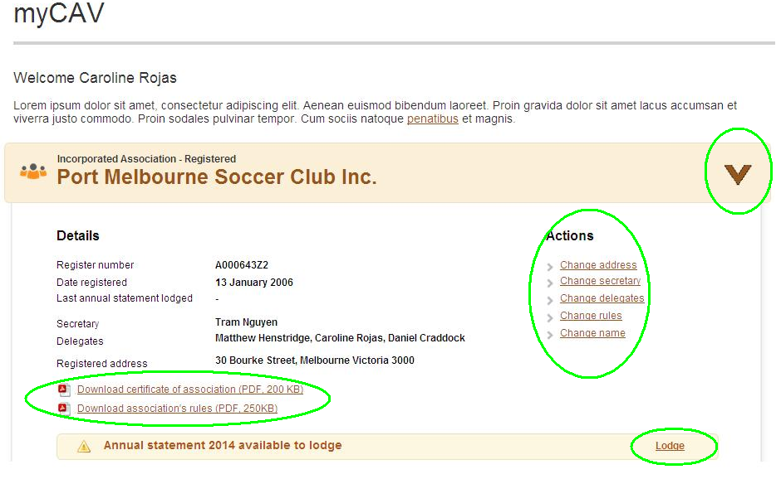
How to lodge your annual statement

All associations must lodge annual statements on myCAV within one month of their annual general meeting (AGM).  An email will be sent to remind you to lodge your statement.  Tier 1 associations – those with annual revenue less than $250,000 - no longer need to lodge a financial statement with their annual statement.  Tier 2 and Tier 3 associations must attach financial statements and a copy of the review or audit report as electronic files.  Select the lodge link on your myCAV home page:  - Enter the information required. | 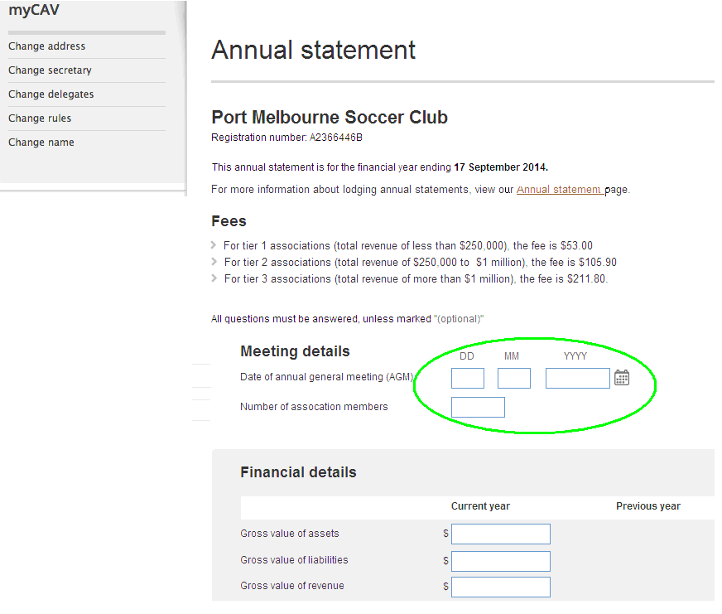
- Attach supporting documents as electronic files by clicking on Select file to attach. Find the documents on your computer, and select Ok.  (Files must be in.doc, .docx, .xls, .xlsx, .text, .pdf format and no larger than 5MB)  - Carefully read the Declaration and select Agree.  - Select Next to continue to payment.  Note:  Agreeing to a Declaration on myCAV is legally binding. | 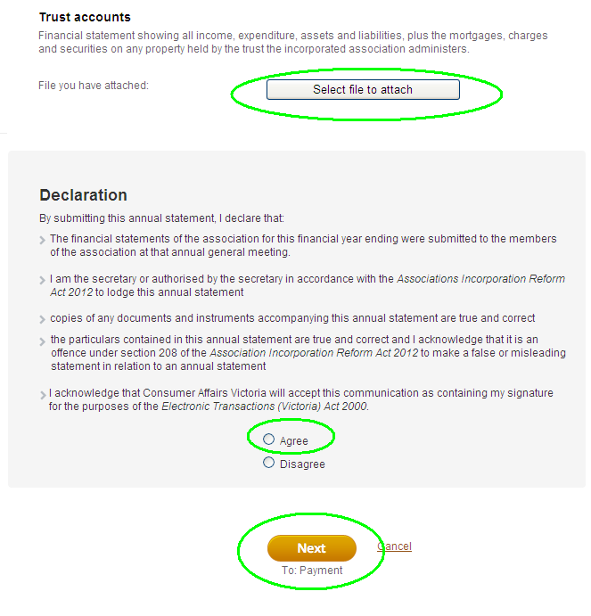
How to make payments on myCAV
When using myCAV, you can choose to make payments online, or in person, using a cheque, at a post office.  To make a payment:  - Tick your payment method.  - Select Next to go to the payment section. | 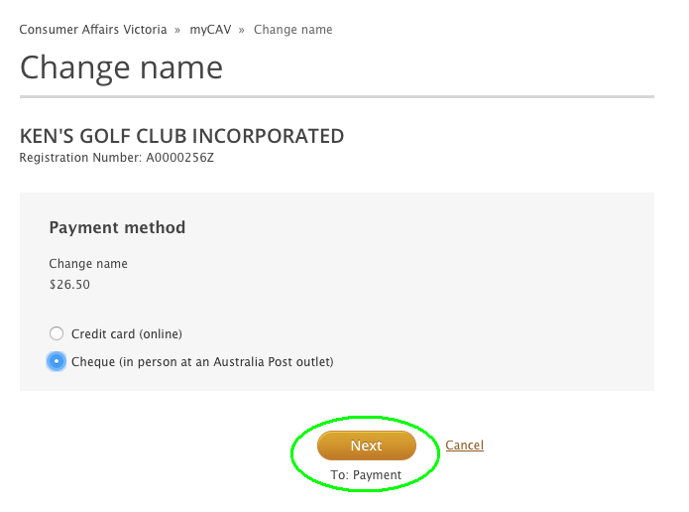
If paying in person:  - Check the information is correct, then select Confirm.  Note:  An invoice will be emailed to you, and you have 14 days to make the payment. You must ask for a receipt at the time of payment. | 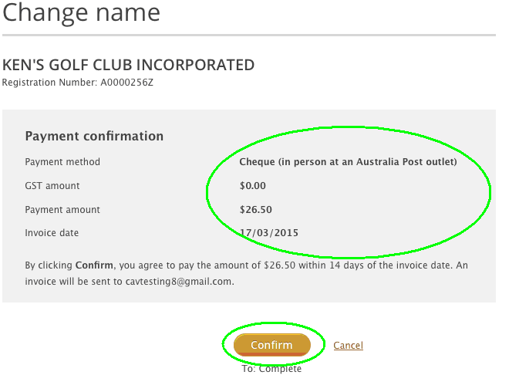
If paying online:  - You will need a debit or credit Visa or MasterCard.  - Enter the card details and select Next to continue.  - If the information is correct, select the Make payment button.  Note:  An instant message will advise if your payment has been successful and a receipt will be emailed to you. | 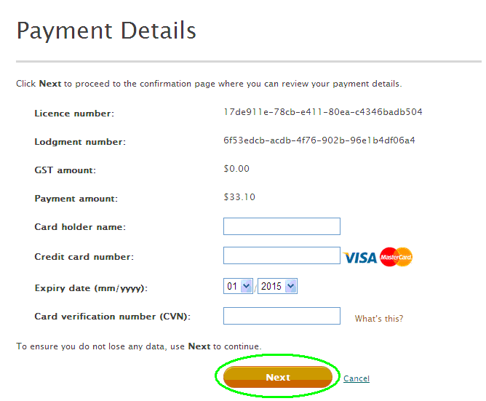
How to change association name

A special resolution is required to change the name of your association.  After the resolution has been passed:  - Select Change name from the Actions List. | 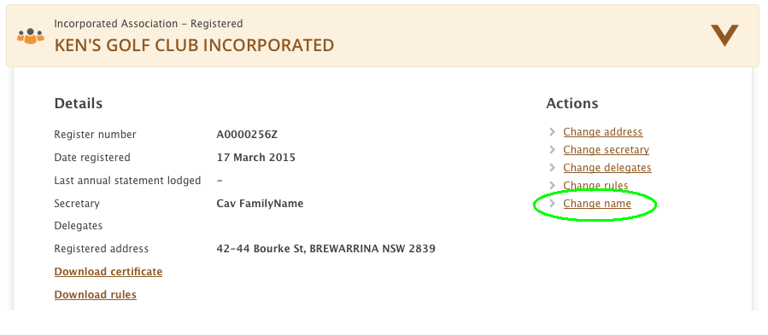
- Enter the proposed name and select the Check name availability button. | 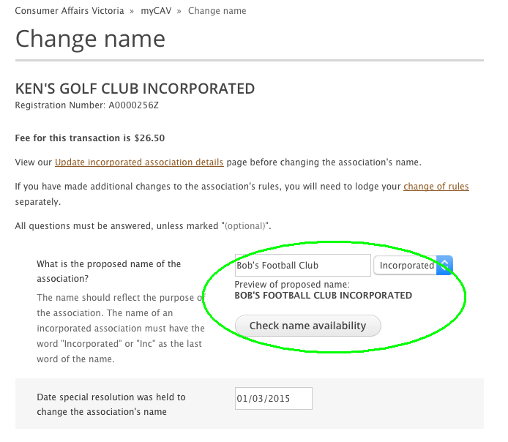
- A message will advise if the name is available.  Note:  If the name is not available, you will need to choose another name.  - Enter the date of the special resolution. | 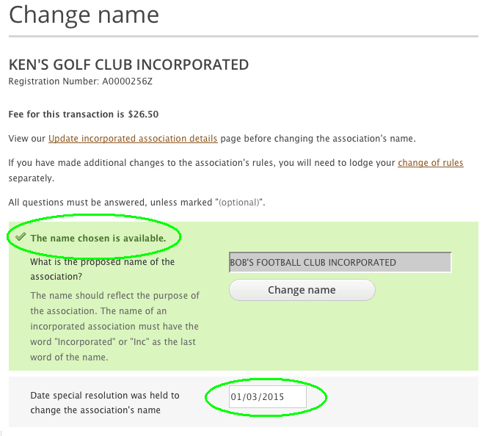
- Attach a copy of your rules with the new name of your association as an electronic file.  - Read the legal and binding Declaration and select Agree and Next to go to payment. | 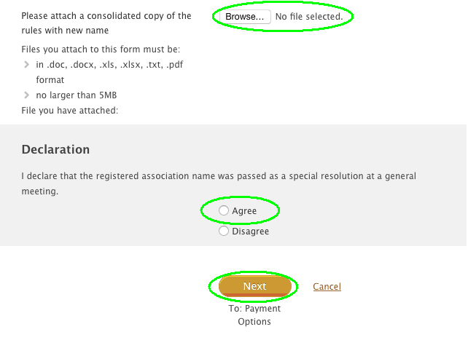
After completing the payment section, you will receive an instant message advising your association name has been changed. | 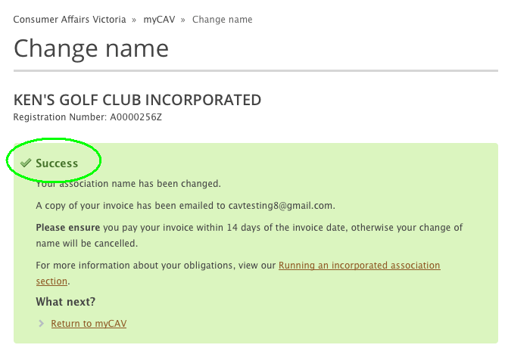
The next time you sign into myCAV you will see the name of your association has been changed. | 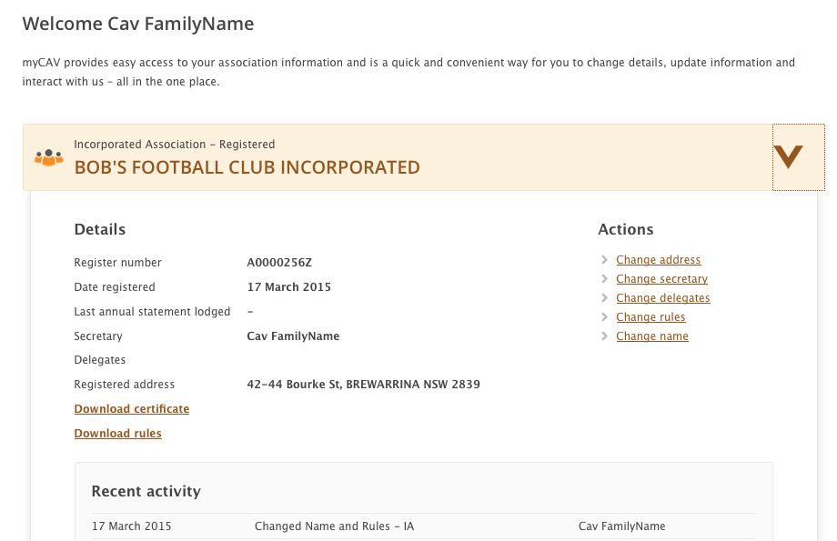
How to change rules

A special resolution is required to change the rules of your association.  After the resolution is passed:  - Select Change rules from the Actions List. | 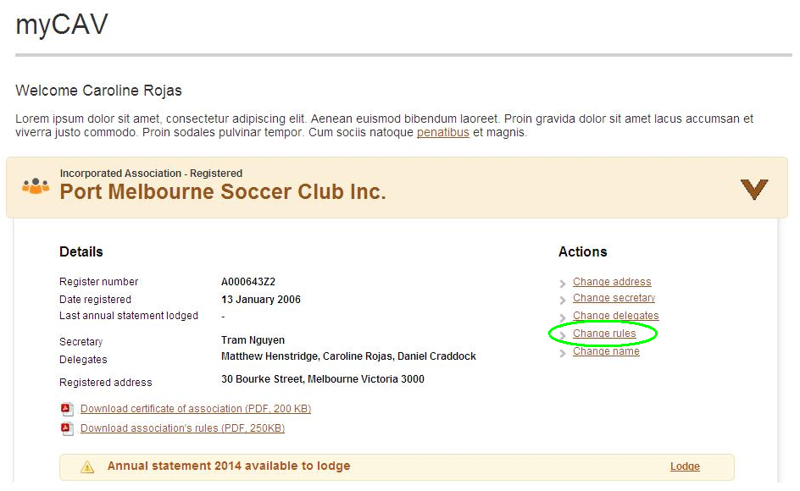
- Select Own rules or model rules from the drop down list.  - Enter the date of the special resolution. | 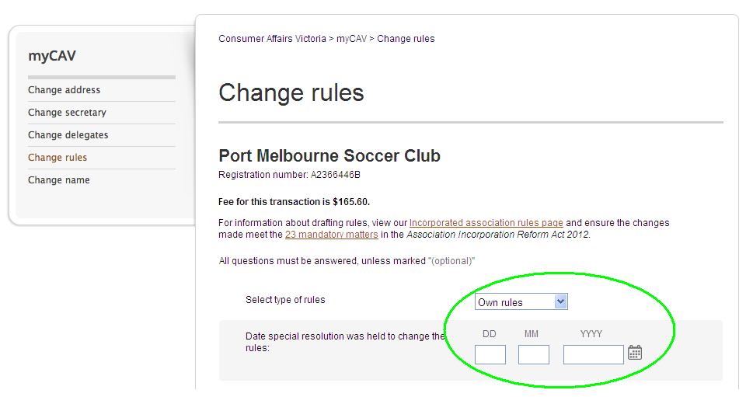
- Attach a copy of the special resolution as an electronic file.  - Enter the financial end of year date and the purpose of your organization.  - Attach an electronic copy of your rules.  - Select Agree to the Declaration and Next to go to payment. | 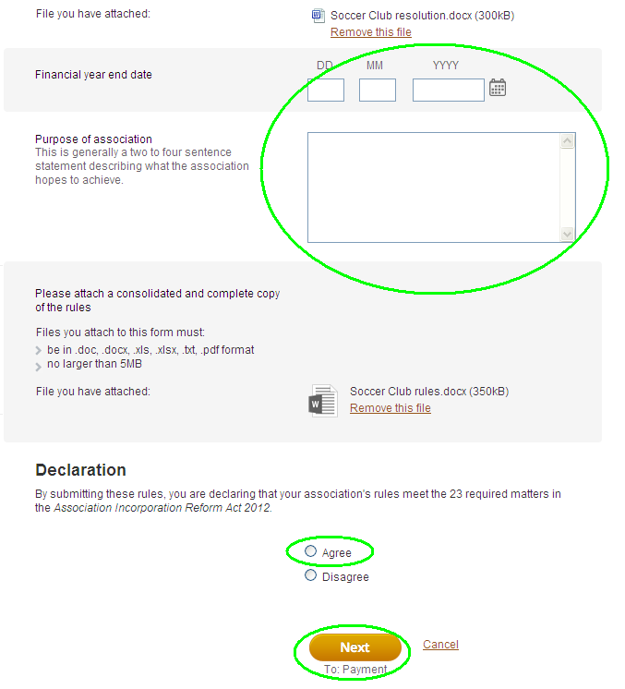
How to change secretary or update details

Only the current secretary can change the name of the secretary.  To change the secretary details:  - Select Change secretary from the Actions list on your myCAV home page.  - Then select Update current secretary’s details or Change to new secretary. | 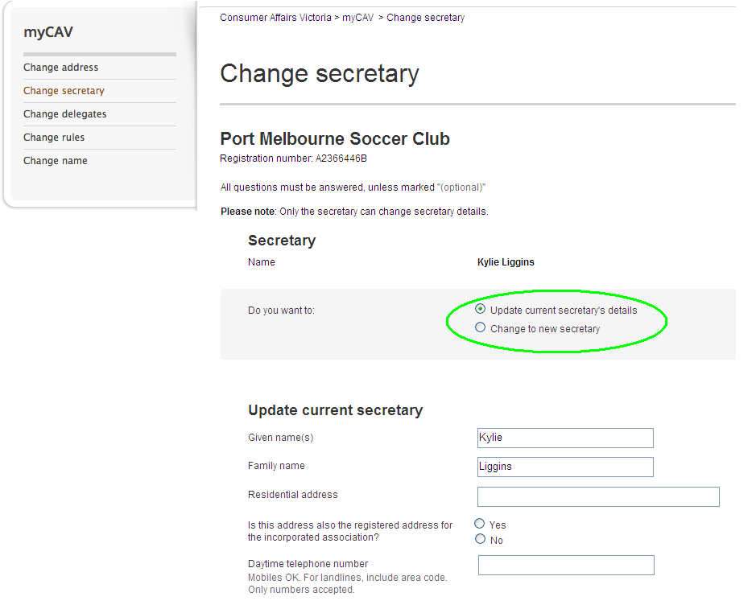
- Enter the new details.  - Select Save.  If the secretary is changed, an email will go to the outgoing secretary and the association’s delegates advising of the change.  The incoming secretary will receive an email confirming their appointment and a link to activate a myCAV account. | 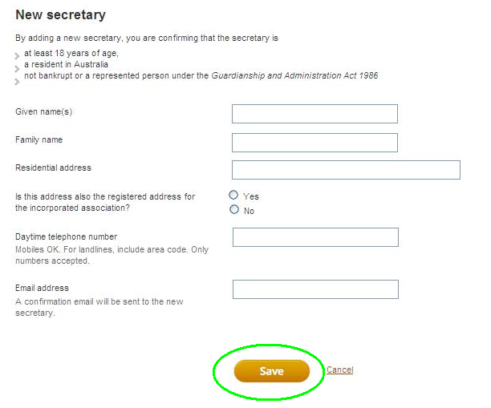
How to add or remove a delegate

A secretary can authorise up to three delegates to help them with administration tasks on myCAV, if required.  To add a delegate:  - Select Change delegates from the Actions list.  - Enter the details of the new delegate and tick to confirm the delegate has been authorised by the secretary.  - Select Add delegate.  If you already have three delegates, the secretary must remove an existing delegate before a new one can be added.  To remove a delegate:  - Select Delete next to their name.  An email will go to the outgoing delegate and the current secretary advising of the change.  Outgoing secretaries and delegates will no longer have access to the association’s details on their myCAV account. | 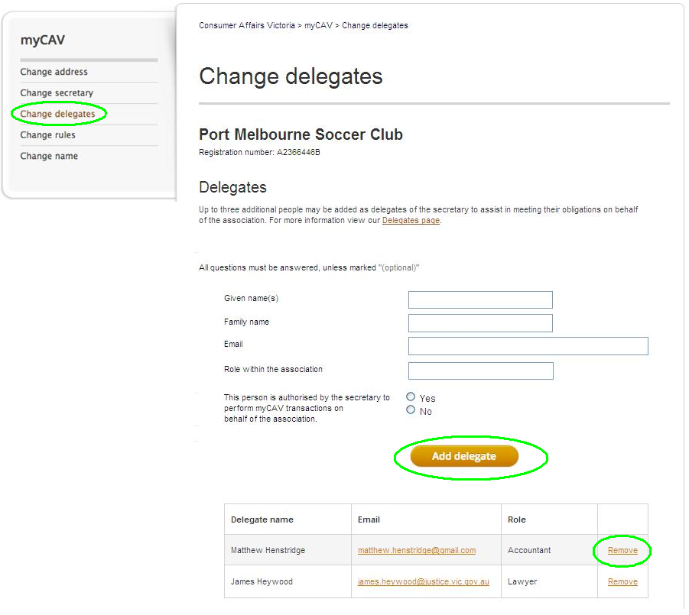
How to change personal details
For privacy reasons, the only personal details you can see on myCAV are your own.  To change your personal details:  - Go to our website and select your name at the top of the screen to open the drop down list.  - Select the task you want to undertake. | 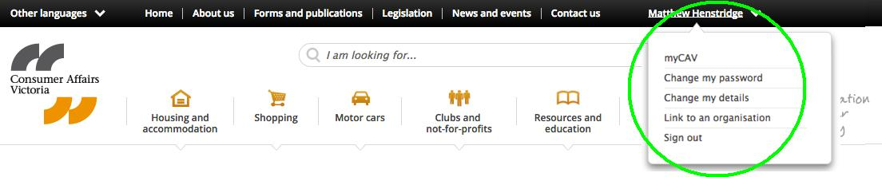
For example to change your password:  - Select Change my password from the list.  - Enter your current password.  - Enter a new password and select Show password to make sure it is correct.  - Select Save and an instant message will confirm the change. | 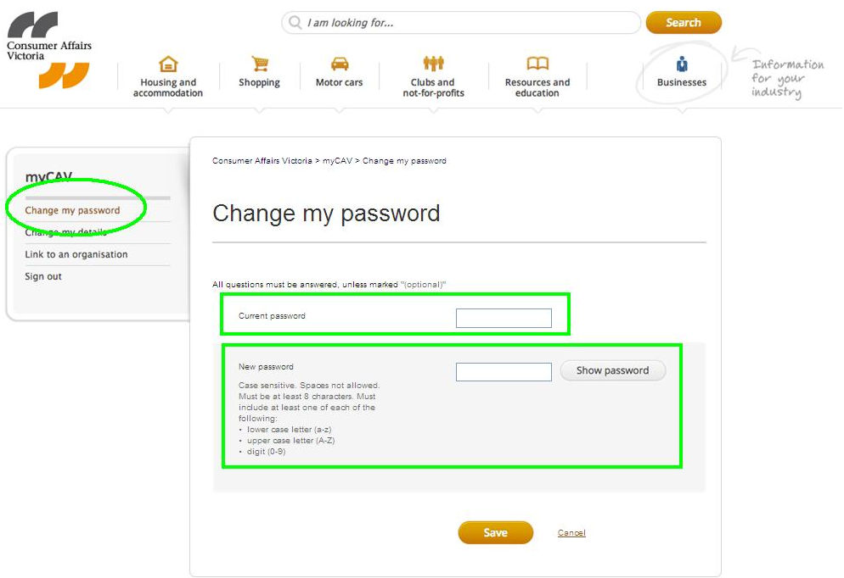
How to reset your password

If you forget your password:  - Go to the myCAV Sign in page and select Forgotten/reset password.  - Enter your email address and select Send link.  An email will be sent to you to change your password.  You have 24 hours to select the link and follow the instructions to create a new password.  If the link expires before you change your password, repeat the process. | 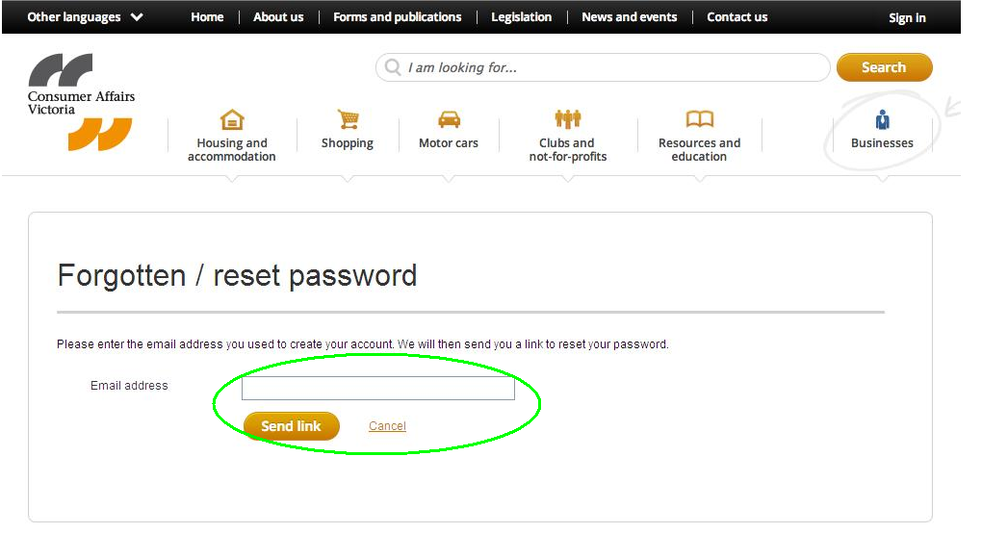
How to sign out of myCAV

For security reasons, always sign out after using myCAV.  - Select Sign out at the top right of the screen. | 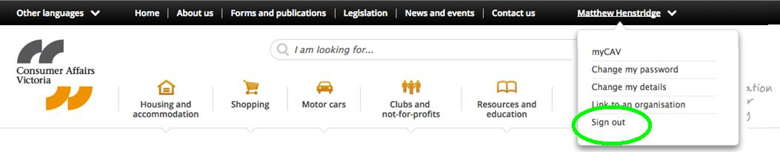

Activities not on myCAV

The only activities that can not be done on myCAV are:

- the amalgamation of associations
- requesting for an extension of time to hold an AGM and lodge an annual statement
- winding up or cancelling an association.

Forms for these activities are available on our website www.consumer.vic.gov.au/associations

Update your internet browser

For the best results, we recommend you use Google Chrome as your internet browser. Chrome is a fast and efficient browser and can be downloaded for free.

Translation services

Information about myCAV is available in different languages on our website www.consumer.vic.gov.au/languages

You can call our free translation service on 131 450. Name your language in English, and ask the interpreter to call our helpline on 1300 55 81 81 during business hours.

Assistance is also available on our Koori Helpline 1300 661 511.

More information

To view our tutorial videos on myCAV and for more information and updates on myCAV visit: consumer.vic.gov.au/associations

To subscribe to our not-for-profit newsletter which includes information for incorporated associations visit: consumer.vic.gov.au/newsletters

myCAV will be updated regularly. While the look of myCAV may change over time, its easy step-by-step processes will continue to help you complete tasks quickly and conveniently for your association.

