Rianttuantu Mibu Aa Fonhmi Caah myCav Hmanning

Konglam

Consumer Affairs Victoria nih (Rianttuantu mibu aa fonhmi) incorporated associations (IAs) caah online in Cozah pehtlaihnak thar an ser.

An ser tharmi myCAV tiah auhmi cu, Digital hman nak lei tthangcho ding in tawlreltu
Cozah (Victorian Government) nih Victoria mipi caah Cozah nih a rianttuanmi le konglam hna hi Online in an luh le rel khawhnak caah tinhmi ah aa telmi a si.

Rianttuantu mibu aa fonhmi dihlak hna nih myCAV cu; kumfatin in an rianttuanmi theihternak ttialmi kuatnak, rianttuan nak ah dihheumi peknak le aa thlengnawngmi theihternak ah hman a herh.

Atu lioah na rianttuannak i na tuahning he khan aa khat dih ko. Nain, Online tu in
tuah a si cang lai.

myCAV Konglam

myCAV cu alak a si; Hman-man aum lo. Catlap hmang in rianttuan a zorter,
cun phunglam kongkau ah tuahawk thil hna kha fawizaang deuh in na tuah khawh.

MyCAV cu a tanglei hna caah na hman khawh:

- rianttuantu mibu aa fonhmi sinah chungtel si ve dingin soknak
- rianrang le fiangfai tein aa fonhmi mibu konglam zoh/relnak
- aa fonhmi mibu konglam tharchuah le thlen khawh colhnak
- kumfatin rianttuanmi theihternak ttialmi kuatnak
- hmunkhat teah tangka lutchuakmi khumhnak (record)

Ai-awhtu Nih Bawmh Khawhmi

myCAV hman dingah, IAs chungttuan hna nih myCAV account, email address le internet hman khawhnak an ngeih hrim hau.

Online hman-ningcang ah bawmh na herh ahcun, an bawmtu dingah chungttuan nih
ai-awhtu pa 3 nawl a pek khawh hna. Phunglam kong ah duhlonak langhtermi cu chuangttuan nih ttuanvo a ngeih tthiam.

Ai-awhtu hna cu:
- aa fonhmi nanmah mibu in chungtel pakhat
- tangka cazin tlaitu silole sihni
- aa fonhmi mibu chungin a lu bik ai-awhtu
- chungkhar silole hawikom.

Ai-awhtu nih chungttuan tuahmi a tuah khawh ve, nain chungttuan a thleng kho lo. Atu lio chungttuan lawng nih chungttuan a thlen khawh.

A tanglei hna nih myCAV hmang in tuah khawhmi
an langhter:

- myCAV account sernak
- aa fonhmi bu le na account pehtlaihternak
- na myCAV innpi hmannak
- kumfatin rianttuanmi theihternak ttialmi kuatnak
- tangka peknak
- aa fonhmi bu min thlennak
- zulhphung thlennak
- chungttuan konglam thlennak
- ai-awhtu chap le zuhnak
- pumpak konglam thlennak
- password tuah-tthannak
- tamdeuh hlat-hlainak

Theihternak konglam pek le hmuh dingah electronic
hman herhnak

Associations Incorporation Reform Act 2012 tangah phunglam (Upadi) ning in chungttuan hna nih myCAV hmang in Consumer Affairs Victoria sinah theihternak konglam pek le Consumer Affairs Victoria sinin theihtenak konglam hmuhnak tuah khawhnak cu electronic hmang in tuah a herh.

myCAV account thar ser ningcang

myCAV account thar ser dingah:  - Kan website www.consumer.vic.gov.au ah kal law, a cung orhlei kil i Sign in (Luhnak) timi kha  Sign in/Create myCAV account (Luhnak/myCAV account sernak) cahmai onnak  dingah hmet.  - Mahhi cahmai hi na  hmuh lai →  - Create myCAV account (myCAV account sernak)  timi kha hmet. | 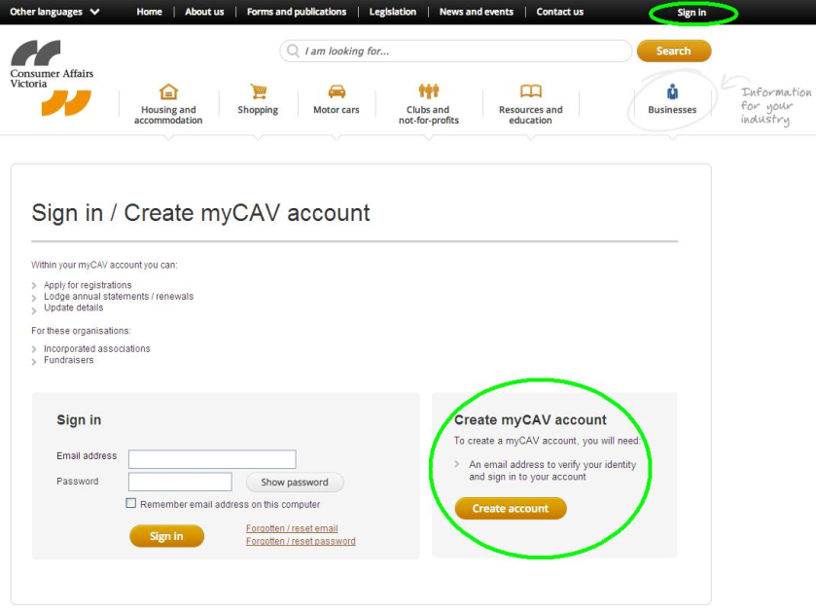
- Yes (Ka hmuh) silole  No (unsure) (Ka hmu  loh (kaa fiang loh)) tiin hi biahalnak hi let Have you received a letter from Consumer Affairs Victoria? (Consumer Affairs Victoria sinin cakuat na hmu cang maw?)  - No (Ka hmu loh) tiin na leh ahcun, hi cahmai hi phi law Create Account (Account Sernak) kha hmet.  - Yes (Ka hmuh) tiin na leh  ah cun, number khumhnak cahmai ah na kal lai. | 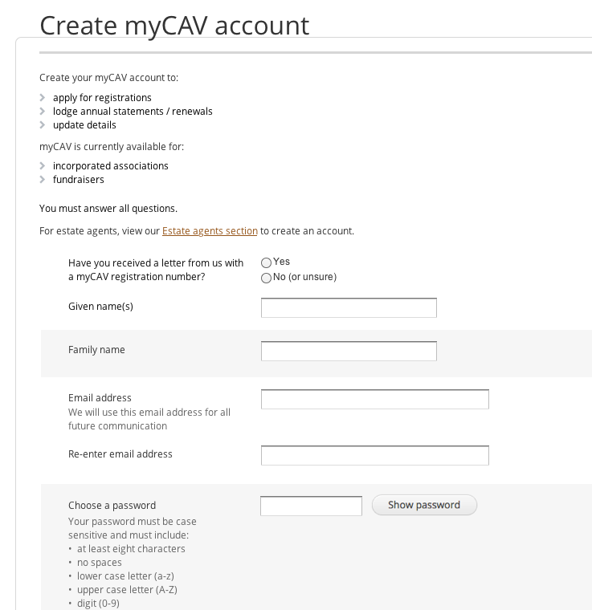
Number khumhnak  cahmai cungah:  - Cakuatmi catlap cung  i myCAV min khumhnak number kha ttial law Next  (A hun changtu) kha hmet. | 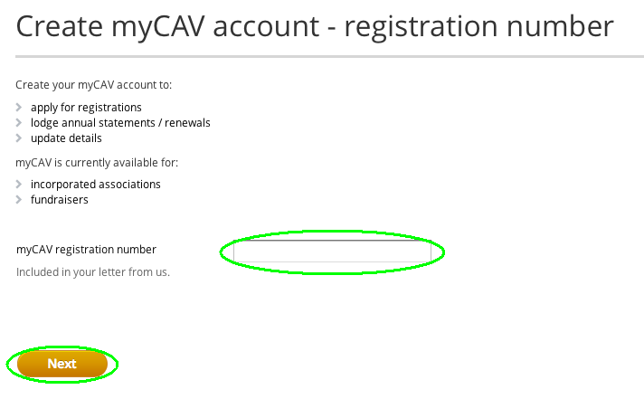
- A cuangmi min hi nangmah na si ahcun fehternak tuah. Yes (Ka si ko) na ti ahcun, pehzulh dingah Next (A hun changtu) kha hmet. | 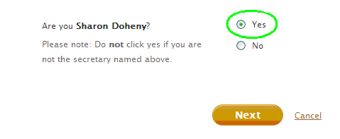
- Na email address le password ttial hna.  - Show password (Password langhternak) kha na password check nak caah hmet.  - Cun Create account (Account ser) kha hmet.  Theihding: Na email le na password kha i cinken hna,  cun midang theihter hna hlah.  Na password cu a tlawmbik cafang pa 8 a si hrim hau i cafang fa pakhat, cafang ngan pakhat, number pakhat le a hleikhun  cafang pakhat zong an i tel hau. | 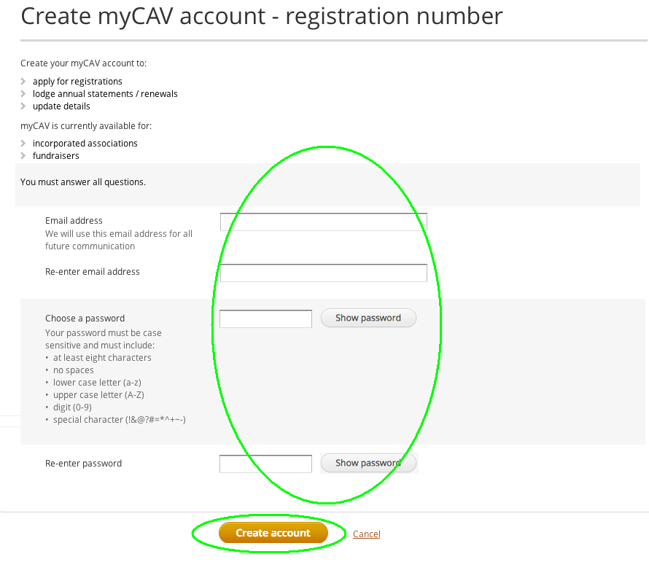
Tlamtling tein na account na serkhawh cang nak cu chikhat teah cakuat nih an theihter lai.  Na sokmi a tlamtlinnak ding caah cakuat chung i sign in (luhnak) link kha hmet. | 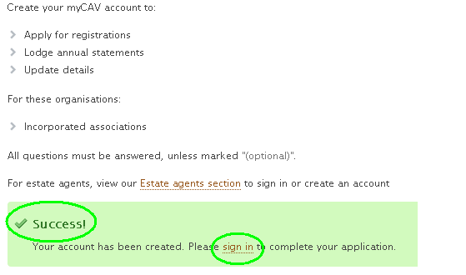
myCAV Sign in (Luhnak) zawnah khan na email address le password ttial, cun myCAV cahmai kalnak dingah Sign in (Luhnak) kha hmet. | 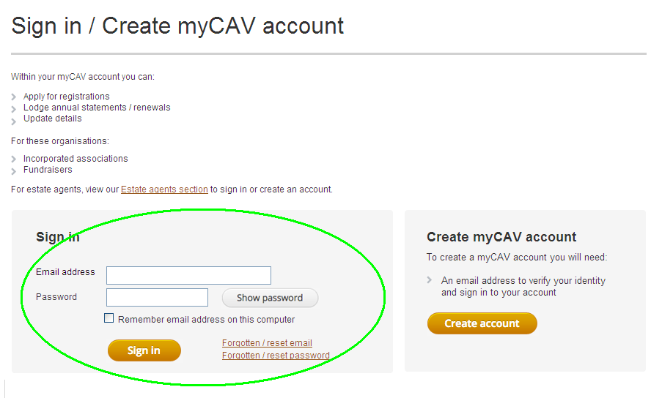
Na myCAV cahmai cung ah na tuahkhawh mi:  - Actions List (Cawlcanghnak) cazin hmangin aa fonhmi nan mibu konglam zoh le thlen.  - Na roca le zulhding hna  kha zuuk (download).  - Hnubik tangka  luhchuahnak zoh.  - Kumfatin rianttuanmi theihternak na ttialmi kha kua. | 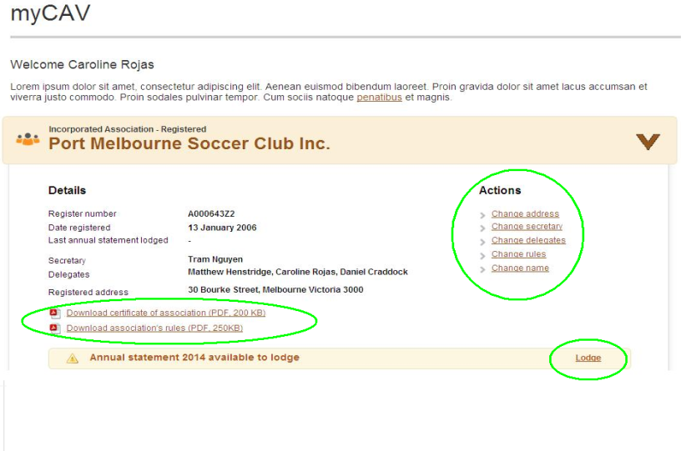
Theihding:  A cuangmi min hi nangmah na si  lo ahcun No (Ka si loh) kha hmet. myCav account thar ser dingah cakuat nih an hal lai.  Account thar ser dingah cakuat chung i link kha hmet law na min, na email address le na password ttial. Cun create account  (account sernak) kha hmet.  myCAV account na ser dih in  aa fonhmi nan mibu sinah na pehtlaihter khawh. | 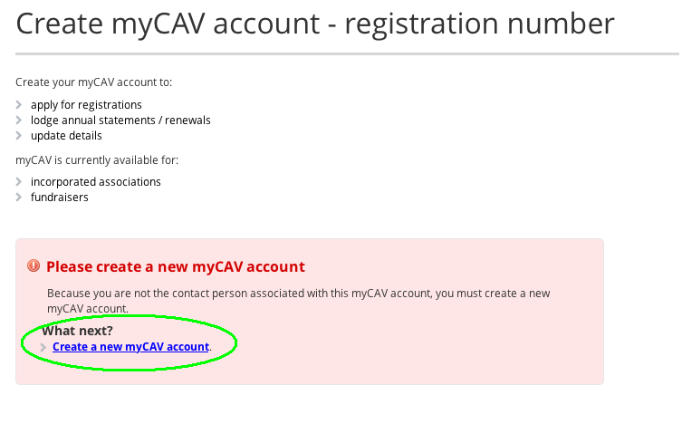
Aa fonhmi nan mibu sinah na account
peh ningcang
myCAV account na ser dih in aa fonhmi nan mibu sinah na pehtlaihter khawh.  - Thimding list on ding ah kan website a cung orhlei kam  I na min khi hmet.  - Link to an organisation  (Libu he pehtleih) timi kha  list chungin thim. | 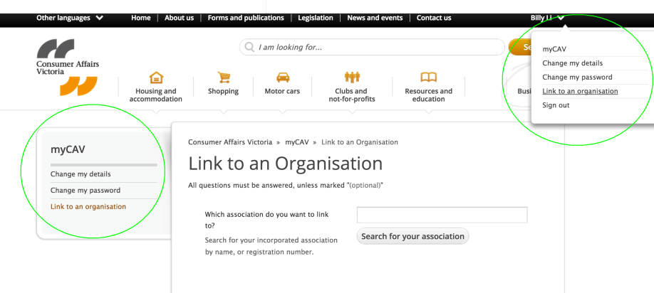
- Pehtlaih dingah na duhmi aa fonhmi bu min kha ttial law Search for your association (Aa fonhmi kan mibu kawlnak) kha hmet.  - Aa fonhmi nan mibu min na hmuh tik ah, a min kha hmet.  - Are you sure you want to link the association as secretary? (Aa fonhmi mibu sinah chungttuan bantuk in pehtlaihnak tuah na duh tak maw?) timi biahalnak a hung cuan tikah OK (OK) hmet. | 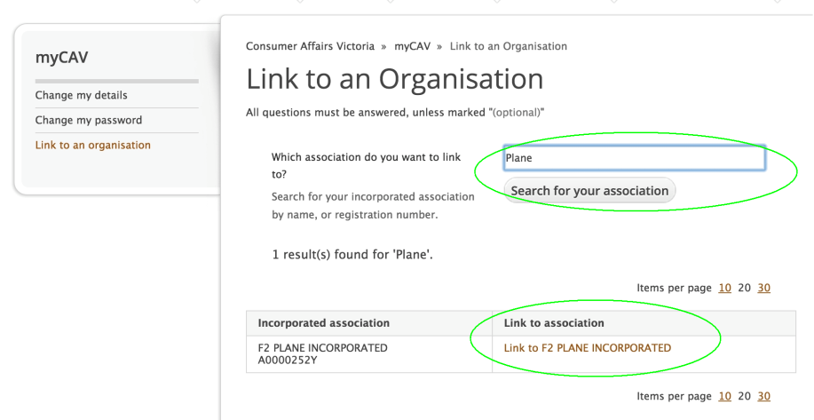
Aa fonhmi nan mibu sinah na account pehtlaihnak na tuahmi  a tlamtlin ahcun chikhat teah cakuat nih theihternak an tuah lai.  myCAV innpi on dingah, cakuat chung i Return to myCAV (myCAV ah kirnak) link  kha hmet. | 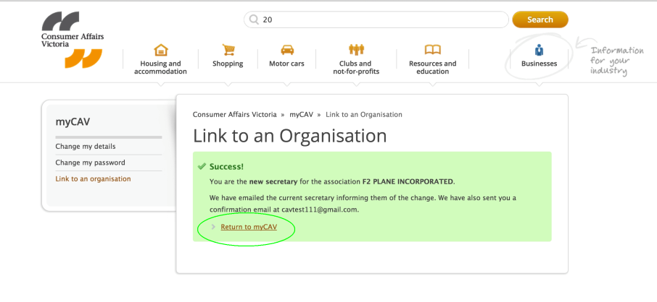
Aa fonhmi nan mibu sinah pehtlaihnak na tuahmi theihternak cu email zongin na hmuh lai.  Email chung i link kha na hmeh tikah myCAV onnak cahmai Sign in (Luhnak) ah na kal lai. | 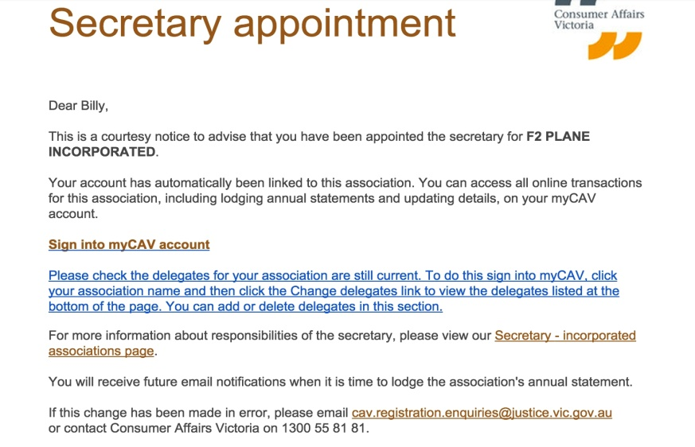
Aa fonhmi nan mibu le na myCAV account na pehtlaihter dih hnu-ah,  na myCAV innpi cu zeitikcaan  paoh ah na lut kho. | 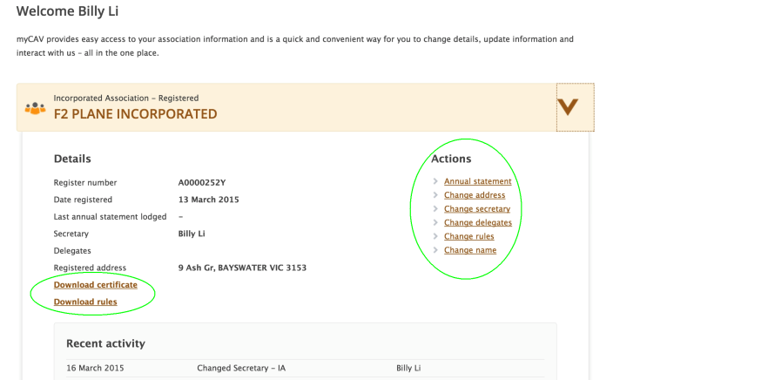
Na myCAV innpi hman ningcang
myCAV chung i a fonhmi mibu konglam cu chungttuan silole  ai-awhtu lawng nih a thlen khawh.  Thlennak tuah a si tikah, chungttuan sinah email in theihternak kuat a si.  A tanglei hna tuah dingah,  na myCAV innpi cung i aa fonhmi  nan mibu min changtu feikawl  kha hmet.  - Hnubik cawlcanghnak le  aa fonhmi nan mibu  konglam zoh/rel.  - Kopi (copy) mi roca hna  le zulhphung hna  zuuk (download).  - Actions List (Cawlcanghnak) cazin hmangin aa fonhmi nan mibu konglam thlennak.  - Caan hman tein kumfatin rianttuanmi theihternak na ttialmi kuatnak. | 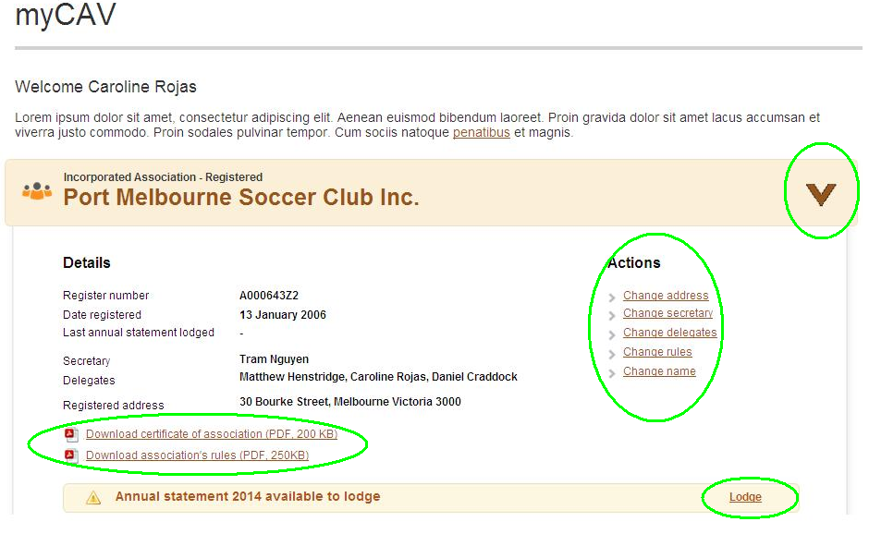
Kumfatin rianttuanmi theihternak na ttialmi
kuat ningcang
Kumtin ngeihmi meeting (AGM) tuah hlan thlakhat chungah, aa fonhmi mibu hna nih kumfatin rianttuanmi theihternak an ttialmi cu myCAV ah an kuat hrim hau. Ca ttialmi kuat dingah email in theihternak kuat  na si lai.  Dotkhatnak (Tier 1) – Aaa fonhmi mibu hna – kumfatin ngunkhuai $250,000 (singhnih le sang-nga) tang a simi nih, an tangka  hman-nak (financial) le kumfatin (annual) rianttuanmi theihternak ttialmi kuat a hau ti lo.  Dot-hnih le dot-thumnak (Tier 2 and Tier 3) – aa fonhmi mibu hna nih an tangka hman-nak ttialmi le an zohtthan-nak kopi siloah zohfelnak an tuah cangmi report cu electronic file in an thil hrim a hau.  Na myCAV innpi i lodge (kuatnak) link kha hmet.  - A herhmi konglam kha ttial.  - Select file to attach (Thil dingmi file thim) timi na hmeh khawh in, dirhkamhtuca hna kha electronic file in thil. File na thil duhmi kha na computer chungah kawl law Ok (Ok) hmet. (File hna cu .doc, .docx, .xls, .xlsx, .text, .pdf format in an si lai i 5MB) nak in an ngan lai lo.  - Declaration (Fiang tein thanhnak) kha ralring tein rel law Agree (Lugtling) kha hmet.  - Tangka peknak kal dingah Next (A hun changtu) kha hmet.  Theihding:  myCAV cung fiang tein thanhmi lungtlinnak cu phunglam he aa tlaimi a si. | 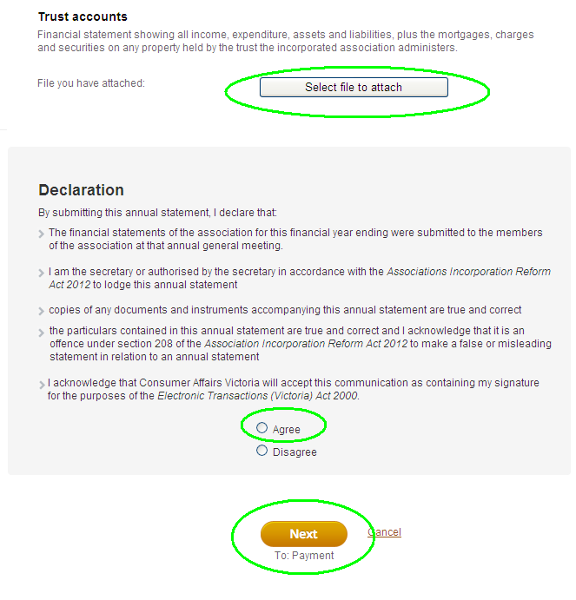  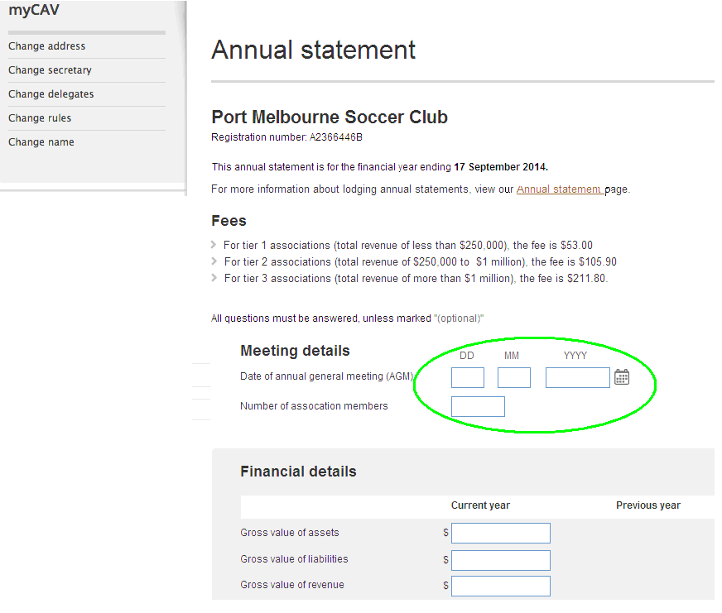
myCAV chungah tangka pek ningcang
myCAV hmang in online siloah mipum in tangka peknak cu naa thim khawh. Post office ahcun cheque in tangka pek a hau.  Tangka pek ding cun:  - Na hman dingmi tangka  peknak thim.  - Peknak cahmai kal dingah Next (A hun changtu) kha hmet. | 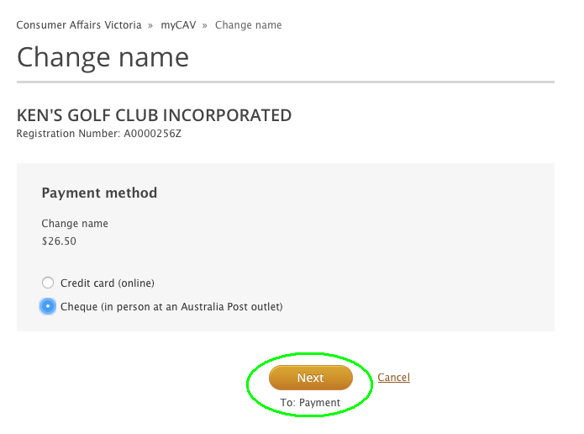
Mipum in tangka pek ding ahcun  - Aa ttialmi kha ahman maw chek ta. Cun, Confirm (A hman ko) kha hmet.  Theihding:  Email in invoice kuat na si lai i, ni 14 chung tangka pek caan na ngei. Tangka na pekmi receipt na hal hrim lai. | 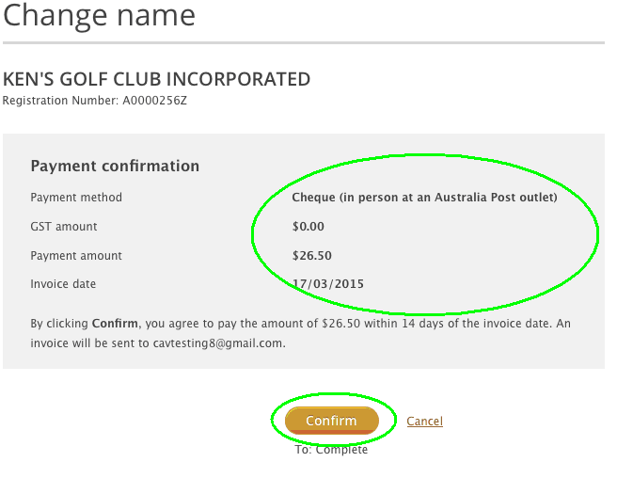
Online in pek ding ahcun:  - Debit siloah credit Visa/MasterCard na herh lai.  - Card cung i aa ttialning khan ttial law Next (A hun changtu) kha hmet.  - Hman tein aa tuah dih ahcun, Make payment (Tangka peknak) kha hmet.  Theihding:  Na tangka pekmi a tlamtlin ahcun, chikhat teah cakuat in theihternak  a rak in tuah lai. Receipt zong na email ah an kuat lai. | 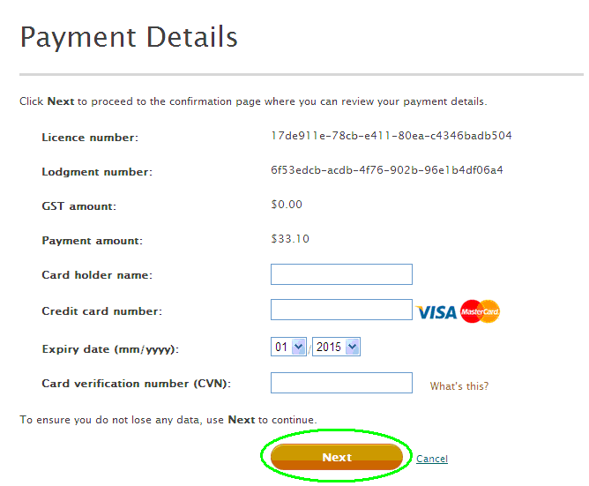

Aa fonhmi mibu min thlen ningcang
Aa fonhmu mibu min thlen ding ahcun, ahleikhun in biakhiahnak tuah a herh.  Ahleikhun in biakhiahnak  tuah hnu-ah:  - Actions List (Cawlcanghnak)  i Change name (Min thlen) kha hmet. | 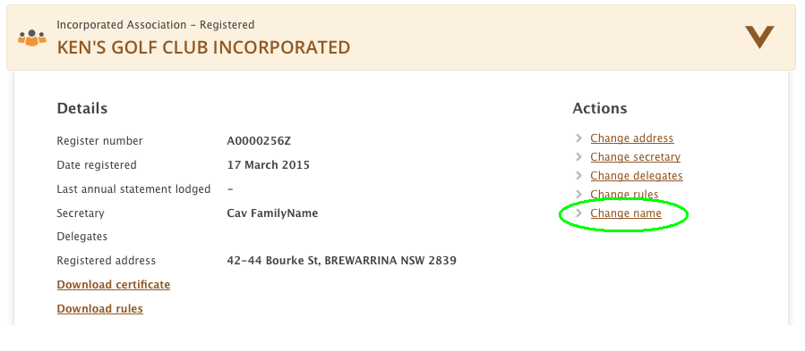
- Lungtlinh mi min kha ttial law, Check name availability (Hi min hi hman khawh a si maw si lo cheknak) kha hmet. | 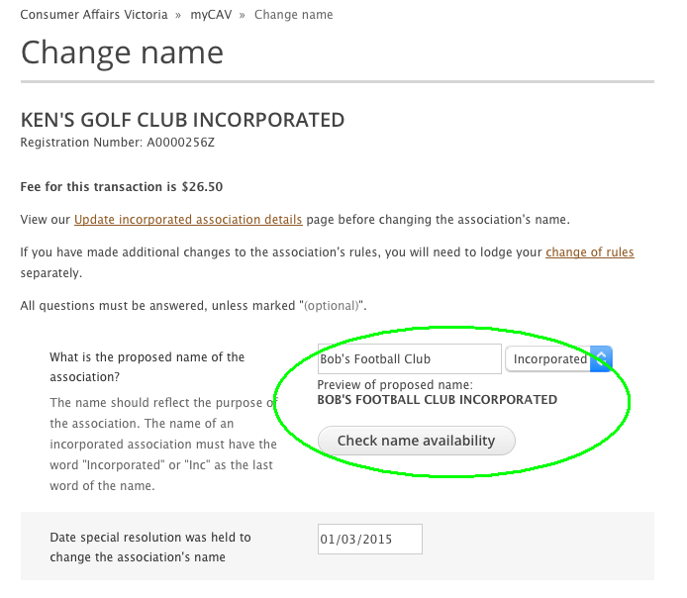
- Min thlenmi kha tlamtlin ahcun, cakuat in theihter si lai.  Theihding:  Min thlenmi a tlamtlin lo ahcun,  min dang thim tthan a hau lai.  - Ahleikhun in minthlennak kongah biakhiahnak tuah  ni/thla kha ttial. | 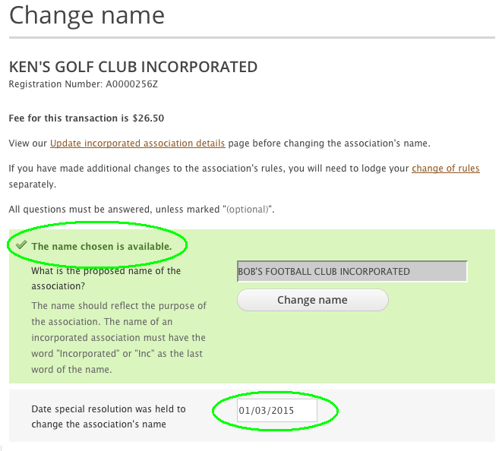
- Aa fonhmi nan mibu min thar le nan zulhphung kopi (copy) hna kha electronic file in thil hna.  - Phunglam ning in fiang tein thanhnak kha rel law Agree (Lungtling) le Next (A hun changtu) kha hmet hna law tangka peknak ah an kalpi lai. | 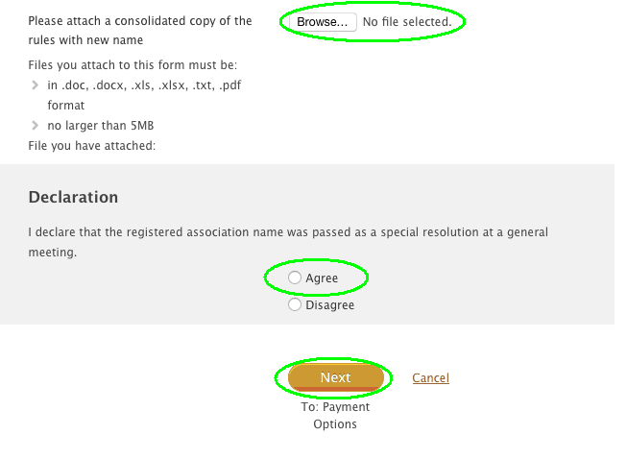
Tangka peknak ah ttial herhmi na ttial hnu-ah, aa fonhmi nan mibu min tlamtling in thlen a si cang nak cu cakuat in theihternak na hmuh colh lai. | 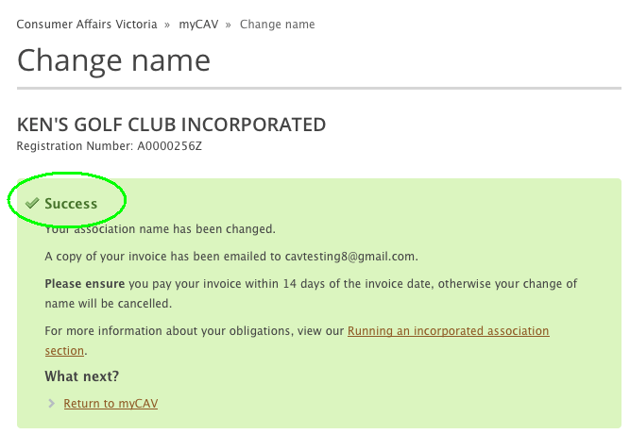
Aa fonhmi nan mibu min thlen a si cang nak cu, myCAV na vun on tthan tikah na hmuh lai. | 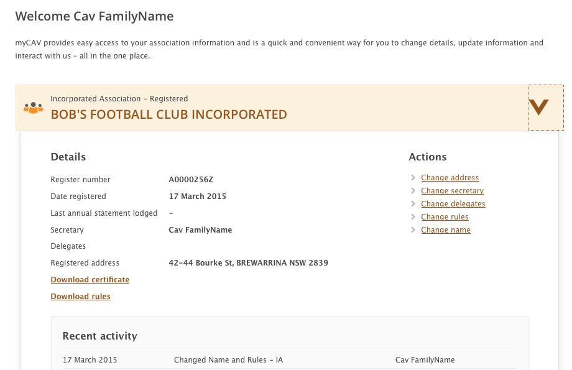

Zulhphung thlen ningcang
Aa fonhmi nan mibu zulhphung thlen ding ahcun, ahleikhun in biakhiahnak tuah a herh.  Ahleikhun in biakhiahnak tuahmi  a tlamtlin hnu-ah:  - Actions List (Cawlcanghnak) ah Change rules (Phunglam thlen-nak) timi kha hmet. | 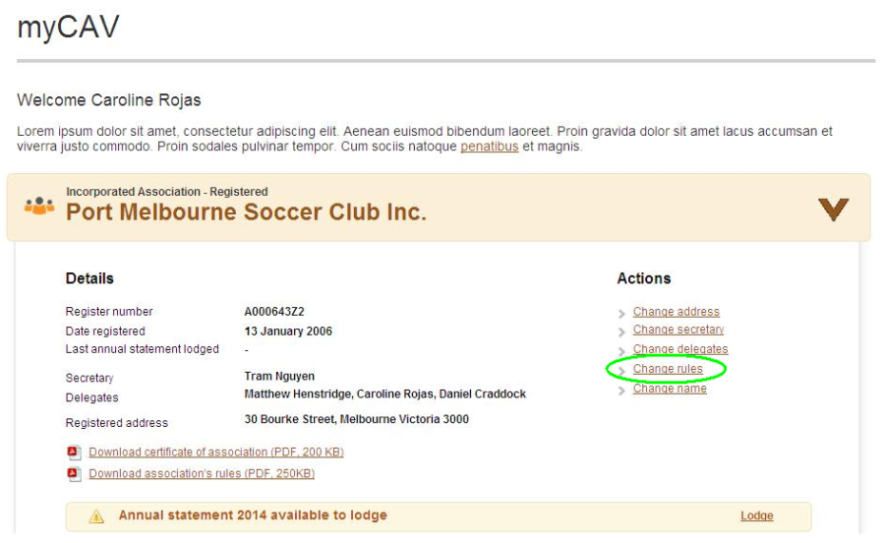
- Own rules (Ngeihmi zulhphung) siloah model rules (zohchunmi zulhphung) kha list chungin thim.  - Ahleikhun in zulhphung thlennak kongah biakhiahnak tuah ni/thla kha ttial. | 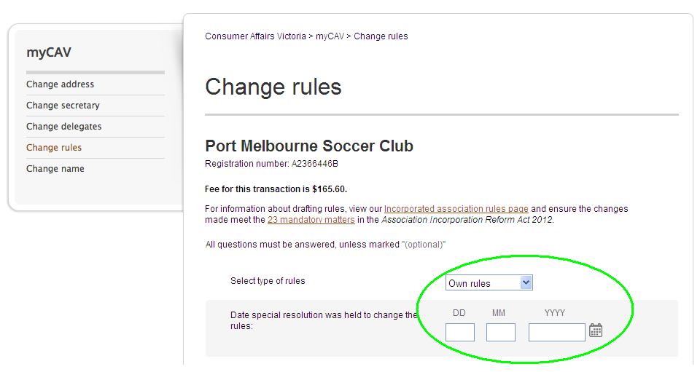
- Ahleikhun in zulhphung  thlen-nak biakhiahmi kha electronic file in thil.  - Nan mibu dirhmi nih zeidah  aa tinh le kumdongh tangka luhchuah caan ni/thla ttial.  - Nan zulhphun kha electronc kopi (copy) in thil.  - Fiang tein thanhnak ahkhan, Agree (Lungtling) kha hmet; Tangka peknak kal dinga Next (A hun changtu) kha hmet. | 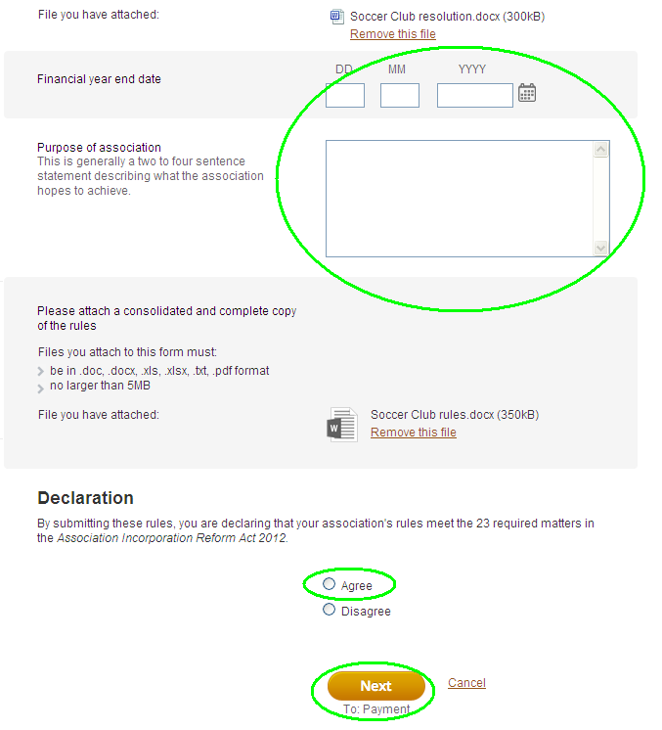
Chungttuan konglam thlen ningcang
Tulio chungttuan lawng nih chungttuan min a thlen khawh.  Chungttuan konglam thlen ning cu:  - Na myCAV innpi cung i Actions List (Cawlcanghnak) i Change secretary (Thleng secretary) kha hmet.  - Cun Change to new secretary (Chungttuan thar ah thleng) silole Update current secretary’s details (tulio chungttuan konglam remh) kha hmet. | 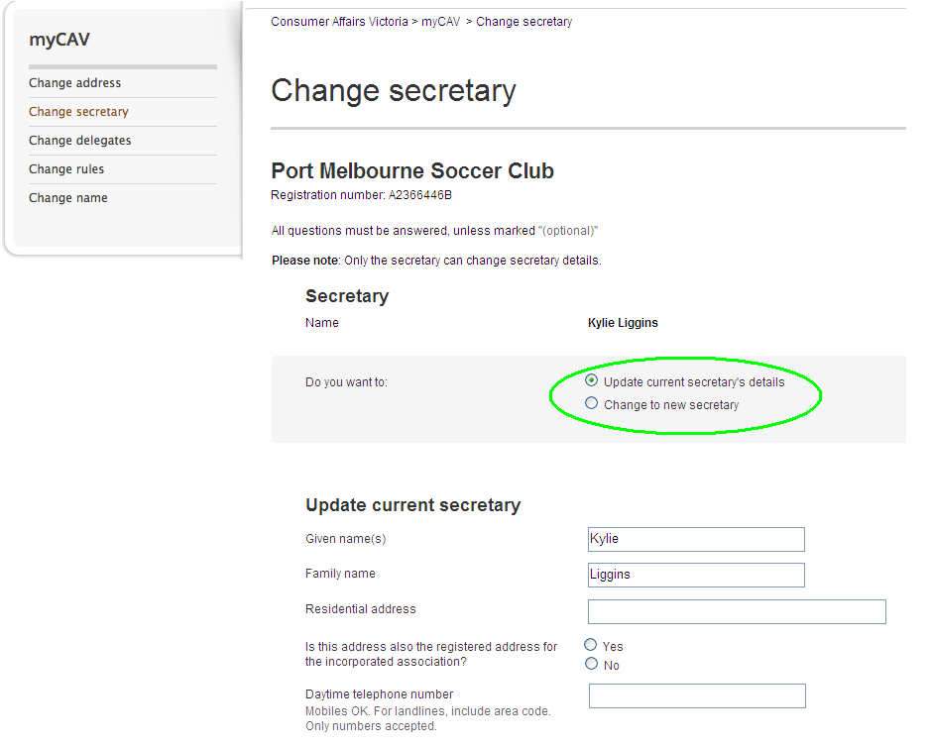
- Thlen tharmi konglam ttial.  - Save (Khumh) hmet.  Chungttuan thlen a si ahcun,  aa fonhmi nan mibu ai-awhtu  le chungttuan sinak in aa dinmi sinah aa thlengmi theihternak  cu email in kuat a si lai.  Chungttuan chawngtu ding nih an  i tonbiaruahnak ding (appointment) le myCAV account nunter ding fehternak link cu email in  a hmuh lai. | 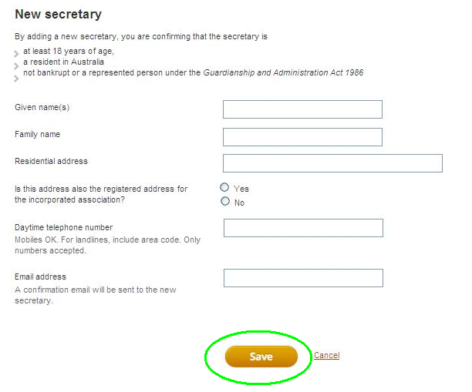

Ai-awhtu chap le zuh ningcang
myCAV tawlrelnak ah a herhning  in tawlreltu dingah chungttuan nih ai-awhtu pathum nawlngeihnak  a pek khawh hna.  Ai-awhtu chap ning:  - Actions List (Cawlcanghnak)  i Change delegates (Thleng ai-awhtu) kha hmet.  - Chungttuan nih ai-awhtu dingah nawlngeihnak a pek cang  ti fehternak ah ai-awhtu thar konglam ttial law fehternak  kha zah.  - Add delegate (Ai-awhtu chap) kha hmet.  Ai-awhtu pathum na ngeih cang ahcun, ai-awhtu thar chaptthannak dingah chuangttuan nih ai-awhtu hlun kha a zuh/hlawnh hrim hau.  Ai-awhtu zuh/hlawnh dingah:  - An min sirlei i Delete  (Hlawnh) kha hmet.  Tulio chungttuan nih ai-awhtu zuh/hlawnhnak a tuahmi cu  ai-awhtu in aa dinmi sinah  email in theihternak tuah a si lai.  Aa dinmi chungttuan le ai-awhtu hna nih, an myCAV account chungah aa fonhmi nan mibu konglam zoh khawhnak an  ngei ti lai lo. | 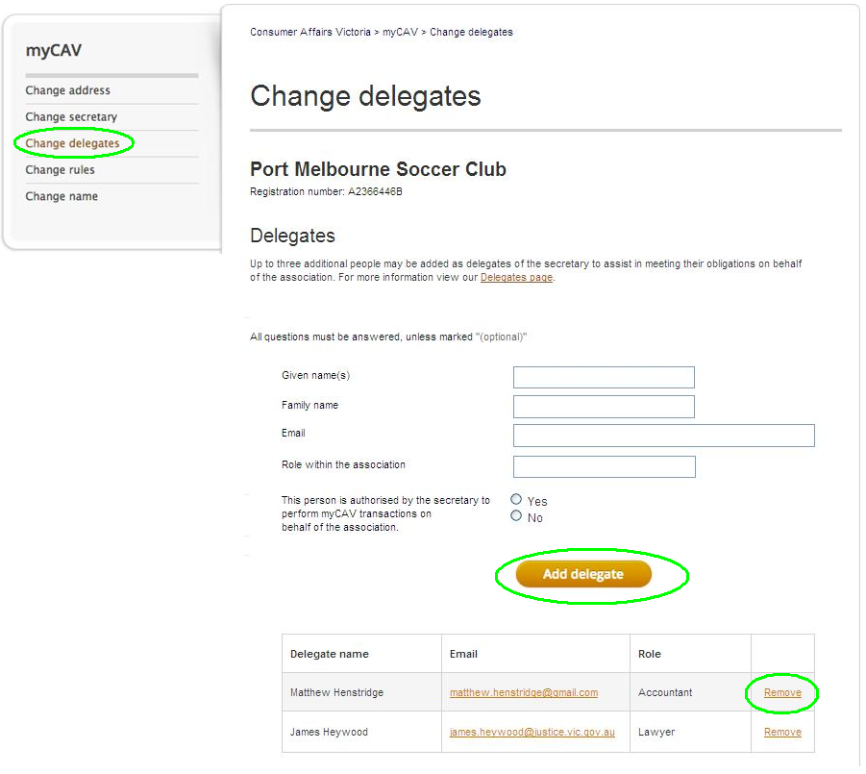
Pumpak konglam thlen ningcang
Pumpak konglam thup an si ruangah, myCAV chungah nangmah konglam lawng na  hmuh khawh.  Na pumpak konglam thlenning cu:  - Kan webite ong law a cunglei cahmai i thim dingmi cazin chung in na min kha hmet.  - Tuah na duhmi thim law hmet. | 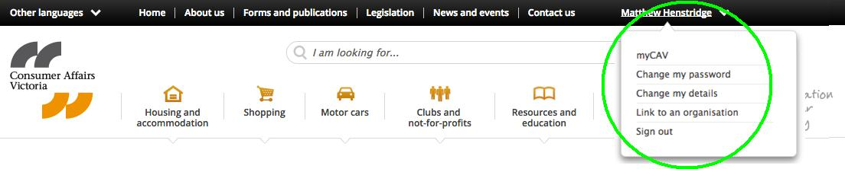
Password thlenning tahchunhnak:  - Cazin chung in Change my password (Ka password thlen) kha hmet.  - Tulio na password ttial.  - A dik ti theihfian nak hnga,  na password thar ttial law Show password (Password langhter) kha hmet.  - Save (Khumh) hmet law chikhat teah cakuat nih thlenmi a fehter lai. | 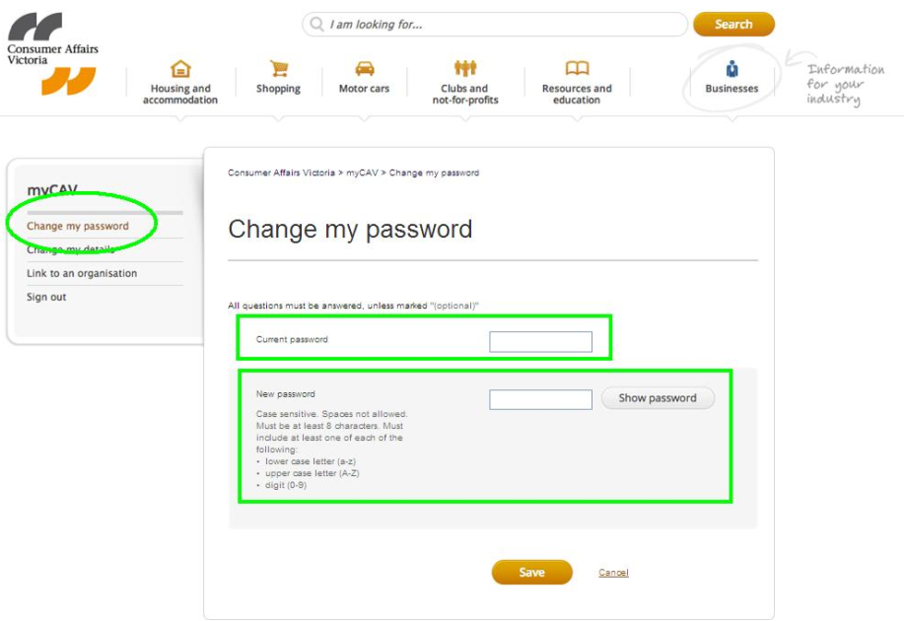

A thar in na password tuah-tthannak ningcang
Na password na philh ahcun:  - myCAV Sign in  (Luhnak) cahmai ong  law Forgotten/reset  (Philh/tuah-tthan) kha hmet.  - Na email address ttial law Send link (Link kua) kha hmet.  Na password thlen dingah email kuat na si lai.  Password thar tuah ningcang zulh ding le link kuatmi on dingah suimilam 24 na ngei.  Password na thlen hlan-ah kuatmi link a caan dih ahcun, a thar in tuah-tthan. | 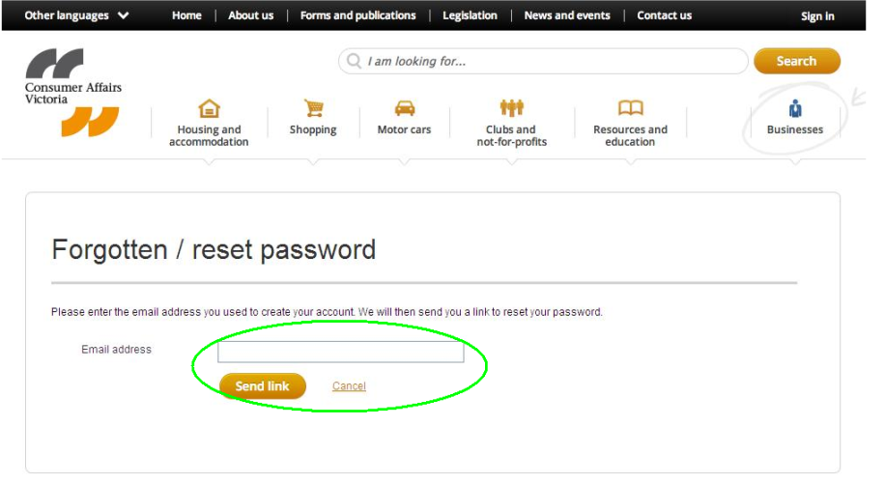

myCAV in chuah ningcang

Humhimnak caah myCAV na hman dih in chuak (sign out) zungzal.  - Cahmai cung orlei kam i Sign out (Chuah) kha hmet. | 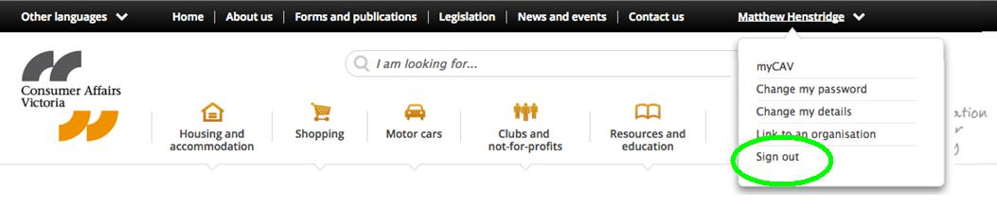

myCAV Chungah Aum Lomi Cawlcanghnak

myCAV chungah tuah-awk a ttha lomi cawlcanghnak hna cu:

- Aa fonhmi mibu hna cawhkalh
- Kumfatin rianttuannak ttialmi Ca kuat dingah AGM (Kum dongh meeting)
thawn deuh dingin hal
- Aa fonmi bu ngerhngawiter le hrawhtthan (Cancel).

Hi hna cawlcanghnak konglam ttialmi ca (forms) cu kan website ah an um
www.consumer.vic.gov.au/associations

Na Internet Browser Tharchuah

Google Chrome hi na internet browser caah a ttha bik i kan in duhpiak. Chrome hi khulrang te le ttha tein rian a ttuan khawh pinah alakka in zuh/laak (download) khawh a si.

Ca/Holh Lehnak Lei Ttuanmi

myCAV konglam cu holhphun dangdang in kan website ah aum
www.consumer.vic.gov.au/languages

Ca/holh lehnak lei ttuanmi hna cu 131 450 ahhin alak in chawnh khawh kan si. Rianttuan caan ah 1300 55 81 81 hi chawn law na holh-min kha Mirang holh in chim, cun holhlettu ka herh tiah hal hna.

1300 661 511 ah Koori nih bawmhnak an tuahmi zong aum.

Konglam Tamdeuh

myCAV hmanning cawnnak video, komlam tamdeuh le myCAV konglam tharchuahmi hna hi zoh le rel na duh ahcun, consumer.vic.gov.au/associations ah rak leng

A miak um loin, rianttuantu aa fonhmi mibu konglam telh-in kan chuahmi thawngzamhca hi pehtlaih (subscribe) na duh ahcun consumer.vic.gov.au/newsletters ah rak leng.

myCAV cu pehzulh tein tharchuah peng a si lai. myCAV muisam cu aa thleng kho tawn lengmang, aa fonhmi nan mibu caah tuah na duhmi cu rang tein in le tlamtling tein na
tuah khawh nak hnga a changchang tein hmuhsakmi tuah ningcang nih a dih tiang an bawmh lai.

