
Consumer Affairs Victoria

Information about shopping and services

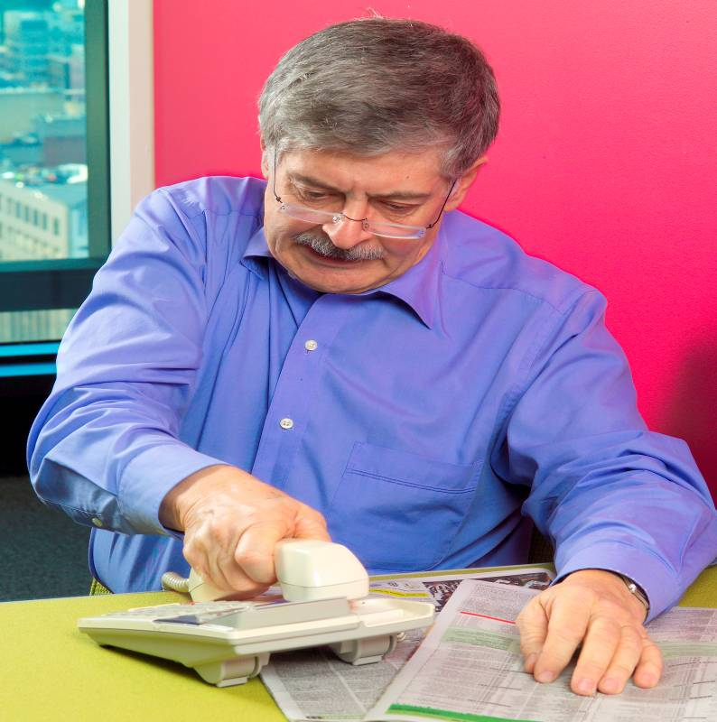
Phone sales


Easy English fact sheet
For more information about this fact sheet, see page 9.

You might need help to read this information.

A friend, family member or support person can help you.



What are phone sales?

- A person calls you at home or at work
- The person tries to sell you a product
- This person is called a sales person.
A product is something you
- buy, for example, gas, electricity, a holiday or pay TV
- pay someone to do for you, for example, paint your house.


What are the laws?

There are laws when you buy a product that costs more than $100.
The laws protect you when you use the phone, internet or mail order to buy a product.


The sales person must tell you all the information before you buy

The sales person must tell you the truth.
The sales person must tell you
- The sales person’s name and the business name
- Prices and any discounts. For example, if you can use a pension card to get a cheaper phone bill
- Any extra money you might have to pay. Extra money is called a fee or a charge
- How long the contract is, for example, six months or one year
- Information about changing your mind after you buy the product.

Can you change your mind?

When you buy a product that costs more than $100,
you have 10 days to change your mind.
The 10 days is called a cooling off period.
What can you do in a cooling off period?
- You can stop the contract
- You can return the product
- You can get a refund.


How do you buy a product?

You agree to buy a product when you say “Yes, I will buy that.” You must
- Understand what you are doing
- Be able to tell the sales person “Yes, I will buy that.”


You agree to buy a product in writing or on a voice tape. The sales person must ask for your permission before they can record your voice on tape.


You can say “no, goodbye”.
You can hang up the phone.

- You do not have talk to a sales person
- A sales person can not ring you again for 30 days about the same product
- A sales person can ring you again if it is about a different product
- If you say “I am too busy to talk”, a sales person can ask you “Can I ring you later?” You can say no.
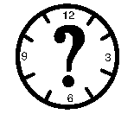
When can a sales person call you?

- Monday to Friday, 9 am to 8 pm
- Saturday, 9 am to 5 pm.

A sales person can not call you on a Sunday or public holiday, for example, Christmas Day or Good Friday.

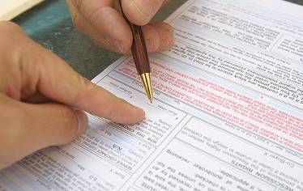
When you buy a product over the phone

- You will get a contract
- The business will post the contract to you.

How do you stop a contract?

- Phone the business and tell them you want to stop a contract
or
- Fill in a form and post it to the business.

The sales person must tell you how to stop a contract.

What happens after you stop a contract?

The business will give you your money back.
If the product is broken you might only get some of your money back.

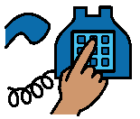

Do-not-call register

- You can tell the government that you do not want phone sales people to call you at home
- You need to phone or fill in a form on the website

Phone 1300 79 29 58
Website www.donotcall.gov.au
- There are some groups and charities that are still allowed to call you.
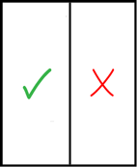
There are a lot of special rules for people who do phone sales

You can get more information from Consumer Affairs Victoria. Look at the next page.


More fact sheets and information

Consumer Affairs Victoria
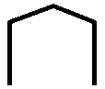   | Address 113 Exhibition Street  Melbourne Victoria 3000
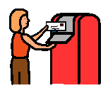 | Phone 1300 55 81 81
 | Mail GPO Box 123  Melbourne Victoria 3001
 | Fax (03) 8684 6295
   | Interpreter 131 450
 | National Relay Service 133 677
 | Email consumer@justice.vic.gov.au
 | Website http://www.consumer.vic.gov.au
This information is written in Easy English. You might need more information about the law.
You can ask Consumer Affairs Victoria for more information.

Version 3. Updated January 2011.

Easy English fact sheet produced by Scope, July 2008.

Look at the Easy English Writing Style Guide for information about the format and writing style of this document.
You can find more information at http://www.scopevic.org.au or
phone (03) 9843 2000.

The Picture Communication Symbols ©1981-2008 by Mayer-Johnson LLC. All Rights Reserved Worldwide. Used with permission.

COMPIC is used with permission. You can find more information about COMPIC at http://www.scopevic.org.au.

