ENFORCEABLE UNDERTAKING

SECTION 218 of the AUSTRALIAN CONSUMER LAW (VICTORIA)

The commitments in this Undertaking are offered to the Director of Consumer Affairs Victoria by:
IN TOUCH FASHIONS & GIFTS PTY LTD
(ACN 062 755 926)
and
HENRY CHEN

TABLE OF CONTENTS
Contents
PARTIES 3
The Director 3
In Touch Fashions & Gifts Pty Ltd 3
Henry Chen 3
LEGISLATION 4
Application of the Australian Consumer Law (Vic) 4
Permanent Bans 4
Mandatory Information Standards 4
Failure to comply with Mandatory Safety Standards -civil proceedings 4
Failure to comply with Manadtory Safety Standards-criminal proceedings 5
Mandatory Information Standards 5
Failure to comply with Manadatory Information Standards- civil proceedings: 6
Failure to comply with Mandatory Information Standards- criminal proceedings 6
Administrative resolution 7
Mandatory Standards 7
CONSUMER AFFAIRS VICTORIA INVESTIGATION 7
Inspection and seizure 7
Determination of Non-Compliance 8
Contraventions of the ACL 8
Acknowledgment of the Breach 9
UNDERTAKINGS 10
Refrain from further non-compliant conduct 10
Payment to the Victorian Consumer Law Fund 10
COMMENCEMENT 10
CONCLUSION/DURATION 10
PUBLIC NATURE OF UNDERTAKING 11
COMPLIANCE AND ENFORCEMENT 11
EXECUTION 12
ANNEXURE A 13

PARTIES

The Director
- The office of the Director of Consumer Affairs Victoria (Director) is provided for under section 107 of the Australian Consumer Law and Fair Trading Act 2012 (Act).
- The Director is responsible for the administration of the Act, the Australian Consumer Law (ACL) which is Schedule 2 to the Competition and Consumer Act 2010 (Cth), applied as a law of Victoria by Part 2-2 of the Act and known as the Australian Consumer Law (Victoria) (ACL (Vic)), together with Victoria’s other consumer protection legislation.
- The Director, as a Regulator for the purposes of the ACL (Vic), and under the provisions of section 218 of the ACL (Vic), may accept a written Undertaking from any person in connection with any matter involving a contravention of the ACL (Vic) in respect of which the Director has a power or function, as a means of resolving contraventions of the ACL (Vic).

In Touch Fashion & Gifts Pty Ltd
- In Touch Fashions & Gifts Pty Ltd (ACN 062 755 926) (Company) is an Australian proprietary company limited by shares, which was registered on 7 December 1993.
- The Company’s registered office is located at unit 5 and 6, 94 The Parade, Norwood, South Australia 5067.
- At times relevant to this Undertaking, the Company carried on business trading as “In Touch Imports” at a retail premises located at 276 Smith Street, Collingwood, Victoria supplying discount goods, including cosmetic and novelty products (retail premises).
- The Company ceased trading at the retail premises in or about May 2019.

Henry Chen
- Henry Chen is and was, at all times relevant to this Undertaking:

  - the sole director and secretary of the Company;
  - the person responsible ultimately for acquiring, or arranging the acquisition of, products supplied by the Company; and
  - a person who was acting on behalf of the Company, in the usual and ordinary course of its business, in respect of the matter set out below.

LEGISLATION

Application of the Australian Consumer Law (Vic)
- On 1 January 2011, the ACL, set out in Schedule 2 to the Competition and Consumer Act 2010 (Cth), was applied by Part 2.2 of the Act as a law of Victoria, which is known as the ACL (Vic).
- Part 3-3 of the ACL (Vic) deals with the safety of consumer goods and product-related services.
- Part 3-4 of the ACL (Vic) deals with the information standards for goods and services.

Permanent Bans
- Section 114(1) of the ACL (Vic) provides for the imposition, by the Commonwealth Minister for Competition Policy and Consumer Affairs (Commonwealth Minister), of a permanent ban for consumer goods of a particular kind to prevent or reduce risk of injury to any person.

Mandatory Safety Standards
- Section 104 of the ACL (Vic) provides for the imposition, by the Commonwealth Minister, of a mandatory safety standard for consumer goods of a particular kind to prevent or reduce risk of injury to any person.

Failure to comply with Mandatory Safety Standards- civil proceedings
- Section 106 of the ACL (Vic) imposes an obligation upon persons to refrain from:

  - in trade or commerce, supplying or offering for supply consumer goods;
  - in or for the purpose of trade or commerce, manufacturing, possessing or having control of consumer goods; or
  - in specific circumstances, exporting consumer goods,
if a safety standard is in force in respect of those goods and those goods, do not comply with the standard.
- A person who contravenes section 106 of the ACL (Vic) may, in civil proceedings brought for contraventions of that section, be subject to the range of remedies available under Part 5-2 of the ACL (Vic), including the imposition of pecuniary penalties in respect of each contravention of not more than:

  - if the person is not a body corporate- $500,000,
  - in the case of a body corporate- $10,000,000 and
- if the court can determine the value of the benefit that the body corporate, and any body corporate related to the body corporate, have obtained directly or indirectly and that is reasonably attributable to the act or omission- three times the value of that benefit;
- if the court cannot determine the value of that benefit- 10% of the annual turnover of the body corporate during the 12-month period ending at the end of the month in which the act or omission occurred or started to occur.

Failure to comply with Mandatory Safety Standards- criminal proceedings:
- Section 194 of the ACL (Vic) creates an offence which is committed if a person:

  - in trade or commerce, supplies or offers for supply;
  - in or for the purposes of trade or commerce, manufacturers, possesses or has control of; or
  - in specific circumstances, exports
consumer goods of a particular kind and a safety standard for consumer goods of that kind is in force and those goods do not comply with that standard.
- A person, other than a body corporate who commits an offence against subsections 194(1), (2), (3) or (5) of the ACL (Vic) is punishable on conviction by a fine of not more than $500,000.
- A body corporate who commits an offence against sub sections 194(1), (2), (3) or (5) of the ACL (Vic) is punishable on conviction, by a fine of not more than the greater of the following,
  - $10,000,000; and
  - if the court can determine the value of the benefit that the body corporate, and any body corporate related to the body corporate, have obtained directly or indirectly and that is reasonably attributable to the commission of the offence- three times the value of that benefit;
  - if the court cannot determine the value of that benefit- 10% of the annual turnover of the body corporate during the 12-month period ending at the end of the month in which the body corporate committed, or began committing, the offence.

Mandatory Information Standards
- Section 134 of the ACL (Vic) provides for the imposition, by the Commonwealth Minister, of a mandatory information standard for consumer goods of a particular kind.

Failure to comply with Mandatory Information Standards -civil proceedings:
- Section 136 of the ACL (Vic) imposes an obligation upon persons to refrain from:

  - in trade or commerce, supplying or offering for supply consumer goods; or
  - in or for the purpose of trade or commerce, manufacturing, possessing or having control of consumer goods;
if an information standard is in force in respect of those goods and those goods do not comply with that standard.
- A person who contravenes section 136 of the ACL (Vic) may, in civil proceedings brought for contraventions of that section, be subject to the range of remedies available under Part 5-2 of the ACL (Vic), including the imposition of pecuniary penalties in respect of each contravention of not more than:

  - if the person is not a body corporate- $500,000.
  - in the case of a body corporate- $10,000,000; and
- if the court can determine the value of the benefit that the body corporate, and any body corporate related to the body corporate, have obtained directly or indirectly and that is reasonably attributable to the act or omission- three times the value of that benefit;
- if the court cannot determine the value of that benefit- 10% of the annual turnover of the body corporate during the 12-month period ending at the end of the month in which the act or omission occurred or started to occur.

Failure to comply with Mandatory Information Standards -criminal proceedings
- Section 203 of the ACL (Vic) creates an offence which is committed if a person:

  - in trade or commerce, supplies or offers for supply; or
  - in or for the purposes of trade or commerce, manufacturers, possesses or has control of, -
consumer goods of a particular kind and an information standard for consumer goods of that kind is in force and those goods do not comply with that standard.
- A person, other than a body corporate who commits an offence against subsections 203(1), (2), (3) of the ACL (Vic) is punishable on conviction by a fine of not more than $500,000.
- A body corporate who commits an offence against subsections 203(1), (2), (3) of the ACL (Vic) is punishable on conviction, by a fine of not more than the greater of the following,
  - $10,000,000; and
  - if the court can determine the value of the benefit that the body corporate, and any body corporate related to the body corporate, have obtained directly or indirectly and that is reasonably attributable to the commission of the offence- three times the value of that benefit;
  - if the court cannot determine the value of that benefit- 10% of the annual turnover of the body corporate during the 12-month period ending at the end of the month in which the body corporate committed, or began committing, the offence.

Mandatory Standards
- For the purposes of Part 3-3 and 3-4 of the ACL (Vic), pursuant to section 65E of the Trade Practices Act 1974 (Cth) and for the purposes of section 65C of the Act in relation to safety standards and section 65D of that Act in relation to information standards, the Commonwealth Minister made an Information Standard, on 29 October 1991, relating to cosmetics by way of Trade Practices (Consumer Product Information Standards) (Cosmetics) Regulations 1991 (Cosmetics Information Standard) which are mandatory standards by the operation of clause 5 to schedule 7 of the Trade Practices Amendment (Australian Consumer Law) Act (No.2) 2010, and which continues in effect as if imposed pursuant to section 134(1) of the ACL (Vic).
- Copies of the safety and information standards are available and may be downloaded from the website at www.productsafety.gov.au.

CONSUMER AFFAIRS VICTORIA INVESTIGATION

Inspection and seizure
- In June 2018 and on 30 January 2019, Consumer Affairs Victoria (CAV) inspectors conducted inspections at the Company’s retail premises. During these inspections, CAV Inspectors identified cosmetic products that did not list any ingredients on the products or packaging, in non-compliance with the Cosmetic Information Standard.
- The Company gave voluntary undertakings to CAV on 24 July 2018 and 30 January 2019 including, amongst other things, to destroy or make the products compliant and not to restock or resell the non-compliant products.
- On 8 February 2019, CAV issued the Company with an Official Warning Notice in relation to the non-compliant products identified at the July 2018 and January 2019 inspections. \
- On 27 March 2019, CAV inspectors conducted a remediation inspection at the Company’s retail premises. CAV staff identified and seized the following cosmetic products that were offered for sale that did not comply the Cosmetic Information Standard:
  - four containers of “Zombie Blood Spray”;
  - one container of “Zombie Skin”;
  - six packets of “Horror Facial Hair Kit”;
  - eight containers of “Creepy Skin”;
  - two packets of “She-n-She” tattoos; and
  - one packet of “Billy’s Australian Collection” tattoos.
(collectively referred to as the “Cosmetic Products”).
- Photographs and descriptions of the Cosmetic Products seized are at Annexure A.
- The “Zombie Blood Spray” referred to in paragraph 31 had previously been identified as non-compliant at the inspection on 24 January 2019.
- During the remediation inspection, CAV inspectors observed several “closing down” signs at the retail premises. A Company employee stated that they had put everything on the shelf as the Company was closing down and was trying to sell as much stock as possible.

Determination of Non-Compliance
- On 27 March 2019, CAV Inspectors determined that the cosmetics seized and referred to in paragraph 31 failed the requirements of regulation 5 of the Cosmetics Standard because:

  - the ingredients of the cosmetics products were not listed on the container; or
  - if the product was not packed in a container, on the product; or
  - if the above could not be complied with because of its size, shape or nature, a list of ingredients were not shown in another way that ensured that a consumer could be informed about the ingredients in the product.

Contraventions of the ACL
- The Director considers that the Company contravened sub-section 136(2) and (3) respectively of the ACL (Vic) by offering to supply and having in its possession or control, in or for the purposes of trade or commerce not less twenty-two cosmetic products that did not comply with the Cosmetics Standard.
- The Director is prepared to deal with these alleged contraventions by accepting this written undertaking pursuant to section 218 of the ACL (Vic).

Acknowledgment of the Breach
- Henry Chen on behalf of the Company, acknowledges that on 27 March 2019, the Company contravened subsection 136(2) of the ACL(Vic) in that, in trade or commerce, the Company did offer to supply consumer goods of a particular kind:
  - for which there was an information standard for goods of that kind in force, namely the Cosmetics Information Standard; and
  - for which the Company has not complied with regulation 5(1) and 5(3) of the Cosmetics Information Standard because:
- the ingredients of the cosmetics products were not listed on the container;
- if the product was not packed in a container, on the product; or
- if the above could not be complied with because of its size, shape or nature, a list of ingredients were not shown in another way that ensured that a consumer could be informed about the ingredients in the product.
- Henry Chen on behalf of the Company, acknowledges that on 27 March 2019, the Company contravened subsection 136(3) of the ACL(Vic) in that the Company did in or for the purposes of trade or commerce, possess or have control of consumer goods of a particular kind:
  - for which there was an information standard for goods of that kind in force, namely the Cosmetics Information Standard; and
  - for which the Company has not complied with regulation 5(1) and 5(3) of the Cosmetics Information Standard because:
- the ingredients of the cosmetics products were not listed on the container;
- if the product was not packed in a container, on the product; or
- if the above could not be complied with because of its size, shape or nature, a list of ingredients were not shown in another way that ensured that a consumer could be informed about the ingredients in the product.
- Henry Chen acknowledges personally that, at all times, he was directly or indirectly knowingly concerned in, and a party to the Company contraventions referred to in paragraphs 38-39 of this Undertaking.
- Henry Chen, individually, and on behalf of the Company, seeks to address these acknowledged contraventions of section 136 of the ACL (Vic) by offering this Undertaking to the Director.

UNDERTAKINGS

Refrain from further non-compliant conduct
- Henry Chen, personally, and on behalf of the Company, undertakes to the Director that he will:

  - refrain from offering to supply;
  - supplying; and
  - being in possession or having under its control-

or being in any way, directly or indirectly knowingly concerned in or party to offering to supply, supplying, manufacturing, possession or controlling any products, which fail to comply with the requirements of any:

- safety standard declared under Division 1 of Part 3-3 of the ACL (Vic);
- interim or permanent ban order imposed under Division 2 of Part 3-3 of the ACL (Vic); or
- information standard made under Part 3-4 of the ACL (Vic).

Payment to the Victorian Consumer Law Fund
- Henry Chen, personally, and on behalf of the Company, undertakes to the Director that he will, within seven days of the commencement of this Undertaking:
- pay a total of $1,000 to the Director, for payment into the Victorian Consumer Law Fund; and
- notify the Director in writing that the payment to the Victorian Consumer Law Fund has been made.

COMMENCEMENT
- This Undertaking comes into effect when:
- The Undertaking is executed by the Company and Henry Chen; and
- The Director accepts the Undertaking so executed.

CONCLUSION/DURATION
- This Undertaking remains in effect for a period of five years from its commencement.

PUBLIC NATURE OF UNDERTAKING
- Henry Chen, personally, and on behalf of the Company acknowledges that:

  - pursuant to section 218 of the ACL (Vic), the Director will register this Undertaking in the Register of Undertakings on the CAV website and the Undertaking will be available for public inspection;
  - the Director and/or the Minister for Consumer Affairs may, from time to time, publicly refer to this Undertaking;
  - this Undertaking in no way derogates from the rights and remedies available to any other person arising from the alleged conduct; and
  - no compensation is payable to it, or on its behalf, arising from the destruction by the Director, or his staff, of any of the goods seized from the premises on 27 March 2019.

COMPLIANCE AND ENFORCEMENT
- Henry Chen, personally, and on behalf of the Company, acknowledges that:
  - CAV will continue to conduct compliance monitoring inspections of premises of suppliers in Victoria, investigate and prosecute breaches of the ACL (Vic) and institute and defend proceedings to achieve the purposes of the ACL (Vic); and
  - the Director reserves the right to enforce a breach of this Undertaking in a Court to the full extent provided by law.

EXECUTION
Signed by: ………………………………………………..…………..
HENRY CHEN - personally and as the sole director and secretary of the Company
On: ………………May 2020

Accepted by: ………………………………………………..…………..
Samuel Jenkin, Director of Consumer Affairs Victoria, pursuant to section 218 of the ACL (Vic).
On: ………….May 2020

ANNEXURE A
Goods seized from the Company by Consumer Affairs Victoria Inspectors on 27 March 2019.

PHOTOGRAPH 1 AND 2 OF “ZOMBIE BLOOD SPRAY

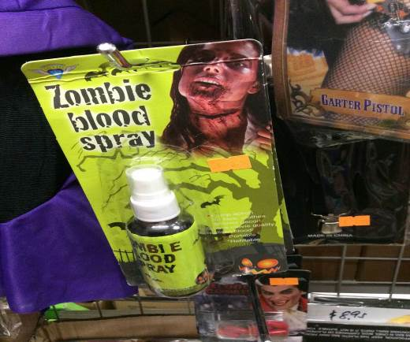

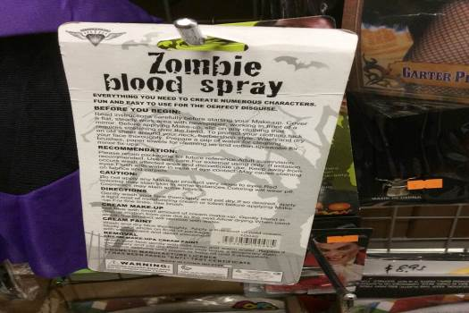
PHOTOGRAPH 3 AND 4 OF “ZOMBIE SKIN”

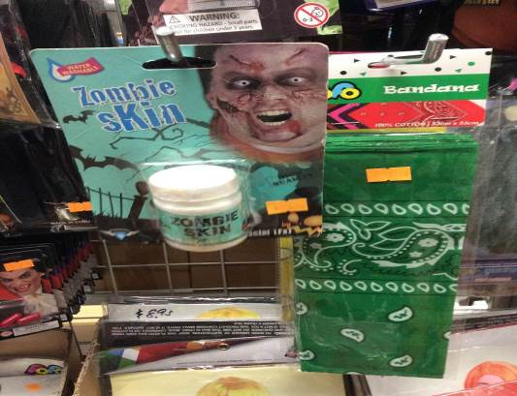

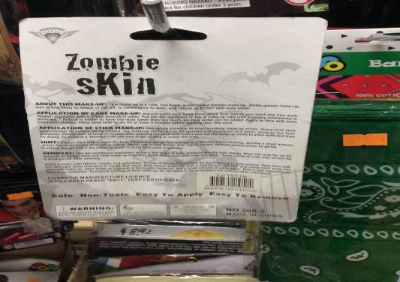

PHOTOGRAPH 5 AND 6 OF “HORROR FACIAL HAIR KIT”

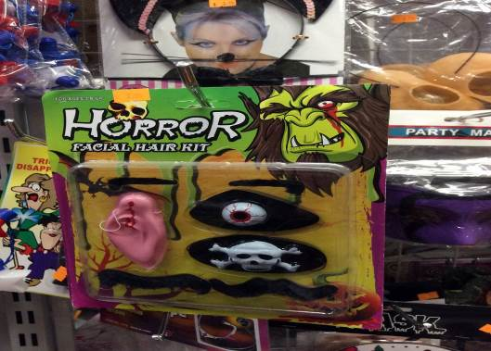

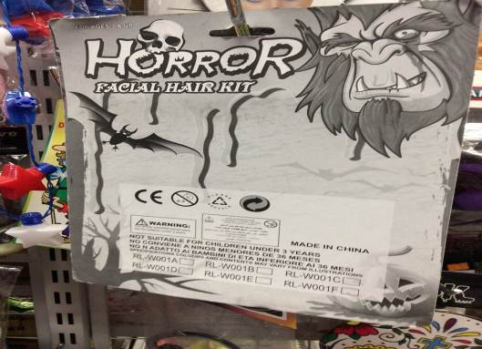

PHOTOGRAPH 7 AND 8 OF “CREEPY SKIN”

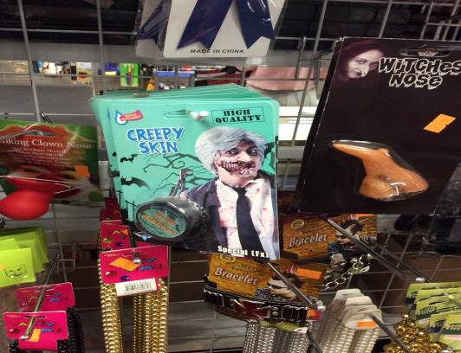

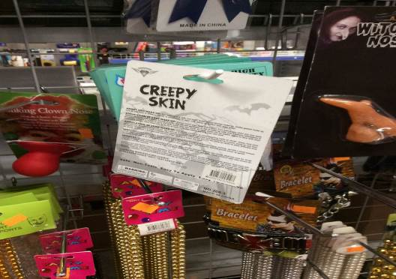

PHOTOGRAPH 9 AND 10 OF “SHE-N-SHE” TATTOOS



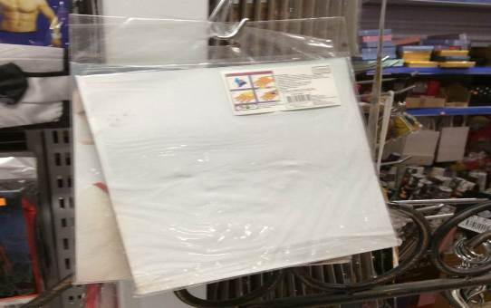

PHOTOGRAPH 11 AND 12 OF “BILLY’S AUSTRALIAN COLLECTION” TATTOOS

