In the Magistrates’ Court Court No. D10430020
of victoria
at MELBOURNE

BETWEEN:

DIRECTOR OF CONSUMER AFFAIRS VICTORIA Plaintiff

– AND –

GIFTS KING IMPORT PTY LTD
ACN 108 011 678 Defendant

ORDER
MAGISTRATE: | Mr Garnett
DATE OF ORDER: | 9 May 2013
NATURE OF MATTER: | Complaint alleging contraventions of sections 106 and 118 of the Australian Consumer Law (Victoria).
HOW OBTAINED: | By Consent
ATTENDANCE: | Mr Peter Hiland, Solicitor for the Plaintiff.  No appearance for the Defendant.
OTHER MATTERS: | N/A
THE COURT DECLARES:
Pursuant to section 226 of the Australian Consumer Law and Fair Trading Act 2012
- That the 7,214 “Musical Birthday Sparkling Candles” (“the candles”) depicted and described in Annexure “A” below, found in the possession, or under the control, of the Defendant on 30 October 2012, do not comply with the permanent ban order on combustible candle holders imposed under Consumer Protection Notice No. 12 of 2011, made under Part 3-3 of the Australian Consumer Law (Victoria), in that the candles are objects designed to hold or decorate a candle, which when subjected to a flame or heat emanating from a candle being so held or decorated, ignite and continue to flame for a period of five seconds after ignition.
THE COURT ORDERS BY CONSENT:
Pursuant to section 174 of the Australian Consumer Law and Fair Trading Act 2012
- That the 7,214 “Musical Birthday Sparkling Candles” (“the candles”), found in the possession, or under the control, of the Defendant between 21 and 23 January 2013, be destroyed by the Plaintiff.
- The Defendant pay to the Plaintiff the costs of:
- the storage of the candles from 21 January 2013 to the date of this order, fixed in the sum of $100; and
- the destruction of the Candles found in the possession, or under the control, of the Defendant between 21 and 23 January 2013, fixed in the sum of $400 –
within 7 days of service upon it of a copy of this Order.
- Reserve liberty to apply.
- The Defendant pay a contribution towards the Plaintiff’s costs of this proceeding, fixed in the sum of $500. Stay 30 days.

DATED: 9 May 2013

Magistrate

ANNEXURE “A”
“Musical Birthday Sparkling Candle” seized from
GIFTS KING IMPORT PTY LTD
at 7 Elna Court, Moorabbin Victoria 3189
by Consumer Affairs Victoria Inspectors on 21 to 23 January 2013

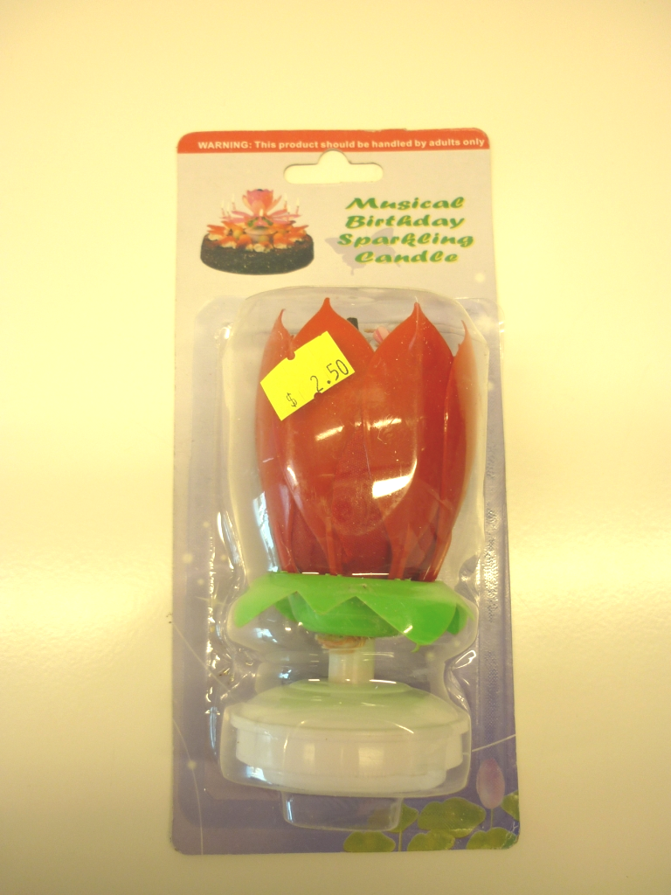 | 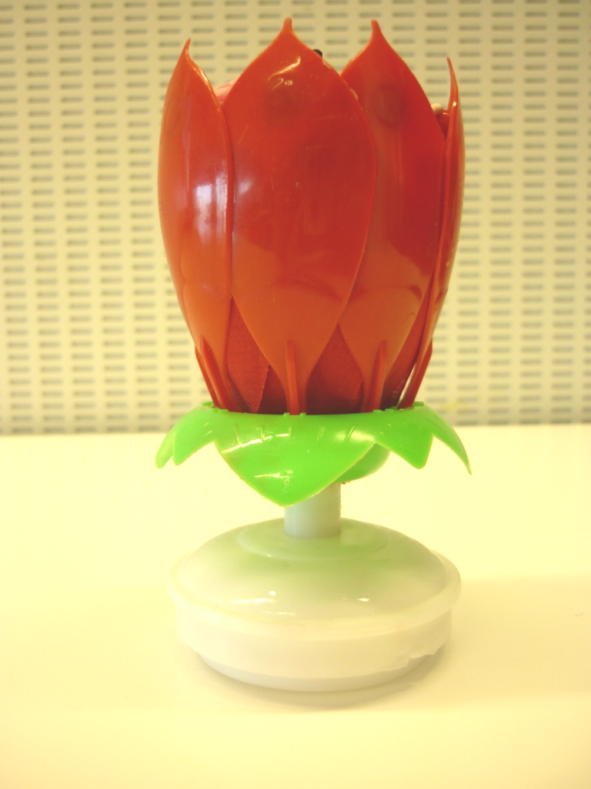
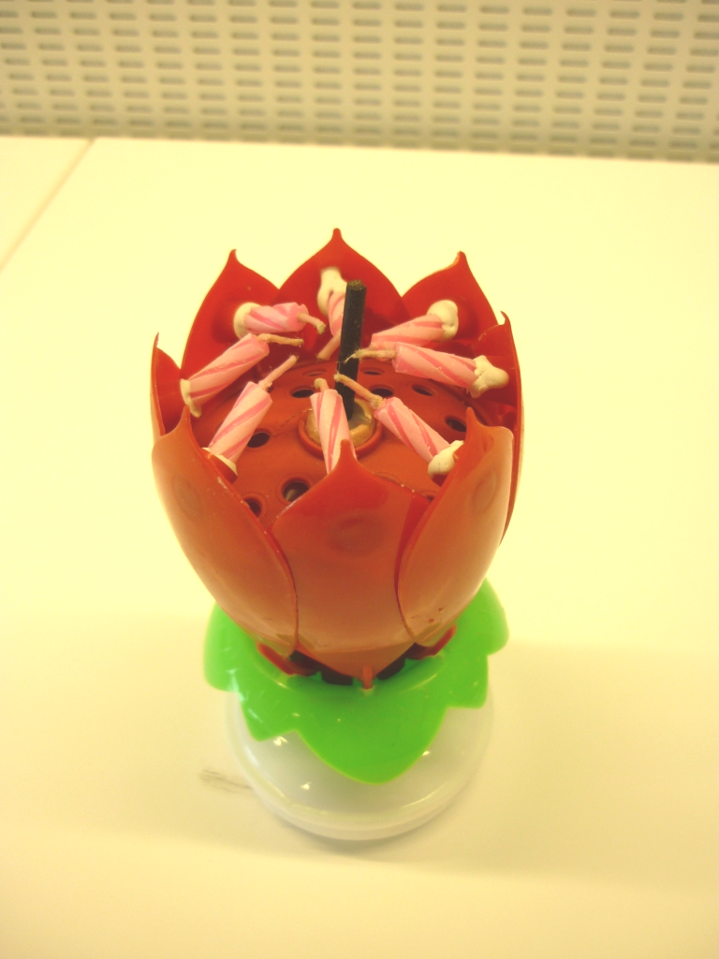 | 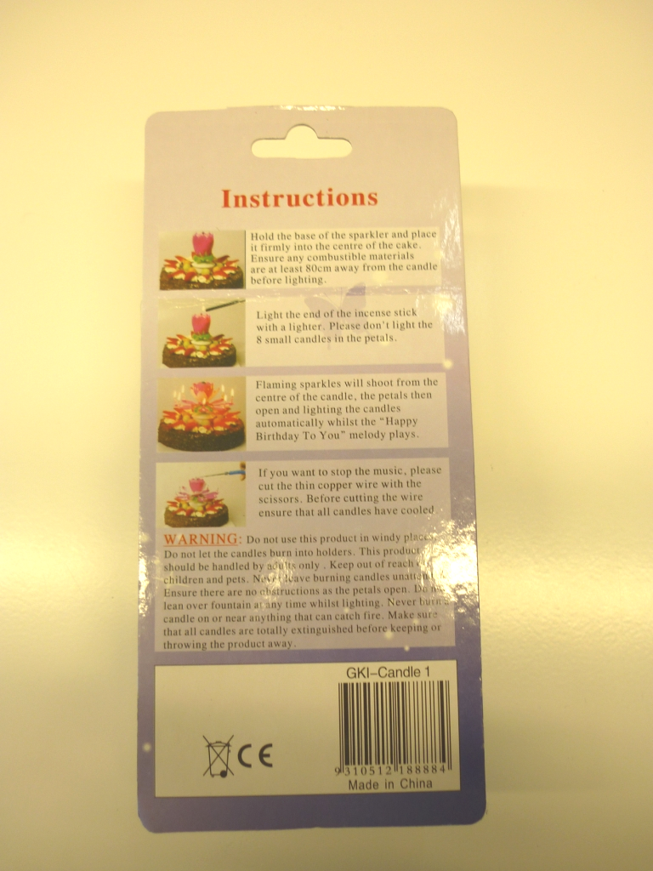
❐ “MUSICAL BIRTHDAY SPARKLING CANDLE”
Description: Coloured plastic candle holder with 7 wax candles. Barcode No. 9310512188884. Item No. GKI–Candle 1.
Units Seized: 7,214

