
YOU ARE HERE
ASSEMBLY AREAS

EVACUATION PROCEDURES

STAGE 1:- Remove people from the immediate Danger Area
Occupants and staff in the immediate danger area are to assemble a safe distance away from the fire and smoke. When the area has been evacuated all doors and windows should be closed to contain fire.
STAGE 2:- Removel to a Safe Area
If the severity of the smoke or fire warrants further evacuation, occupants should be moved through fire/smoke doors to a safe area.
STAGE 3:- Complete Evacuation of Entire Complex Should the emergency necessitate evacuation of the whole building, the Manager or the Fire Service will direct occupants from the safe place to one of the ASSEMBLY AREAS.
STAGE 4:- Roll Call.
To be conducted as soon as possible and to ensure all Persons are accounted for. Report all missing persons to FIRE OFFICERS.

EVACUATION DIAGRAM
Premises Name

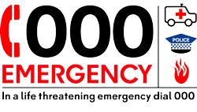

In an emergency dial 000

