Product safety guide for business
The Australian Consumer Law logo appears on the cover of this document.

Contents
Contents 1
Publisher information 3
Copyright 3
Introduction – About this guide 3
Your responsibility to know about changes to the law 3
Words used in this guide 3
Product safety in Australia 4
Your responsibilities 4
Where to get help 5
National product safety laws 5
More information 8
Baby products 8
Baby bath aids 8
Baby dummies 9
Baby dummies with unsafe decorations 10
Baby dummy chains with unsafe decorations 10
Baby walkers 11
Folding cots 12
Household cots 13
Prams and strollers 14
Clothing and accessories 15
Care labelling for clothing and textiles 15
Nightwear for children 16
No holes tongue stud 17
Sunglasses and fashion spectacles 17
Confectionery 18
Mini jelly cups containing konjac 18
Furniture 19
Bean bags 19
Bunk beds 20
Hardware and building materials 21
Fire extinguishers (portable aerosol) 21
Fire extinguishers (portable non-aerosol) 21
Gas masks containing asbestos 22
Health and cosmetics 23
Cosmetics and toiletries 23
Glucomannan in tablet form 23
Hot water bottles 24
Toothpaste containing DEG (diethylene glycol) 24
Homewares and furnishings 25
Blind and curtain cords 25
Candles with lead wicks 26
Combustible candle holders 26
Spas and swimming pools 27
Spa and pool skimmer boxes, filters, outlets and covers 27
Sports and recreation 27
Basketball rings and backboards 27
Bicycles 28
Bicycle helmets 29
Exercise cycles 30
Moveable soccer goals 31
Swimming and flotation aids for children 32
Treadmills 33
Tobacco and smoking accessories 34
Disposable cigarette lighters 34
Reduced fire risk cigarettes 35
Smokeless tobacco products 36
Tobacco products – labelling 36
Toy-like novelty lighters 37
Toys and novelties 37
Balloon-blowing kits 37
Children’s plastic items with more than 1% DEHP 38
Flotation and aquatic toys 39
Fire footbags 40
Inflatable toys, novelties and furniture containing beads 40
Knives – toy and novelty 41
Magnets in toys 41
Novelty cigarettes 42
Projectile toys 43
Sky lanterns 44
Toys containing lead and other elements 45
Toys for children under three 46
Yo-yo balls 47
Vehicles and vehicle accessories 48
Child car restraints 48
Elastic luggage straps 49
Miniature motorbikes (monkey bikes) 49
Motor vehicle recovery straps 50
Motorcycle helmets 51
Portable ramps for motor vehicles 51
Tinted headlight covers 52
Trolley jacks 53
Vehicle jacks 54
Vehicle support stands 55
Contacts 56
State and territory contacts 56
Other contacts 57

Publisher information
The guide was developed by:
- Australian Capital Territory Office of Regulatory Services
- Australian Competition and Consumer Commission
- Consumer Affairs and Fair Trading Tasmania
- Consumer Affairs Victoria
- New South Wales Fair Trading
- Office of Consumer and Business Services South Australia
- Queensland Office of Fair Trading
- Western Australia Department of Commerce, Consumer Protection

Copyright
Copyright:
© Commonwealth of Australia 2012
All material presented in this publication is provided under a Creative Commons Attribution 3.0 Australia licence. For more information, visit the Attribution 3.0 Australia (CC BY 3.0) page on the Creative Commons website.
The full legal code for the CC BY 3.0 AU licence is available on the Attribution 3.0 Unported page on the Creative Commons website.
ISBN 978-0-642-74816-4

Introduction – About this guide
This Product safety guide for business has been designed to help you:
- understand Australia’s national product safety laws
- ensure you only sell products that comply with those laws.
The guide provides information in simple language to help you understand some aspects of the law; for example, it shows some of the key requirements of bans and standards that apply to specific products. You must not rely on this book as a complete guide to complying with the law.
Always check the Product Safety Australia website for information about the law for a particular product.

Your responsibility to know about changes to the law
The information in this guide is current at the date of publication; however, it is your responsibility to ensure you are informed and aware of changes to the law. To do this, you can:
- check the Product Safety Australia website for current safety warnings, bans and standards
- register at the Product Safety Australia website to receive email alerts about changes to product safety laws.

Words used in this guide
In this guide:
- sell means supply, offer to supply, manufacture, possess or have control of a product
- supplier and business refer to manufacturers, importers, wholesalers and retailers of consumer products. All these types of businesses must comply with product safety laws
- a business can be one person or a company. Product safety laws apply to your business regardless of your business structure; that is, whether you are a sole trader, partnership, corporation, co-operative or other type of business entity.

Product safety in Australia

Your responsibilities
You must make sure the products you sell comply with product safety laws.
If you sell unsafe products, you risk:
- those products harming your customers
- having those products seized
- having to conduct a recall
- being fined or taken to court
- getting a bad reputation.

How can I make sure my products are safe?
- Use this guide to understand which products are banned or restricted, and the types of requirements they must comply with.
- If you plan to sell a product that has a mandatory safety standard, ask your supplier for proof it has been tested to meet the relevant standard. See ‘Testing’ in the next section of this guide.
- Register at the Product Safety Australia website to receive email alerts about product safety laws. These laws change as new products come on to the market and hazards are identified.
- Register at the Product Safety Recalls Australia website to receive email alerts about product recalls.
- Contact your state or territory consumer protection agency for advice. See ‘Contacts’ inside the back cover of this guide.

Testing
Some product safety laws have requirements that you can check yourself; for example, a warning label on the packaging, or a simple measurement. Where possible, these requirements are included in this guide.
However, some product safety requirements can only be checked by a specialist testing laboratory; for example, how much lead a product contains, or whether it meets a particular level of strength and durability.
It is important to:
- read the information about the product on the Product Safety Australia website, including the relevant consumer protection notice or regulation. This will help you determine whether testing is required
- ask your suppliers for copies of test reports from an accredited testing laboratory. If they cannot provide these, you may need to commission a laboratory to test the product for you. You should always confirm that the product has been tested against the relevant standard.
For more about testing, see Product safety: A guide to testing, available from the Product Safety Australia website.

Exporting products
Special rules apply to consumer products that are supplied for export only. If you export products, you should seek independent legal advice about your product safety responsibilities.

Frequently asked questions
Does the government approve products before they go on the market?
No. Government agencies may test some products as part of product safety surveys, but businesses are responsible for ensuring the products they sell comply with product safety laws.
If a product has been imported into Australia, does that mean it complies with product safety laws?
No. Imported products have not necessarily been checked for compliance with these laws, even if they have been cleared by Australian Customs. Businesses are responsible for making sure the products they sell comply with product safety laws.
If a product has a Standards Australia sticker or tag, does that mean it complies with product safety laws?
A sticker or tag means the product meets the requirements of a Standards Australia standard. Sometimes these are the same as the requirements of a product safety law (for example, a ban or mandatory standard). However, you still need to check what the law says, as there may be differences.

Where to get help
The government agencies that regulate product safety in Australia are:
- the Australian Competition and Consumer Commission (ACCC)
- consumer protection agencies in each state and territory.
These agencies:
- inform and advise business and consumers about product safety
- help businesses comply with the law
- monitor the marketplace for product safety issues
- work with business and industry groups to make products safe
- create new laws where necessary
- enforce the law.
If you have a question or concern about product safety in your business, contact the ACCC or your state or territory consumer protection agency for help. See ‘Contacts’ inside the back cover of this guide.
Some specific types of products are covered by other government authorities – for example, food safety is regulated by Food Standards Australia New Zealand. For a list of products and the relevant authorities, visit the Product Safety Australia website.

National product safety laws
The Australian Consumer Law (ACL) is a national, state and territory law that became effective on 1 January 2011.
The ACL includes product safety laws applying to:
- consumer products – things intended for or likely to be used for personal, domestic or household use or consumption
- product-related services – services related to consumer products; for example, installation, maintenance, repair, cleaning, assembly or delivery.
The ACL allows Australian governments to regulate consumer products by:
- issuing safety warning notices
- banning products, either on an interim (states, territories or Commonwealth) or permanent basis (Commonwealth only)
- imposing mandatory safety standards (Commonwealth only)
- recalling products
- imposing information standards (Commonwealth only).

Safety warning notices
A safety warning notice is a formal warning published by a state, territory or Commonwealth government minister, informing consumers and businesses about products or product-related services that may cause injury or are under investigation.
When a warning notice is published about a product, businesses can choose whether to stop selling that product. It is up to a business to assess the risks involved. If you choose to keep selling the product, you should also stay informed about any updates to the safety warning notice.
If the safety warning notice announced an investigation, the minister must publish the outcome on the internet as soon as possible.
You can find out more about safety warning notices at the Product Safety Australia website.

Bans
There are two types of bans:
- interim bans can be imposed by a state, territory or Commonwealth government minister. An interim ban lasts for 60 days and can be extended for up to another 60 days
- permanent bans can only be imposed by the Commonwealth minister.
It is illegal for a business to sell a banned product.
You can find out more about bans at the Product Safety Australia website.

Mandatory safety standards
A mandatory safety standard means a product must meet certain requirements before you are allowed to sell it. These can relate to:
- the way the product is manufactured or processed
- what it contains
- how it works
- tests it must pass
- warnings or instructions that must accompany it.
It is illegal for a business to sell products that do not comply with a mandatory safety standard.
Mandatory safety standards can only be imposed by a Commonwealth government minister.
You can find out more about mandatory safety standards at the Product Safety Australia website.

Information standards
The ACL also allows the regulation of products by imposing information standards. These standards require you to provide consumers with certain information about a product; for example, a list of ingredients.
It is illegal for a business to sell products that do not comply with an information standard.
You can find out more about information standards from:
- the Product Safety Australia website
- Avoiding unfair business practices: a guide for businesses and legal practitioners, available from the Australian Consumer Law website.

Recalls
A recall is when a business:
- permanently removes a product from sale and use, by asking all purchasers to return it, or
- temporarily removes a product from sale and use because it needs a repair to make it safe.
A recall can be:
- voluntary – initiated by a business, or
- compulsory – ordered by a government minister.
Most recalls are voluntary actions by businesses that have discovered a potentially dangerous defect in a product. You should recall a product immediately if you realise it:
- may cause injury
- does not comply with a safety standard, or
- is banned.
For more information, visit the Product Safety Recalls Australia website.

Mandatory reporting
If you become aware of a death, illness or serious injury caused by a product (or a product-related service) that you supplied, you must report it to the Commonwealth minister within 48 hours. This requirement is known as ‘mandatory reporting’.
You can submit a mandatory report online at the Product Safety Australia website.
For more about mandatory reporting, see the Mandatory reporting guidelines, also available from the Product Safety Australia website.

Prosecutions and penalties
Businesses may be penalised for failing to comply with product safety requirements under the ACL. This applies to all types of business entities, including (but not limited to) sole traders, partnerships, co-operatives and corporations.
A business may be found guilty of a criminal offence if it fails to comply with a ban, mandatory safety standard, information standard or compulsory recall notice. Fines of up to $220,000 for an individual or $1.1 million for a body corporate apply. Alternatively, civil penalties for the same amounts apply.
Consumer protection agencies may also:
- issue an infringement notice (some agencies)
- issue a public warning notice
- apply for a court order to disqualify a person from managing a company
- accept an enforceable undertaking, requiring a supplier to agree to conditions or obligations
- issue a substantiation notice, requiring a supplier to substantiate their claims that a product complies with a particular standard
- seek injunctions, requiring a supplier to do something or stop doing specified things.
Penalties may also apply for failing to:
- nominate a standard if required to do so by a consumer protection agency (in relation to mandatory safety standards)
- notify a person outside Australia of a recall, if required to do so
- notify the Commonwealth minister within 48 hours of becoming aware of an incident in which a product may have caused death, serious injury or illness.

More information

Australian Consumer Law
Australian Consumer Law website

Product Safety Australia
Product Safety Australia website

Recalls Australia
Product Safety Recalls Australia website

Baby products

Baby bath aids
This baby bath aid shown below does not comply with safety laws because it has no warning label.
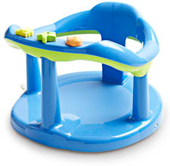
The required warning label is shown below.
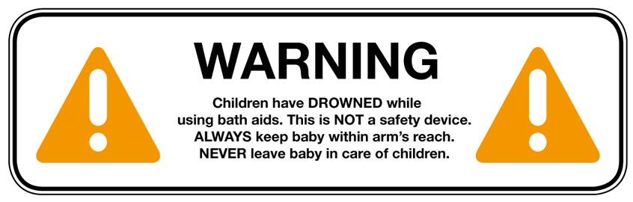
WARNING LABEL SHOWN AT REDUCED SIZE
Baby bath aids include bath seats, cradles, hammocks, recliners, supports and rings. Babies are at risk of drowning if these products are not used correctly.
A baby bath aid must have a warning label that is:
- permanent and water-resistant
- in a contrasting colour to the product and packaging
- on the product’s top surface
- easy to see, even when the product is being used.
The warning label must meet size and wording requirements set out in the mandatory standard.
These include:
- the word ‘WARNING’ in capital letters and 10mm high
- the safety alert triangle symbol, with each side of the triangle measuring at least 30mm.
As a guide, it should look similar to the example shown above.
This label must also be on the packaging, unless the packaging is transparent and the product’s warning label can easily be seen through it.
For more information, visit the Product Safety Australia website.

Baby dummies
The baby and novelty dummies shown below do not comply with safety laws because they have a chain or cord.
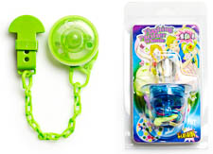
Unsafe dummies can cause a child to choke, strangle or suffer infection.
A dummy must have:
- a shield that has two or more ventilation holes
- a teat that does not allow fluid to leak inside or fill the teat
- a securely attached ring or handle that can be gripped by an adult for easy removal of the dummy
- no sharp edges or points that could injure a child.
The dummy’s packaging must:
- not include any pin, ribbon, string, cord, chain or other device for attaching the dummy to the baby. These can cause strangulation or cut off blood supply to hands and fingers
- include the name and address of the Australian manufacturer or distributor
- include this warning notice:
WARNING
DO NOT TIE A DUMMY AROUND A BABY’S NECK AS IT PRESENTS A STRANGULATION HAZARD
Imitation or novelty dummies that do not meet all the above requirements may also be considered in breach of the law.
For more information, visit the Product Safety Australia website.

Baby dummies with unsafe decorations
Baby dummies with decorations, such as the ones shown below, must comply with safety laws as the decorations may be a choking hazard.
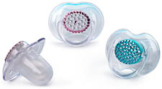
Baby dummies with crystals, beads or similar decorations (also known as ‘bling’) must pass tests that ensure the decorations are securely attached.
Babies can inhale, swallow or choke on unsafe decorations that fall off or become loose.
You can’t always see if a decoration is unsafe, so it is important to have products tested by a professional testing agency or ask your supplier for copies of compliance test certificates.
For more information, visit the Product Safety Australia website.

Baby dummy chains with unsafe decorations
Decorations on baby dummy chains may be a choking hazard if they do not comply with safety laws.
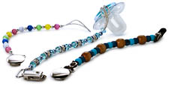
Baby dummy chains with crystals, beads or similar decorations (also known as ‘bling’) must meet requirements for:
- length of the chain
- testing for impact resistance, strength and durability.
These products include pins, ribbons, strings, cords, chains, twines, leathers, yarns or similar products designed to be attached to a dummy.
Babies can inhale, swallow or choke on unsafe decorations if they fall off or become loose. Long chains or similar products are also a strangulation hazard.
You can’t see if a chain or decoration is unsafe, so it is important to have products tested by a professional testing agency or ask your supplier for copies of compliance test certificates.
For more information, visit the Product Safety Australia website.

Baby walkers
This baby walker shown below does not comply with safety laws because it lacks clearly displayed warning labels.
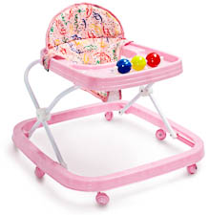
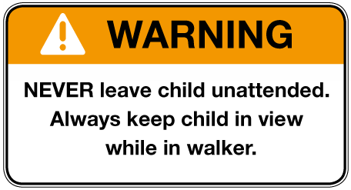
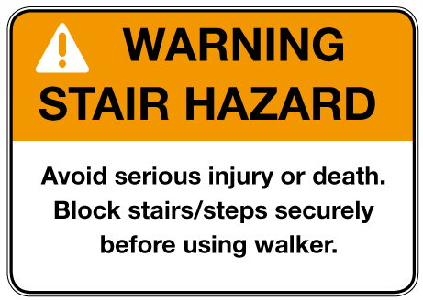
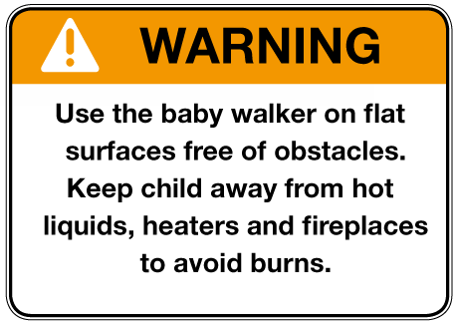
Children are at risk of head injuries and other serious injuries if a baby walker tips over or falls down stairs.
A baby walker must:
- have a braking mechanism to stop it falling down steps and stairs
- be designed to resist tipping when it runs into an obstacle or when the child leans out of it.
The walker must also have three permanent warning labels that are easy to see, in contrasting colours, and meet all other requirements set out in the mandatory standard. The labels should look similar to the three examples shown above.
For more information, visit the Product Safety Australia website.

Folding cots
This folding cot shown below breaches safety laws because it does not have the required warning labels or an adequate locking mechanism.
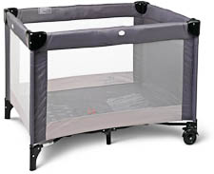
Children are at risk of serious injuries, suffocation or strangulation from folding cots that have unsafe features or are used incorrectly.
Folding cots (also known as portacots) must have:
- a firm mattress that touches the cot on every side and fits snugly
- no inflatable parts
- no footholds that would allow a child to climb out
- a cot depth that meets minimum measurements (visit the Product Safety Australia website for more information)
- locking devices on the frame with a clearly distinct locked position, designed so a child inside cannot unlock them
- the following permanent safety markings on the inside:
- instructions for assembly and locking procedures
- a warning to check before each use that the cot is correctly assembled and that locking devices are fully engaged
- either a warning to only use a mattress of specified dimensions or a warning to only use the mattress supplied with the product – both are allowed
- a warning not to add an extra mattress as this may cause suffocation.
For more information, visit the Product Safety Australia website.

Household cots
This household cot shown below fails to comply with safety laws because it has dangerous gaps that could trap a child’s head or limbs, and dangerous protrusions that could snag clothing and cause strangulation.
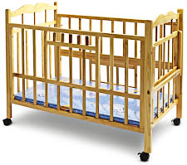
Unsafe household cots can pose a risk of suffocation, strangulation or serious injuries.
Household cots (including convertible cot/beds and second-hand cots) must meet requirements covering:
- strength, durability and stability
- measurements
- gaps
- footholds and protrusions
- sharp edges
- labels and safety markings, including information about the supplier.
There are also special labelling requirements for antique and collectable cots.
For more information, visit the Product Safety Australia website.

Prams and strollers
The photo below shows a stroller that does not comply with safety laws because it does not have red parking activators and a tether strap.
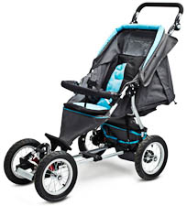
Unsafe prams and strollers can cause serious injuries, strangulation or suffocation.
Prams and strollers must have:
- a tether strap to stop the pram or stroller rolling away
- red parking activators, with surrounding framework and mouldings in a contrasting colour
- parking release mechanisms located so a child in the stroller cannot easily reach them.
They must also meet requirements for:
- number and type of parking devices
- safety harnesses
- safety warnings
- informative labels
- design and construction
- performance testing.
For more information, visit the Product Safety Australia website.

Clothing and accessories

Care labelling for clothing and textiles
If you sell clothing or textiles, they must have care labelling that complies with product information laws.
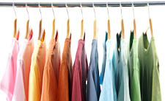
If you sell clothing or textiles, they must have care labelling that complies with product information laws. Care labelling provides consumers with information on how to properly care for clothing and textiles; for example, washing instructions.
There is no safety hazard associated with incorrect care labelling of these products; however, it is in your interest to make sure your products are correctly labelled. Under the Australian Consumer Law, consumers can return a product that becomes damaged as the result of incorrect care labelling.
This applies to care labelling for:
- clothing
- household textiles
- furnishings
- piece goods made from textiles (for example, fabrics sold by the metre)
- plastic-coated fabrics
- suede skins
- leathers
- furs.
You can learn more from the Supplier guide – Care labelling for clothing and textile products, available from the Product Safety Australia website.
Note: New South Wales has special laws requiring textile products to be labelled with the fibres they contain. The label may also include the percentage of each fibre. For more information, visit the New South Wales Fair Trading website.

Nightwear for children
This photo below shows children’s nightwear that does not comply with safety laws because it does not have correct fire danger labelling.
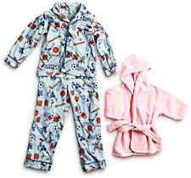
Warning label
FIRE WARNING:
Regardless of the fabrics recommended on this package as suitable for this garment, for the safety of your children, do not make loose-fitting or nightdress styles from fabrics which burn readily. Avoid chenille, molleton and flannelette fabrics made from 100 per cent cotton, and acrylic fabrics.
Children are at increased risk of serious burns if their nightwear is of an unsafe design, or does not have the correct label to warn parents of fire danger.
The following items in children’s sizes 00–14 must have either a ‘low fire danger’ or ‘high fire danger’ label, depending on the fabric and type of garment:
- pyjamas
- pyjama-style overgarments
- nightdresses and nightshirts
- dressing gowns and bathrobes
- babies’ sleeping bags, including those with sleeves or arm openings
- all-in-ones (also called jumpsuits or bodysuits). This includes babies’ all-in-ones for day wear
- loose boxer shorts
- other items styled and recognised as nightwear.
They must also meet requirements for design and construction.
The type of label required depends on the flammability of the fabric, which can only be tested in a professional test facility.
Paper patterns for children’s nightwear must have the safety warning label, shown above, on the envelope.
For more information, visit the Product Safety Australia website.

No holes tongue stud
You cannot sell ‘no holes’ tongue studs, such as the one shown below. They are banned because they pose a serious safety risk.
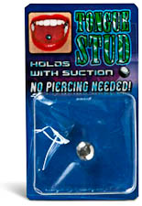
It is illegal to sell ‘no holes’ tongue studs. These studs have an opening on one side only, which acts to create a vacuum securing the stud to the tongue without the need for piercing.
If a tongue stud detaches from the tongue, it is possible to inhale or swallow it, causing serious injury.
For more information, visit the Product Safety Australia website.

Sunglasses and fashion spectacles
If you sell sunglasses or fashion spectacles, they must comply with safety laws.
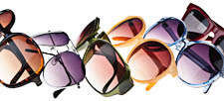
Sunglasses and fashion spectacles include:
- one-piece sunglasses
- visor-type sunglasses
- clip-on sunglasses
- children’s sunglasses.
Incorrect labelling and use of these products can cause eye injuries or impaired vision.
Sunglasses and fashion spectacles must be marked or labelled with:
- the name of the manufacturer or supplier
- a lens category number (0 to 4) and description, as listed on the Product Safety Australia website.
They must also meet design, construction and testing requirements.
For more information, visit the Product Safety Australia website.

Confectionery

Mini jelly cups containing konjac
These mini jelly cups shown below do not comply with safety laws because they contain konjac.
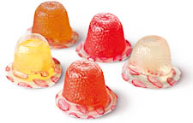
Konjac is a food additive that does not dissolve easily. Mini jelly cups containing konjac can get stuck in the throat and restrict or block air supply.
It is illegal to sell mini jelly cups that:
- have a height or width 45mm or smaller
- contain konjac, also known as:
- glucomannan
- conjac
- konnyaku
- konjonac
- taro powder
- yam flour.
For more information, visit the Product Safety Australia website.

Furniture

Bean bags
If you sell bean bags, they must comply with safety laws.
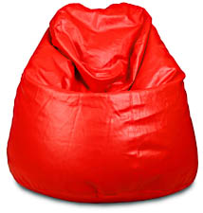
Warning label
WARNING
Small Lightweight Beads Present A Severe Danger To Children If Swallowed Or Inhaled
Children are at risk of choking if they inhale the polystyrene beads contained in bean bags.
Bean bags and bean bag covers must have a child-resistant slide fastener on any opening through which you can insert or remove filling. This fastener is usually a zip with its tag removed, which locks in place to prevent easy opening.
Bean bags, bean bag covers, packaging and filling must have the warning label shown above fixed securely or printed on them, in contrasting colours.
The word ‘WARNING’ must be in capital letters at least 5mm tall. The other words must be in title case, with the first letter of each word at least 5mm tall.
These requirements apply to products filled with polystyrene foam beads, such as:
- aqua bean bags for swimming pools
- baby bed bean bags
- chairs, cushions, lounges
- foot stools, futon mattresses
- novelty cushions for children
- nursing and therapeutic pillows and cushions
- pet beds
- pillows and stable tables.
They also apply to bean bag covers and packages containing bean bag filling.
For more information, visit the Product Safety Australia website.

Bunk beds
The bunk bed shown below has dangerous gaps in the frame and extended corner posts that do not comply with safety laws.
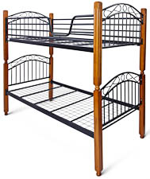
Children are at increased risk of concussions, fractures, strangulation and other injuries from bunk beds that do not comply with safety laws.
Bunk beds must have:
- guard rails permanently fixed to all four sides and ends
- at least 260mm between the top of the guard rail and the top of the mattress base
- no dangerous gaps that could trap a child’s head or limbs
- no parts that stick out more than 8mm.
They must also meet requirements for design, construction, testing and labelling.
For more information, visit the Product Safety Australia website.
Note: Queensland has special laws for bunk beds in short-term rental accommodation. For more information, visit Queensland Office of Fair Trading website.

Hardware and building materials

Fire extinguishers (portable aerosol)
Portable aerosol fire extinguishers must comply with safety laws.
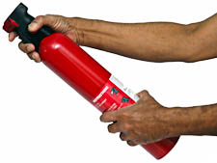
There are safety requirements to ensure fire extinguishers work effectively and are used correctly.
Portable aerosol fire extinguishers must meet requirements for:
- labelling with the manufacturer’s or distributor’s name and their trade name or trademark
- materials and construction design
- performance testing
- identification colours.
For more information, visit the Product Safety Australia website.

Fire extinguishers (portable non-aerosol)
Portable non-aerosol fire extinguishers must comply with safety laws.
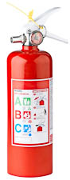
There are safety requirements to ensure fire extinguishers work effectively and are used correctly.
Portable non-aerosol fire extinguishers must meet requirements for:
- materials and construction design
- performance testing
- identification colours.
For more information, visit the Product Safety Australia website.

Gas masks containing asbestos
Gas masks must comply with safety laws and not contain asbestos.
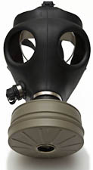
It is illegal to sell gas masks with asbestos breathing devices. These expose the user to asbestos fibres, which can cause the fatal lung disease mesothelioma.
For more information, visit the Product Safety Australia website.

Health and cosmetics

Cosmetics and toiletries
Cosmetics and toiletries must have clear and accurate labelling in order to comply with safety laws.
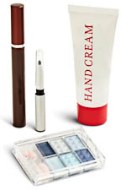
Incorrect labelling of cosmetics and toiletries is dangerous to people with sensitivities or allergies. If labels are missing or inaccurate, consumers can be exposed to ingredients that cause them harmful allergic reactions or even death.
Ingredients must be listed:
- on the container (for example, a cardboard box enclosing a tube of toothpaste), or
- on the product itself, if it does not come in a container.
If neither of the above is possible (for example, if the product or container is very small), the ingredient information must be displayed nearby or provided in a leaflet for consumers to view.
Ingredients must be listed in English, and in the order set out in the mandatory standard.
For more information, visit the Product Safety Australia website.

Glucomannan in tablet form
Glucomannan manufactured in tablet form does not comply with safety laws.

Glucomannan is an appetite suppressant that swells in the stomach to create a feeling of fullness. In tablet form, it is likely to swell prematurely and cause a blockage in the throat.
It is illegal to sell glucomannan in tablet form. Other available forms of glucomannan (powder and capsule) are not banned.
For more information, visit the Product Safety Australia website.

Hot water bottles
The hot water bottle shown below does not have the required safety warnings on it, and therefore does not comply with safety laws.
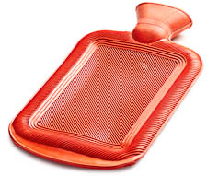
Using an unsafe hot water bottle, or using a hot water bottle incorrectly, can cause serious burns.
Hot water bottles must have the following safety warnings on both the product and any packaging:
- Do not use boiling water
- WARNING – HOT WATER BOTTLES CAN CAUSE BURNS. AVOID PROLONGED DIRECT CONTACT WITH THE SKIN.
- (If the bottle is made of rubber) This hot water bottle is made of natural rubber
- (If the bottle is designed to be partly filled) This hot water bottle is designed to be partly filled
- (If the bottle is designed to be completely filled) This hot water bottle is designed to be completely filled.
Hot water bottles must also meet design and performance requirements, including pressure resistance tests.
For more information, visit the Product Safety Australia website.

Toothpaste containing DEG (diethylene glycol)
The toothpaste products shown below do not comply with safety laws as they contain too much of the chemical compound DEG.
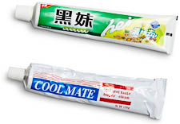
It is illegal to sell toothpaste containing more than 0.25 per cent by weight of diethylene glycol (DEG). DEG is a toxic substance used by some overseas manufacturers as a substitute for glycerine in toothpaste. High levels of DEG may cause kidney and liver failure.
You can’t see DEG, so it is important to have products tested by a professional testing agency, or ask your supplier for copies of compliance test certificates.
For more information, visit the Product Safety Australia website.

Homewares and furnishings

Blind and curtain cords
Corded blinds and curtains must comply with safety laws.
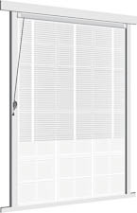
Unsafe blind and curtain cords can become caught around a child’s neck and cause strangulation.
A corded internal window covering (such as a blind or curtain) must have this warning label or swing tag attached to the cord:
WARNING
Young children have died by wrapping loose curtain and blind cords or chains around their necks. Secure cords or chains with cord guides or keep them out of reach by winding them around a cleat. Move cots and furniture away from window covering cords or chains. Do not remove this label.
If the window covering is packaged, the packaging must have this warning label in red capital letters at least 5mm tall, on a white background:
WARNING
Curtain and blind cords have caused the death of young children and must be installed so that they are not a strangulation hazard. Follow the installation instructions.
Window coverings must also come with:
- detailed installation instructions
- any components specified in the installation instructions.
For more information, visit the Product Safety Australia website.

Candles with lead wicks
The candles shown below have wicks that do not comply with safety laws because they have too much lead.
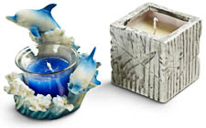
Emissions from candles containing lead are hazardous, especially to children, pregnant women and unborn babies.
It is illegal to sell:
- candles with wicks that contain more than 0.06 per cent of lead
- candle wicks that contain more than 0.06 per cent of lead.
You can’t see lead in candle wicks, so it is important to have products tested by a professional testing agency or ask your supplier for copies of compliance test certificates.
For more information, visit the Product Safety Australia website.

Combustible candle holders
The combustible candle holders shown below do not comply with safety laws. The holders and their decorations can catch fire when in use and pose a serious fire hazard.
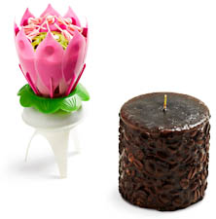
Unsafe candle holders and candle decorations can cause fires.
It is illegal to sell candle holders and candle decorations that can ignite and continue to flame for five seconds or more, when subjected to flame or heat from the candle they are holding or decorating.
For more information, visit the Product Safety Australia website.

Spas and swimming pools

Spa and pool skimmer boxes, filters, outlets and covers
The photo below an example of a portable spa. If you sell this type of product you must check it complies with safety laws.
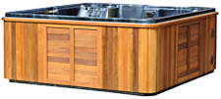
It is illegal to sell:
- potty-shaped skimmer boxes designed for installation in domestic swimming pools or spas
- transportable swimming pools or spas with integrally moulded potty-shaped skimmers
- transportable pools or spas with filters or outlets that could trap part of a person’s body or hair – for example, an outlet with a cover that comes off easily.
People have suffered serious injuries or died after becoming trapped by potty-shaped skimmer boxes and unsafe outlets.
For more information, visit the Product Safety Australia website.

Sports and recreation

Basketball rings and backboards
Basketball rings and backboards, such as the one shown below, must have clearly visible safety warnings to comply with safety laws.
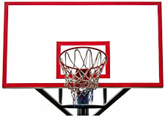
Basketball rings (also known as basketball hoops) and backboards can cause serious injury if they are incorrectly installed or used.
Both these products must have the following warning on their packaging:
WARNING:
IMPROPER INSTALLATION OR SWINGING ON THE RING MAY CAUSE SERIOUS INJURY OR DEATH
Backboards must also have this warning permanently and clearly marked on them in letters at least 10mm tall:
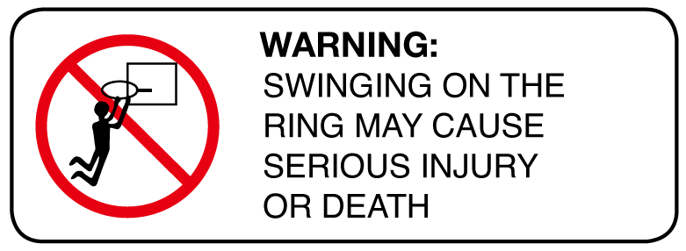
WARNING:
SWINGING ON THE RING MAY CAUSE SERIOUS INJURY OR DEATH
All the above warnings must meet size and colour requirements set out in the mandatory standard.
For more information, visit the Product Safety Australia website.

Bicycles
The bicycle shown below does not comply with safety laws because it has no chain guard, bell or front brakes.
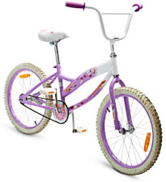
Note: This information applies to fully and partially assembled pedal bicycles (also known as pushbikes).
Cyclists are at risk of serious injuries or death if parts of a bicycle fail, or if it lacks safety features such as a chain guard.
Bicycles must meet requirements covering:
- information markings
- labelling of components
- instructions for assembly, use and maintenance
- number and type of braking systems
- design and construction
- safety features, such as reflectors.
For more information, visit the Product Safety Australia website.

Bicycle helmets
When tested against the required Australian standard, the helmet shown below did not provide the required level of impact protection to comply with safety laws.
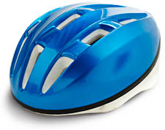
Cyclists are at risk of serious injury or death if a bicycle helmet is unsafe or incorrectly used.
Bicycle helmets must meet requirements covering:
- design and construction
- performance testing
- safety markings on the helmet
- instructions for safe use and care, including how to position, fasten and adjust the helmet
- packaging.
For more information, visit the Product Safety Australia website.

Exercise cycles
The photo below shows an example of an exercise cycle. If you sell this type of product it must comply with safety laws.
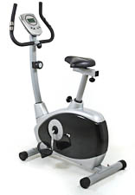
Exercise cycles (also known as exercise bikes) can cause serious injuries if they are of unsafe construction, or if their moving parts are accessible to children.
Exercise cycles must meet requirements for:
- design; for example, the bike must have protective guards to prevent children’s fingers getting caught in the bike’s moving parts
- testing; for example, the seat and its support must be tested for resistance to breaking.
Instructions supplied with the exercise cycle must cover:
- assembly
- maintenance
- correct adjustment of the seat.
For more information, visit the Product Safety Australia website.

Moveable soccer goals
The photo below shows an example of a moveable soccer goal. If you sell this type of product it must comply with safety laws.
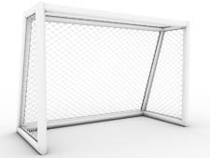
Moveable soccer goals can be extremely dangerous if they tip over.
Moveable soccer goals weighing 28kg or more must have:
- at least one anchor point at each side of the rear ground bar
- this warning permanently and clearly marked on the underside of the crossbar and on the outside of both upright posts, with upper case letters at least 25mm tall and lower case letters at least 12.5mm tall:
WARNING:
ALWAYS ANCHOR GOAL—NEVER CLIMB OR HANG ON CROSSBAR. Unanchored goals can tip over causing serious injury or death.
Goals must not fall over, or fail to return to their original position, when subjected to particular testing procedures.
For more information, visit the Product Safety Australia website.

Swimming and flotation aids for children
The flotation aid shown below does not comply with safety laws because it does not have the correct warning label or meet buoyancy requirements.
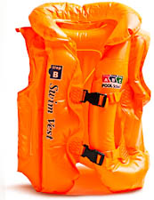
Flotation aid warning notice
WARNING:
USE ONLY UNDER COMPETENT SUPERVISION
Swimming aid vest warning notice
WARNING:
USE ONLY UNDER COMPETENT SUPERVISION. NOT FOR USE IN BOATING
This information applies to children’s armbands, attached rings and swimming aid vests.
It does not apply to:
- inflatable novelty shapes and unattached complete or partial rings (see Flotation and aquatic toys, later in this document)
- items for therapeutic use by people with a disability
- kickboards, life jackets or other personal flotation devices.
Children are at increased risk of drowning from swimming and flotation aids that are non-compliant or used incorrectly.
Flotation aids and swimming aid vests must be marked with the relevant warning notice shown above.
The words in these warning labels must be in block capitals, at least 6mm tall when the aid is deflated, and in a colour contrasting with the background.
Swimming and flotation aids must meet requirements for design, construction and performance.
Their packaging must be marked with information on:
- the purpose of the product
- the age or weight range it is designed for.
For more information, visit the Product Safety Australia website.

Treadmills
The photo below shows an example of a treadmill. If you sell this type of product, it must have the correct warning labels.
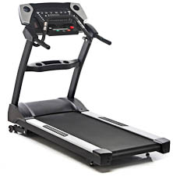
If children touch the moving surface of a treadmill, it can cause friction burns and amputation.
Treadmills must have this warning label:
WARNING:
Keep young children away from this machine at all times. Contact with the moving surface may result in severe friction burns.
The word ‘WARNING’ must be in bold and upper case. The upper case letters must be at least 5mm tall and the lower case letters at least 2.5mm tall.
The warning label must be:
- permanent
- visible to the user of the treadmill when it is in use
- separate from any other warning label.
For more information, visit the Product Safety Australia website.

Tobacco and smoking accessories

Disposable cigarette lighters
The disposable cigarette lighters shown below fail to comply with safety laws because they have no child lock mechanism.
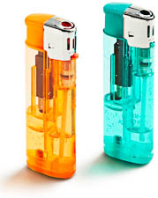
This information applies to refillable lighters with an import value of less than $5, all disposable cigarette lighters, and novelty lighters.
Children can burn themselves or cause fires if they play with unsafe disposable cigarette lighters.
Disposable cigarette lighters must have a device that stops small children from accidentally operating them. For example:
- a button that must be activated before the lighter can work
- a release catch that enables the spark wheel to be used, or
- a metal guard that must be pressed firmly in order to rotate the spark wheel.
Lighters must be permanently marked with:
- the name of the manufacturer or distributor
- a warning with the words KEEP AWAY FROM CHILDREN or KEEP OUT OF REACH OF CHILDREN.
If the lighter is in a package when sold at retail, this information must be displayed on the packaging.
For more information, visit the Product Safety Australia website.

Reduced fire risk cigarettes
If you sell reduced fire risk cigarettes, they must comply with safety laws.
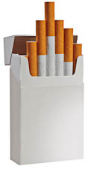
Reduced fire risk cigarettes are manufactured in a way that:
- slows down the rate at which the cigarette burns
- makes the cigarette more likely to self-extinguish if the smoker does not draw on it.
They must meet specific standards relating to fire risk, and have this statement on the retail pack:
AUSTRALIAN FIRE RISK STANDARD COMPLIANT. USE CARE IN DISPOSAL.
This statement:
- must be clearly legible
- must not obscure any warning messages, explanatory message or graphic required by law
- may be printed onto an adhesive label, or directly onto the packaging.
If an adhesive label is used, it must be one that cannot be easily removed, and that cannot be removed without damaging the pack.
For more information, visit the Product Safety Australia website.

Smokeless tobacco products
You cannot sell smokeless tobacco products, such as the one shown below, because they pose a health risk.
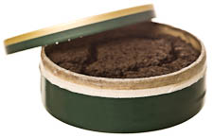
It is illegal to sell smokeless tobacco products. These include:
- oral snuff
- chewing tobacco
- pastes and powders applied to teeth and gums.
These products are banned due to health risks.
For more information, visit the Product Safety Australia website.

Tobacco products – labelling
Tobacco products, such as the cigarette package shown below, must have clearly visible warnings to comply with safety laws.
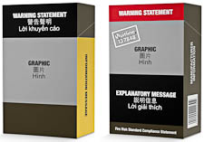
Tobacco products (such as cigarettes, cigars and loose tobacco) must meet labelling requirements that include:
- health warnings and information messages
- graphic images
- the area of the pack that must be covered by the warnings, messages and images
- the format of the printed text and backgrounds.
For more information, visit the Product Safety Australia website.

Competition and Consumer (Tobacco) Information Standard 2011
This new mandatory standard for tobacco labelling commenced on 1 January 2012 and takes full effect on 1 December 2012.
Until 30 November 2012, tobacco products covered by the previous 2004 regulations must comply with either those regulations or the new standard, as shown in the packaging above.
From 1 December 2012, all tobacco products must comply with the new standard.

Toy-like novelty lighters
The novelty lighters shown below look like children’s toys, and therefore do not comply with safety laws.
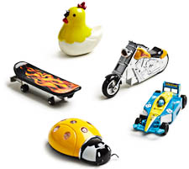
It is illegal to sell toy-like novelty lighters that:
- look like stylised animals or cartoon characters
- are made in typical toy-like sizes, shapes and colours
- are likely to appeal to children under five.
Children who mistake these lighters for toys and play with them are at risk of serious burns.
For more information, visit the Product Safety Australia website.

Toys and novelties

Balloon-blowing kits
The balloon-blowing kits shown below do not comply with safety laws because they contain the harmful substance benzene.
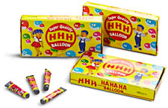
It is illegal to sell balloon-blowing kits containing benzene.
Benzene is a cancer-causing substance that is extremely harmful if swallowed or inhaled.
Balloon-blowing kits contain a blow-pipe and a synthetic glue-like substance used to make inflated balloons by blowing the substance from the pipe.
For more information, visit the Product Safety Australia website.

Children’s plastic items with more than 1% DEHP
Some soft plastic children’s toys, items and components do not comply with product safety laws because they contain too much DEHP.
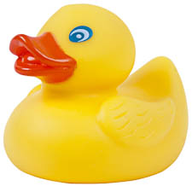
Diethylhexyl phthalate (DEHP) can harm the reproductive systems of young children if they suck or chew on a plastic object that contains it.
It is illegal to sell children’s plastic items that:
- contain, or have an accessible component containing, more than one per cent DEHP, and
- are intended for use by children up to three years of age, and
- are products that children can readily chew or suck.
Only products or components made from soft flexible plastic or foamed plastic will potentially contain DEHP. These may include, for example:
- toys (including bath toys)
- musical instruments
- dummies and pacifiers
- teething rings, teething rails and gum soothers
- rattles
- bibs
- comforting objects
- feeding bottles
- sip/sucking cups
- children’s bowls, plates and cutlery.
You can’t see DEHP, so for relevant products always ask your supplier or manufacturer for written confirmation that the products comply with the ban.
For more information, visit the Product Safety Australia website.

Flotation and aquatic toys
The aquatic toy shown below does not comply with safety laws because it does not have the required safety warning labels.
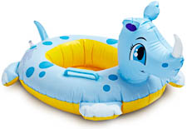
Warning notice
WARNING
AQUATIC TOY
USE ONLY UNDER SUPERVISION
This information applies to inflatable novelty shapes, inflatable toy boats for shallow water, and unattached rings (complete or partial).
It does not apply to swimming and flotation aids for children (see Swimming and flotation aids for children, earlier in this document), beach balls, surfboards, body/boogie boards, kickboards, inflatable air beds, inflatable boats for deep water.
Children are at increased risk of drowning if they use flotation and aquatic toys without adult supervision.
Flotation and aquatic toys must have the warning shown above on them. The warning must be:
- permanent
- in capital letters at least 6mm tall when the product is deflated
- in a contrasting colour to the product.
These products must also have non-return air valves and permanently attached stoppers.
For more information, visit the Product Safety Australia website.

Fire footbags
You cannot sell fire footbags, such as the one shown below.
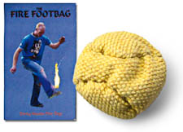
It is illegal to sell fire footbags. These are balls made of fire-resistant material which are intended to be doused in flammable liquid, set on fire, and thrown or kicked for amusement. They have the potential to ignite flammable items or burn the user.
For more information, visit the Product Safety Australia website.

Inflatable toys, novelties and furniture containing beads
Inflatable furniture must comply with safety laws.
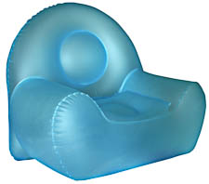
Inflatable products containing pellets or beads are a choking hazard for children, especially if the product bursts or is punctured. Beads can also come out through the air valve.
It is illegal to sell inflatable toys, novelties or furniture that:
- can be inflated by mouth, and
- contain small beads or pellets of material (such as polystyrene beads) that may be inhaled during inflation or deflation.
For more information, visit the Product Safety Australia website.

Knives – toy and novelty
If a toy stationery set contains a knife or cutter, such as the ones shown below, it must be clearly labelled on the packaging.
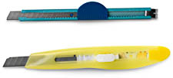
Children are at risk of injury when using knives or cutters without adult supervision.
It is illegal to sell children’s art, craft and stationery sets with undeclared knives or cutters. If a set contains a knife or cutter, this information must be prominently displayed on the packaging in letters at least 3mm tall.
For more information, visit the Product Safety Australia website.

Magnets in toys
Toys with small, strong magnets that can easily become detached do not comply with safety laws.
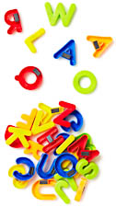
Small, strong magnets are dangerous to children if they are swallowed. These magnets can lock together through the walls of the intestines, causing serious injuries and death.
If a toy contains a small, strong magnet or magnetic component, the packaging and instructions must include this warning:
WARNING!
The product contains small magnet(s). Swallowed magnets can stick together across intestines causing serious infections and death. Seek immediate medical attention if magnet(s) are swallowed or inhaled.
Toys containing small, strong magnets must also pass safety tests.
For more information, visit the Product Safety Australia website.

Novelty cigarettes
You cannot sell novelty cigarettes, such as the ones shown below.
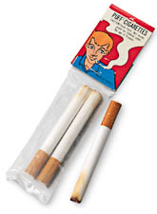
It is illegal to sell novelty cigarettes, also known as ‘puff cigarettes’. These contain a fine powder such as talc (hydrated magnesium silicate) or similar substances, allowing users to produce a cloud of fine dust by blowing or inhaling.
Novelty cigarettes can cause:
- respiratory tract irritation and inflammation
- lung, skin and ovarian cancers.
For more information, visit the Product Safety Australia website.

Projectile toys
This photo below shows a projectile toy that does not comply with safety laws because it has small parts, and can be used with improvised projectiles such as nails.
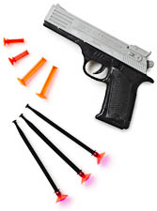
Small parts cylinder
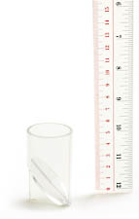
Projectile toys include:
- dart guns
- bow and arrow sets
- other pull-back toys that shoot small objects into the air.
Unsafe darts can be a choking hazard, while shooting mechanisms can cause injury if they are used incorrectly.
Projectile toys must have:
- protective tips on the projectiles
- a perimeter ring on the rotor, if the toy has this feature
- a shooting mechanism that cannot shoot other objects placed in it, such as pencils, nails or stones, without modification by the user
- a warning about the dangers of misuse.
Projectiles with suction cup tips must not be small enough to fit entirely into the test cylinder (small parts cylinder) shown above. For more information, see Testing, earlier in this document.
For more information, visit the Product Safety Australia website.

Sky lanterns
You cannot sell sky lanterns, such as the one shown below.
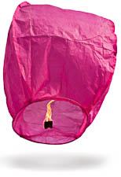
It is illegal to sell sky lanterns. These are miniature, unmanned hot air balloons that use an open flame to heat the air inside the lantern, causing it to lift into the atmosphere.
Sky lanterns can cause fires if they come into contact with combustible material – for example, by landing in a tree or on a building.
For more information, visit the Product Safety Australia website.

Toys containing lead and other elements
Some children’s toys, such as the ones shown below, do not comply with product safety laws because they contain unsafe levels of lead and other elements.
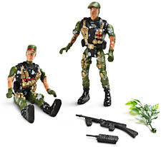
Lead and other elements can cause serious illness, permanent health damage or death.
It is illegal to sell children’s toys and finger paints that have more than the amount of lead or other elements shown in the table below.
You can’t see lead or other elements in a product, so before you start selling children’s toys or finger paints you should either:
- have them tested by a professional testing agency, or
- ask your supplier for copies of compliance test certificates.
For more information, visit the Product Safety Australia website.
Table: Migration levels of elements present in toys and finger paints
 | Elements – Migration levels (mg/kg)
Product | Antimony | Arsenic | Barium | Cadmium | Chromium | Lead | Mercury | Selenium
Toys | 60 | 25 | 1000 | 75 | 60 | 90 | 60 | 500
Finger paints | 10 | 10 | 350 | 15 | 25 | 25 | 10 | 50
* ‘Migration level’ refers to the amount of an element that is drawn out of an object or substance and absorbed by a person.

Toys for children under three
Toys with unsafe parts that can come loose or detach do not comply with safety laws.
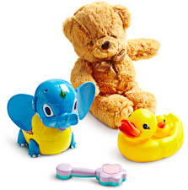
Small parts cylinder
Children under three often put objects in their mouths, and can choke on unsafe small toys and small parts.
Toys for children under three must not:
- be small enough to fit entirely into the test cylinder (small parts cylinder) shown above
- have any parts that can come off or become loose, that are smaller than the test cylinder.
For more information, see Testing, earlier in this document.
This mandatory standard applies to all products manufactured, designed, labelled or marketed as toys for children under three.
However, even if toys are labelled or marketed as being for older children, the mandatory standard may still apply if the toys are commonly recognised as being intended or suitable for children under three.
For more information, visit the Product Safety Australia website.

Yo-yo balls
The banned yo-yo balls shown below do not comply with product safety laws because they have highly elastic cords that can cause strangulation.
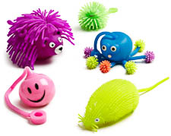
It is illegal to sell yo-yo balls. These toys have:
- a soft synthetic ball, often shaped like a cartoon character or animal
- an elastic cord that can be stretched to at least 500mm in length, usually with a loop to attach it to the user’s finger.
Some yo-yo balls have a centre filled with liquid or air. They may also contain a novelty such as a flashing light.
Yo-yo balls are banned because:
- the cord can cause strangulation
- if liquid leaks from the centre, this can cause illness and skin reactions.
For more information, visit the Product Safety Australia website.

Vehicles and vehicle accessories

Child car restraints
The child car restraint shown below does not comply with safety laws because it does not have clearly visible warning labels.
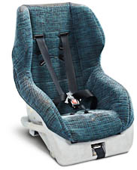
This information covers child restraints, chairs, harnesses, booster seats, booster cushions and converter seats for use in motor vehicles. It does not apply to:
- child restraints designed for children with a disability
- features that already come with the car.
Children are at risk of suffocation, strangulation, serious injuries or death if a car restraint fails or has unsafe features.
Child car restraints must meet requirements covering:
- instructions attached to the product, or provided in a pocket as part of the product
- warning labels
- harnesses, straps and covers
- anchoring systems
- performance testing
- durability of components so they are able to resist regular wear.
For more information, visit the Product Safety Australia website.

Elastic luggage straps
An elastic luggage strap must have the correct safety warning label.
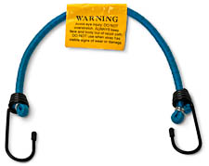
Elastic luggage straps (also called ‘octopus straps’) can cause serious injuries to the eyes, face and body if they recoil during use.
Elastic luggage straps must have a label permanently attached, with this warning:
WARNING.
Avoid eye injury. DO NOT overstretch. ALWAYS keep face and body out of recoil path. DO NOT use when strap has visible signs of wear or damage.
The label must be in black letters on a yellow background. It must have:
- the word ‘WARNING’ in capital letters at least 4mm tall
- the words ‘DO NOT’ and ‘ALWAYS’ in capital letters at least 2mm tall
- the remaining words in lower case letters at least 2mm tall.
For more information, visit the Product Safety Australia website.

Miniature motorbikes (monkey bikes)
The monkey bike shown below fails to comply with safety laws as it does not meet the requirements for braking design, foot peg performance, throttle performance, engine stop and steering design.
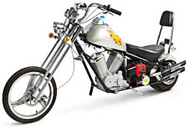
Miniature motorbikes are small replica motorcycles with petrol-driven motors. They are also known as monkey bikes, mini bikes or pocket bikes.
Riders are at risk of serious injury or death if parts of a miniature motorbike fail.
Miniature motorbikes must meet specific design and construction requirements for their:
- throttle
- braking system
- foot pegs
- steering
- supplemental engine stop.
For more information, visit the Product Safety Australia website.

Motor vehicle recovery straps
The vehicle recovery straps shown below do not comply with safety laws as they do not have the required safety information permanently fixed to them.
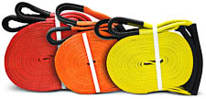
If motor vehicle recovery straps are used incorrectly, they can recoil and hit people nearby, causing serious injury or death.
Motor vehicle recovery straps must have this information permanently fixed to them (for example, on a label stitched to the strap):
- the name or logo of the strap’s Australian manufacturer, importer, distributor or other supplier
- its batch code or serial number
- its minimum breaking strength, expressed in metric units
- a recommendation that the minimum breaking strength of the strap should be between two and three times the vehicle’s gross vehicle mass (GVM)
- advice that the strap must be suited to the GVM of the lighter of the two vehicles used in the recovery process.
The information must be clearly visible and legible when the strap is being used.
Other requirements relate to:
- information that must be displayed on the motor vehicle recovery strap packaging, or on a label attached to the packaging
- instructions that must be provided on how to use and maintain the strap.
For more information, visit the Product Safety Australia website.

Motorcycle helmets
The motorcycle helmet shown below does not comply with safety laws as it does not meet the performance requirements of the Australian standards when tested.
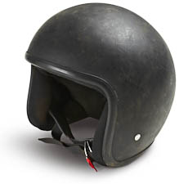
Motorcycle riders are at risk of serious injury or death if their helmet fails or they use it incorrectly.
Motorcycle helmets must meet requirements covering:
- construction and performance
- testing
- labelling
- safety instructions
- safety warnings included with the helmet.
For more information, visit the Product Safety Australia website.

Portable ramps for motor vehicles
Portable vehicle ramps, such as the one shown below, must comply with safety laws.
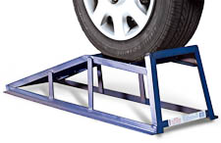
Warning notice
WARNING:
USE ONLY ON HARD LEVEL SURFACES
Portable ramps are used to support a motor vehicle during maintenance, or for display. They can cause death or serious injury if they are poor quality or incorrectly used.
Each portable ramp must have a durable, permanently attached plate showing:
- the name and address in Australia of the manufacturer, importer or other supplier
- the nominated capacity of the ramp, stated as ‘Safe Working Load’ in kilograms
- the nominated tyre size, stated as ‘Maximum Tyre Diameter’ and ‘Maximum Tyre Width’ in millimetres
- the warning notice shown above, in letters at least 5mm tall on a contrasting background
- the manufacturing batch identification.
Portable ramps must come with:
- clear instructions explaining the safe use of the ramp. These must include the safety recommendations stated in the mandatory standard
- assembly instructions, if assembly is required.
They must also meet requirements for materials and finish, design, and performance under test conditions. For more information, visit the Product Safety Australia website.

Tinted headlight covers
Headlight covers, such as the one shown below, must comply with safety laws.
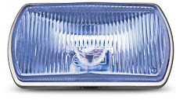
A tinted headlight cover is used to enhance the appearance of a motor vehicle headlight. However, unsafe tinted covers can reduce the visibility of a car to other road users and the ability of the driver to see objects and potential road hazards. This can lead to serious injury or death.
It is illegal to sell tinted headlight covers that restrict more than 15 per cent of a headlight’s beam. This must be tested using Standard Illuminant A, a standard of the International Commission on Illumination (CIE).
For more information, visit the Product Safety Australia website.

Trolley jacks
The trolley jack shown below does not comply with safety laws because it does not meet design, performance and labelling requirements.
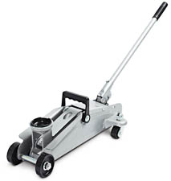
Warning notice
WARNING
THE JACK MUST BE USED ONLY ON HARD LEVEL SURFACES AND BE FREE TO ROLL DURING LIFTING AND LOWERING. DO NOT GET UNDER A VEHICLE THAT IS SUPPORTED BY A TROLLEY JACK – USE SUPPORT STANDS.
A trolley jack is a device designed to raise a vehicle via the vehicle’s chassis. It usually has wheels for manoeuvring, a handle for positioning and hydraulic cylinders for lifting the vehicle. Trolley jacks can cause death and serious injury if they are poor quality or incorrectly used.
There is a separate mandatory standard for vehicle jacks – see Vehicle jacks, the next product in this section.
A trolley jack must be permanently and legibly marked with:
- the nominated capacity as ‘Working Load Limit’ in kilograms
- the warning notice (shown above) in letters at least 5mm tall on a contrasting background
- the name and address in Australia of the manufacturer, importer or other supplier
- the manufacturing batch identification
- the correct hydraulic fluid for use with the jack, and an instruction to keep it at the recommended level.
It must also be permanently and legibly marked with the following instructions:
- The unlifted wheels of the vehicle should be chocked.
- The load should be centrally located on the head cap.
- No person should remain in a vehicle that is being lifted.
- Read the vehicle manufacturer’s owner’s manual before lifting the vehicle.
- The hydraulic trolley jack should be used for lifting and lowering only.
Trolley jacks must also meet requirements for design, construction, performance and testing; instructions for assembly, safe use and maintenance; and information on the packaging (if packaged). For more information, visit the Product Safety Australia website.

Vehicle jacks
Vehicle jacks, such as the one shown below, must comply with safety laws.
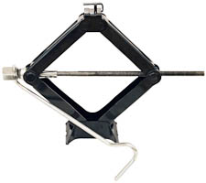
Vehicle jacks are designed to raise vehicles for repair or maintenance. They include:
- hydraulic jacks
- lever jacks
- pantograph (scissor) jacks
- screw jacks
- caravan/trailer jacks
- high lift jacks.
There is a separate mandatory standard for trolley jacks – see Trolley jacks, the previous product in this section.
Using an unsafe vehicle jack, or using a jack incorrectly, can cause injury or death.
Vehicle jacks must meet requirements for:
- design and construction
- testing
- performance
- safety markings
- instructions for safe use.
For more information, visit the Product Safety Australia website.

Vehicle support stands
Vehicle support stands, such as the one shown below, must comply with safety laws.
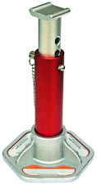
Warning notice
WARNING:
USE ONLY IN PAIRS AND ON HARD LEVEL SURFACES (e.g. CONCRETE), ENSURING THE STAND IS POSITIONED UNDER A SOLID PORTION OF THE VEHICLE AND THAT THE LOCKING MECHANISM IS FULLY ENGAGED.
Vehicle support stands are designed to be used in pairs to support the axle or chassis of a vehicle. The vehicle is lowered onto the vehicle support stands, creating access to the underside of the vehicle for maintenance or storage purposes.
Using unsafe vehicle support stands, or using stands incorrectly, can cause injury or death.
Each vehicle support stand must be permanently and legibly marked with:
- the name and address of the manufacturer, importer or other supplier
- the nominated capacity stated as ‘Working Load Limit’ in kilograms
- the maximum working height in millimetres
- clear and adequate operating instructions
- the manufacturing batch identification
- the warning notice shown above.
Vehicle support stands must also meet requirements for:
- design, construction and testing
- information on the packaging (if the product is packaged)
- instructions for assembly and safe use.
For more information, visit the Product Safety Australia website.

Contacts

State and territory contacts
If you have a question about product safety, contact the consumer protection agency in your state or territory:

Australian Capital Territory

Office of Regulatory Services
T. (02) 6207 3000
Office of Regulatory Services website

Commonwealth

Australian Competition and Consumer Commission (ACCC)
T. 1300 302 502
Product Safety Australia website

New South Wales

NSW Fair Trading
T. 13 32 20
New South Wales Fair Trading website

Northern Territory

ACCC Darwin Office
T. (08) 8946 9666
Product Safety Australia website

Queensland

Office of Fair Trading
T. 13 74 68
Queensland Office of Fair Trading website

South Australia

Consumer and Business Services
T. 131 882
South Australia Consumer and Business Services website

Tasmania

Consumer Affairs and Fair Trading
T. 1300 65 44 99
Tasmania Consumer Affairs and Fair Trading website

Victoria

Consumer Affairs Victoria
T. 1300 55 81 81
Consumer Affairs Victoria website

Western Australia

Department of Commerce
T. 1300 30 40 54
Western Australia Department of Commerce website

Other contacts

Language assistance
Call 13 14 50 and ask for an interpreter in your language.

Information and updates

Product Safety Australia
Product Safety Australia website

Recalls Australia
Product Safety Recalls Australia website

Australian Consumer Law
Australian Consumer Law website

