Compliance and enforcement
How regulators enforce the Australian Consumer Law
This publication was developed by:
– Australian Capital Territory Office of Regulatory Services
– Australian Competition and Consumer Commission
– Australian Securities and Investments Commission
– Consumer Affairs and Fair Trading Tasmania
– Consumer Affairs Victoria
– New South Wales Fair Trading
– Northern Territory Consumer Affairs
– Office of Consumer and Business Affairs South Australia
– Queensland Office of Fair Trading
– Western Australia Department of Commerce, Consumer Protection

Copyright
© Commonwealth of Australia 2010
This work is copyright. You may download, display, print and reproduce this material in unaltered form only (retaining this notice) for your personal, non-commercial use or use within your organisation. Apart from any use as permitted under the Copyright Act 1968, all other rights are reserved.
Requests and inquiries concerning reproduction and rights should be posted at the Commonwealth Copyright Administration website at ag.gov.au/cca or addressed to:
Commonwealth Copyright Administration
Attorney-General’s Department
3-5 National Circuit
Barton ACT 2600
ISBN 978-0-642-74657-3
Contents

Introduction 4
1. Elements of compliance and enforcement 6
– Reducing consumer detriment 6
– Compliance 6
– Enforcement 6
– Dispute resolution 6
2. Approaches to compliance and enforcement 7
– Risk-based approach 7
– Outcome-focussed approach 7
– Guiding principles 7
3. Applying the law 9
– Setting priorities 9
– Compliance and enforcement options 9
– Regulator actions 10
4. Impact on traders and consumers 11
– Regulator independence 11
– Common questions 11
– Where to get more information 12
Contacts 13
Introduction

The Australian Consumer Law (ACL) is a new national consumer law, replacing Commonwealth, state and territory generic consumer protection laws. The law applies at the Commonwealth level and in each state and territory.
Compliance and enforcement with the law will be on a ‘one-law, multiple-regulators‘ model, with existing consumer regulators enforcing the uniform law.
It is the responsibility of traders to comply with the ACL at all times.
About this publication
This document sets out the principles that guide the compliance and enforcement approach of the government consumer agencies that administer the ACL.
These agencies are listed on page 14 and are referred to as ’the ACL regulators’. This document outlines how they:
> respond to consumer issues and evidence of consumer detriment
> use their compliance and enforcement powers
> approach ACL compliance.
The ACL regulators have endorsed this publication, which will guide their compliance and enforcement efforts for the new law.
The approach outlined in this document does not apply to other laws administered by the consumer agencies. It complements any general policies relating to compliance and enforcement used by the ACL regulators.
Other guides in this series
This publication is part of a series of Australian Consumer Law guides. Others cover:
> consumer guarantees
explains supplier, manufacturer and importer responsibilities when there is a problem with goods and services; refunds, replacements, repairs and other remedies
> product safety
covers safety standards, recalls, bans, safety warning notices and mandatory reporting requirements
> unfair business practices
covers misleading or deceptive conduct, unconscionable conduct, country of origin, false and misleading representations, information standards
> unfair contract terms
outlines what an unfair term is and which contracts are affected by the law
> sales practices
outlines unsolicited supplies, unsolicited consumer agreements, pyramid schemes, pricing, lay-by agreements, referral selling, harassment and coercion, proof of transaction and itemised bills.
For more information, visit the Australian Consumer Law website, consumerlaw.gov.au, or contact the relevant ACL regulator – see Contacts on page 14.
The Australian Treasury also publishes information about the ACL – see The Australian Consumer Law – a guide to provisions, available from the Australian Treasury website at treasury.gov.au.
About the Australian Consumer Law
The ACL is the law governing consumer protection and fair trading in Australia. From 1 January 2011, it applies nationally and as a law of each state and territory. The ACL also incorporates the national unfair contract terms law.
It is a key part of regulatory reforms initiated by the Council of Australian Governments (COAG) to deliver a seamless national economy, and implements recommendations made in 2008 by the Productivity Commission in its review of Australia’s consumer policy framework.
The Intergovernmental Agreement for the Australian Consumer Law states that the objective of the new national consumer policy framework is to:
> improve consumer wellbeing through empowerment and protection
> foster effective competition, and
> enable the confident participation of consumers in markets in which both consumers and suppliers trade fairly.
This is supported by six operational objectives:
> to ensure that consumers are sufficiently well informed to benefit from and stimulate effective competition
> to ensure that goods and services are safe and fit for the purposes for which they were sold
> to prevent practices that are unfair
> to meet the needs of those consumers who are most vulnerable or are at the greatest disadvantage
> to provide accessible and timely redress where consumer detriment has occurred, and
> to promote proportionate, risk-based enforcement.
The ACL replaces previously separate Commonwealth, state and territory legislation. This means that:
> a trader who operates across jurisdictions will have a single set of rules and responsibilities to comply with (in addition to any jurisdictional legislation that covers their particular industry); and
> a consumer moving between jurisdictions or buying from interstate will have the same set of protections that they are used to in their home jurisdiction, and consumers that transact across Australian jurisdictional borders have uniform protections.
Legal structures
The ACL is contained in a schedule to the Competition and Consumer Act 2010 (CCA). Aspects of the ACL are reflected in the Australian Securities and Investments Commission Act 2001 (Cth), to protect consumers of financial products and services.
As a law of each jurisdiction — Commonwealth, states and territories — the ACL will be enforced by courts and tribunals in each jurisdiction subject to the specific rules that apply to enforcement processes, courts and tribunals in each state and territory jurisdiction.
One law, multiple regulators
COAG has agreed that the ACL will operate under an arrangement described by the Productivity Commission as a ‘multiple regulator model’. The ACL is a single national law enforced in all jurisdictions by the various jurisdictions’ consumer regulators.
Under this arrangement ACL regulators work to:
> ensure that marketplace misconduct is addressed
> employ the most effective means of addressing consumer harm through cooperative and complementary enforcement action
> avoid unnecessary duplication of effort in the effective administration of the ACL, and
> ensure, wherever appropriate, a consistent approach to dispute resolution and enforcement action.
The ACL regulators coordinate their activity through the Standing Committee of Officials of Consumer Affairs (SCOCA).
Private rights
Aside from compliance and enforcement by ACL regulators, the ACL creates private rights that persons can enforce through Commonwealth, state and territory courts and tribunals.
01. Elements of compliance and enforcement

Reducing consumer detriment
ACL regulators use a range of activities and powers to encourage and enforce compliance with the law.
A core issue for regulators is to minimise consumer detriment. Consumer detriment is:
> the direct financial or material loss or disadvantage from a trader not complying with the law (for example, goods damaged or not delivered)
> costs incurred in seeking a remedy to the loss (for example, time lost in repeated trips to a trader to seek a refund).
ACL regulators may act to address actual detriment or the risk or potential of detriment.
Compliance
ACL regulators aim to promote a high level of compliance with the law. For this, consumers as well as traders need to be aware of their rights and responsibilities, and how to obtain redress. Providing information and advice to consumers and traders for this purpose is a key function of ACL regulators.
Our compliance efforts will include a focus on consumer and trader education, working with business and industry to promote compliance with the law. We will use market intelligence to improve our knowledge of market conditions and the experiences of consumers and traders.
Enforcement
To be effective, compliance measures must be supported by a range of escalating enforcement options that can be used if a trader fails to comply or when there is a serious contravention of the ACL.
ACL regulators have a range of civil, administrative and criminal enforcement remedies at their disposal under the ACL and supporting legislation.
When enforcing the law, ACL regulators seek to:
> stop the unlawful conduct
> undo the harm caused by the contravening conduct (for example, by corrective advertising or redress for those adversely affected)
> ensure future compliance with the law
> deter future offending conduct
> encourage the effective use of compliance systems
> when warranted, punish the wrongdoer with penalties or fines.
ACL regulators will choose the most appropriate enforcement tools to achieve these outcomes in a timely and proportionate manner.
Dispute resolution
State and territory ACL regulators play an important role in resolving disputes between consumers and traders about goods and services covered by the ACL. Each regulator provides information on its website about dispute resolution.
Even if a dispute is resolved between the consumer and trader, the regulator may still take compliance and enforcement action. In these cases, the regulator does not take the side of either the consumer or the trader.
02. Approaches to compliance and enforcement

Risk-based approach
To make the best use of resources and maximise public benefit, compliance and enforcement activity will target areas of strategic priority, and incidents with evidence or likelihood of consumer detriment.
The ACL regulators cannot pursue all complaints. They consider complaints carefully and exercise discretion, directing resources to matters that provide the greatest overall benefit for consumers.
As these matters may vary within a jurisdiction or between jurisdictions, priorities for enforcement action
differ accordingly.
Outcome-focussed approach
ACL regulators can use a range of administrative, civil and criminal enforcement remedies. A regulator will choose from a range of tools to suit the individual case and to achieve a range of outcomes, which can go beyond just punishing wrongdoing.
This means regulators can design an enforcement strategy to achieve one or more of the following:
> make a trader aware of how the law affects their operations – for example through education, advice, warnings or reprimands
> get a fair remedy for the individual consumer (or class of consumers) concerned – for example, through obtaining redress, an injunction (an order for the trader to do, or cease doing, something) or an enforceable undertaking (where a trader agrees to an ongoing obligation to do something)
> stop a pattern of continuing conduct and deter future misconduct – for example through injunctions, enforceable undertakings or prosecution.
Guiding principles
ACL regulators use the following guiding principles when undertaking compliance and enforcement activity.
Transparency
ACL regulators will deal with consumers and traders in an open and transparent manner. This means consumers and traders will understand what is expected from them and what they can expect from the regulator. Transparency has two aspects:
> compliance and enforcement takes place within appropriate corporate governance processes and can be reviewed by appropriate courts, tribunals and public administration review agencies (such as public service ombudsmen and auditors-general)
> the ACL regulators do not make private arrangements — matters taken to enforcement action (for example, matters dealt with through litigation or formal resolution) will be made public.
Confidentiality
Enquiries into complaints and investigations are undertaken according to the appropriate legal privacy requirements of the jurisdiction and according to each regulator’s specific policies and procedures. ACL regulators balance confidentiality requirements and the need to inform the public when in the public interest.
Timeliness
Complaint handling, dispute resolution, investigation processes and the resolution of enforcement matters should be conducted as efficiently as possible. This will help to avoid costly delays and business uncertainty, and to minimise detriment to consumers while maximising the effectiveness of the activity.
Proportionality
Any enforcement action should be in proportion to the level of consumer detriment and to the seriousness of the breach. More serious offences — those involving deceit, dishonesty or unconscionable conduct; the potential for death and injury; the targeting of vulnerable groups; wilfully repeated conduct; a significant impact on market integrity; and those resulting in wide consumer detriment — will result in more serious enforcement action.
Targeted
ACL regulators should make effective use of limited resources by targeting issues and traders in line with risks, new and emerging issues, and enforcement priorities. Each year, ACL regulators will undertake coordinated and targeted compliance activity on a limited number of national projects. The ACL regulators may make public reference to those national projects as appropriate.
Accountability
All ACL regulators are accountable to the public for their compliance and enforcement activity. The specific mechanisms will vary between jurisdictions depending on the:
> public administration legislation
> regulator-enabling legislation, and
> governmental, departmental and agency codes of conduct.
National awareness
ACL regulators make decisions mindful of the national implication of actions and the public interest. Compliance priorities in state, territory and regional markets have regard to the broader national environment.
03. Applying the law

Setting priorities
Each ACL regulator exercises its compliance and enforcement powers independently, in the public interest and with integrity and professionalism.
An ACL regulator will choose how it will use its resources to pursue particular cases to achieve the most effective outcomes for both individual consumers and consumers in general, having regard to all the circumstances of the case.
To assist with this determination, ACL regulators will give enforcement priority to matters that demonstrate one or more of the following:
> conduct of public interest or concern
> conduct resulting in significant consumer detriment
> conduct affecting disadvantaged or vulnerable consumer groups
> conduct that suggests a pattern of non-compliance by the trader or is indicative of a risk of future misconduct
> conduct involving a significant new or emerging market issue
> conduct that is industry-wide or likely to become so
> a significant impact on market integrity
> whether action is likely to have a worthwhile educative or deterrent effect
> conduct demonstrating a blatant disregard for the law.
When appropriate, an ACL regulator may also pursue matters that test or clarify the law.
An ACL regulator is less likely to pursue matters that:
> are one-off, isolated events
> are more appropriately resolved directly between the parties under an industry code (for example, by mediation or an industry dispute resolution body)
> involve issues more effectively dealt with by another agency, or
> are best dealt with between private parties (the ACL provides complainants with a private right of action in these circumstances).
Litigation is costly compared to other compliance and enforcement actions. Where breaches are blatant, repeated and/or cause significant detriment, the regulator will target those traders for prosecution. ACL regulators have a range of other tools available, which may be used as an alternative to prosecution.
Compliance and enforcement options
Criminal prosecution for breaches of the law is only one of a range of approaches ACL regulators may take
to ensure compliance with the law. Other tools and strategies include:
> education, advice and influencing good practice
> voluntary industry self-regulation codes
> ‘without prejudice’ discussions
> dispute resolution
> formal written warnings
> infringement notices
> enforceable undertakings
> public warnings
> court orders
> injunctions
> compensation orders
> civil penalties, including pecuniary penalties and disqualification orders.
Regulator actions
The compliance pyramid below summarises the general approach to compliance and enforcement under the ACL. It shows the range of enforcement remedies available to ACL regulators.
While criminal prosecution is reserved for a smaller number of significant cases, ACL regulators use the range of different compliance and enforcement tools that can be applied more broadly than criminal prosecution.
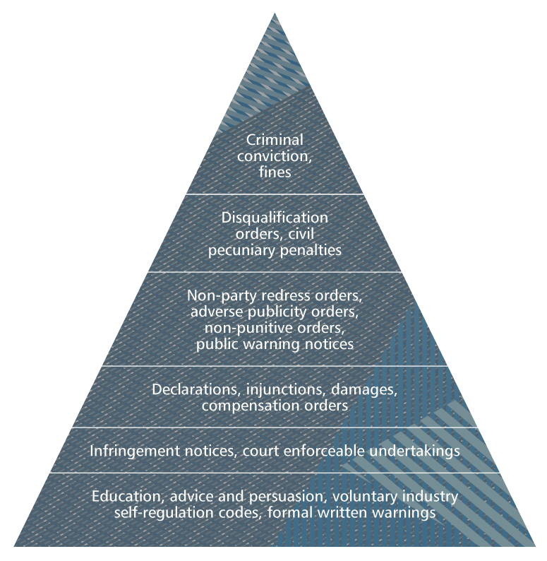
04. Impact on traders and consumers

Regulator independence
The ACL is one national law with multiple regulators. Each regulator is independent, has its own enabling legislation and exercises its powers and functions accordingly.
ACL regulators have put in place systems to create a national approach to compliance and enforcement. They agree to:
> have regard to this compliance and enforcement document
> regularly consult and communicate about priorities, markets, compliance and enforcement
> general principles for handling and managing complaints and market intelligence under the ACL
> general principles for compliance and enforcement action to bring about trader compliance for serious breaches of the ACL.
The following principles apply to compliance and enforcement action:
> it is the obligation of all traders to comply with the ACL
> there are private rights of action for traders and consumers under the ACL
> the ACCC and ASIC have national responsibilities and can act in all state and territories
> each state and territory regulator can act in its own jurisdiction, as defined by its own legislation
> circumstances will vary between jurisdictions and ACL regulators will have varying priorities relevant to their jurisdiction.
This means ACL regulators may take different compliance and enforcement actions from time to time. This may reflect co-ordination between regulators to take action in a particular jurisdiction, or reflect a particular priority in a specific jurisdiction, rather than inconsistent application of the law.
All ACL regulators participate in SCOCA, which has established arrangements to enhance consistency, co-ordination and co-operation amongst the ACL regulators. It has agreed to produce an annual report on compliance and enforcement of the ACL.
Common questions
Why might an ACL regulator investigate a business?
A business may be investigated by an ACL regulator as a result of:
> a complaint from a consumer, competitor or other regulator
> market intelligence
> information from whistleblowers or other informers
> a targeted compliance activity designed to identify and reduce non-compliant behaviour by businesses in a particular
industry or area.
What happens if a consumer complains about a business?
In many cases, the relevant ACL regulator will first encourage the consumer and business to resolve or settle the dispute informally.
The ACL regulator:
> cannot force a business or consumer to settle the dispute
> can investigate a business when a law may have been broken, even if the complaint was resolved.
In some cases, ACL regulators will conduct a number of inquiries before contacting the business in order to gather sufficient facts about the matter and to protect the integrity of the investigation.
Where to get more information
Visit consumerlaw.gov.au or contact the relevant ACL regulator (details, page 14). Guides to other aspects of the ACL are also available (see list on page 5).
Contacts

Australian Competition and Consumer Commission
GPO Box 3131
Canberra ACT 2601
T. 1300 302 502
accc.gov.au

Australian Capital Territory
Office of Regulatory Services
GPO Box 158
Canberra ACT 2601
T. (02) 6207 0400
ors.act.gov.au

New South Wales
NSW Fair Trading
PO Box 972
Parramatta NSW 2124
T. 13 32 20
fairtrading.nsw.gov.au

Northern Territory
Office of Consumer Affairs
GPO Box 1722
Darwin NT 0801
T. 1800 019 319
consumeraffairs.nt.gov.au

Queensland
Office of Fair Trading
GPO Box 3111
Brisbane QLD 4001
T. 13 QGOV (13 74 68)
fairtrading.qld.gov.au

South Australia
Office of Consumer & Business Affairs
GPO Box 1719
Adelaide SA 5001
T. (08) 8204 9777
ocba.sa.gov.au

Tasmania
Office of Consumer Affairs & Fair Trading
GPO Box 1244
Hobart TAS 7001
T. 1300 654 499
consumer.tas.gov.au

Victoria
Consumer Affairs Victoria
GPO Box 123
Melbourne 3001
T. 1300 55 81 81
consumer.vic.gov.au

Western Australia
Department of Commerce
Locked Bag 14
Cloisters Square WA 6850
T. 1300 30 40 54
commerce.wa.gov.au
Australian Securities and Investments Commission
PO Box 9827
(in your capital city)
T. 1300 300 630
asic.gov.au

