

Consumer Affairs Victoria

Year in Review 2014-15

Contents
Our story 3
From the Director 3
Our direction 5
Our vision 5
Our goals 5
Our focus 5
Our functions 5
Our regulatory approach 5
Our performance 7
Our achievements 8
1 Businesses are compliant with consumer laws 8
2 Victorians exercise their consumer rights 16
3 A fair and safe rental market for Victorians 27
4 A modern and effective consumer law framework 31
5 A sustainable and innovative regulator 37
Glossary 42
Consumer Affairs Victoria 43
Coinciding with the launch of our inaugural Year in Review is the CAV Report on Operations 2014-15, which was tabled in the Victorian Parliament in accordance with the Director of CAV’s legislative requirements. The Report on Operations contains financial and performance information and is available at the Annual report page on the Consumer Affairs Victoria website.

Our story

From the Director

Welcome to our Year in Review. This year, we have taken a new approach to our annual reporting, by launching this interactive website for the Victorian community to learn about our work throughout 2014-15. The Year in Review provides more detailed information about individual cases and activities in a digital format, to provide Victorians with a full and accessible picture of Consumer Affairs Victoria (CAV) and our role.
The launch of our Year in Review coincides with the tabling of the CAV Report on Operations 2014-15 in the Victorian Parliament. The Report on Operations provides data to the Parliament and the community about our services. The Year in Review provides information and stories about the services we have provided to hundreds of thousands of Victorian consumers, businesses, tenants and landlords. We also report on the significant compliance and enforcement actions taken to promote business conformance with consumer protection laws. In addition, we record the registration and licensing transactions that enable the effective operations of businesses and associations. In all, we have provided almost one million discrete services to the Victorian community.
Our achievements in 2014-15 also reflect our focus in providing digital services. Almost three million visits to our website, and thousands of downloads of our apps demonstrate the demand for effective online regulation services. These complement our increasing use of social media to inform consumers, businesses, tenants and landlords of their rights and responsibilities. We continue to maintain a digital first approach to all our communications.
And at the pointy end, we have focused on using the full range of regulatory tools, including undertakings and court actions, to address serious wrong conduct by businesses and significant breaches of consumer protection laws.
In addition to these activities, we have taken a lead in ensuring an effective consumer protection framework, through activities such as our Better Business Initiative and by leading a national credit card chargebacks project.
In June 2015, Consumer Affairs Minister Jane Garrett launched Fairer Safer Housing, an initiative which centres on a review of the Residential Tenancies Act 1997, the primary consumer protection law for Victorians living in rental housing. We are extremely pleased to lead this review, and the response to our initial consultation paper, Laying the Groundwork, has demonstrated the strong interest of the Victorian community in this important work.
March 2015 marked the departure of CAV’s longest-serving Director, Dr Claire Noone. Claire’s expertise in regulation and unwavering passion for supporting a fair marketplace in Victoria has left an indelible mark on our organisation. The achievements detailed in our Year in Review and the Report on Operations are a testament to Claire’s commitment and success. It is also important that I acknowledge the great leadership of Phil D’Adamo and Elizabeth Lanyon, who acted in the Director role following Claire’s departure until I commenced on 31 August 2015.
The Year in Review also reflects the commitment and passion of our staff across Victoria in ensuring businesses, consumers, tenants and landlords know about and play by the rules.
Our team has provided an outstanding service to the community in the past year.

Simon Cohen
Director
Consumer Affairs Victoria

Our direction

Our vision
A fair and competitive marketplace in Victoria

Our goals
- Businesses are compliant with consumer laws
- Victorians exercise their consumer rights
- A fair and safe rental market for Victorians
- A modern and effective consumer law framework
- A sustainable and innovative regulator

Our focus
The focus underpinning the implementation of our vision and broader strategy includes:
- risk-based monitoring and enforcement
- tools that enable business compliance
- business compliance through partners
- access to information on consumer rights
- digital first in all our work.

Our functions
Consumer Affairs Victoria is the state’s consumer affairs regulator. Our role is to:
- review and advise the Victorian Government on the consumer protection framework
- provide information and advice to consumers, tenants, businesses and landlords on their rights, responsibilities and changes to relevant laws
- register and license businesses and occupations
- enforce and ensure compliance with consumer laws.
We provide administrative support to several statutory offices and bodies including the Business Licensing Authority, the Estate Agents Council, the Motor Car Traders Claims Committee and the Residential Tenancies Bond Authority, as well as supporting Consumer Affairs ministerial advisory roles.

Our regulatory approach
When businesses comply, consumers are protected. This knowledge guides the way we regulate. We use an integrated compliance approach to help reduce consumer detriment, ensure businesses comply with consumer laws, and to promote a thriving Victorian economy.
Integrated compliance is about using all our tools effectively. We:
- provide compliance information to businesses so that they understand their obligations and the consequences of not meeting them
- work with industry partners to achieve compliance. This means working with our colleagues in other jurisdictions, as well as organisations who are working towards similar outcomes. By doing so, we can improve the way we provide information to businesses and better target groups with specialised information needs
- provide information to consumers and tenants to help them assert their rights in a dispute, thus holding businesses to account for compliance.
We use compliance tools to monitor businesses, stop misconduct and prevent future breaches. We take a risk-based approach to compliance monitoring, targeting those that pose the highest risk to Victorians.
For the most serious matters or systemic non-compliance, we take enforcement action to put a stop to, and deter, unlawful conduct.

Our performance


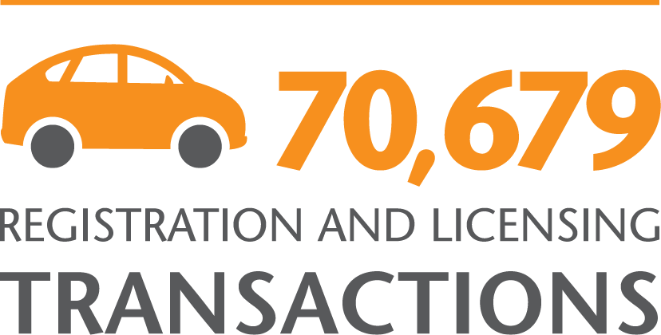





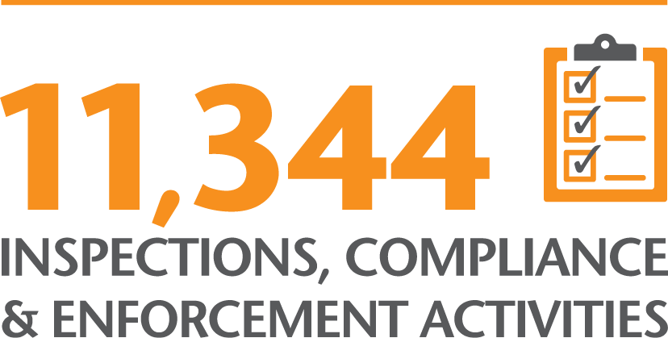

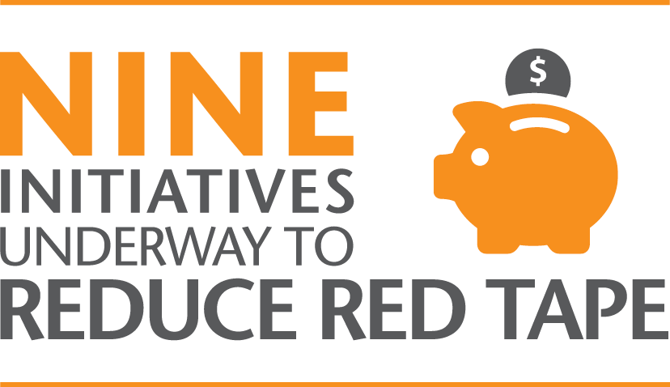

Our achievements
This section details our achievements in 2014-15, broken down by each of our corporate goals. These goals represent major focus areas for the organisation and working towards them supports us in achieving our overarching vision of a fair and competitive marketplace in Victoria.

1 Businesses are compliant with consumer laws
The key to achieving a fair and competitive marketplace is ensuring that businesses comply with consumer laws. We focus on achieving high levels of business compliance by working with industry and partner organisations, and with consumers on asserting their consumer rights. We continue to support businesses by providing them with tools that help them to meet their obligations. Our risk-based approach to compliance means that we will act quickly against those causing most harm, protecting consumers earlier, more efficiently and more effectively.

Our integrated compliance model
We use an integrated approach to improve compliance with the law and reduce consumer detriment. By actively engaging with consumers, businesses, community agencies and regulatory partners, we work towards our vision of a well-functioning consumer marketplace. In turn, this contributes to a thriving economy and inclusive community in Victoria.
Integrated compliance is about using all of our tools effectively - from early intervention such as education, advice and dispute resolution, through to court action for the most serious matters. Our operations must align with the internal and external environments in which we operate.
We consider seven key principles when managing any matter that comes to us.

Outcome-focused
The goal of improving compliance is to stop non-compliant conduct and reduce consumer detriment in the short and long term, particularly by tackling systemic issues.

Tailored
We tailor our solutions to the specific problem, by assessing the underlying cause and selecting the right tool for the job.

Integrated
We are more effective when we align our activities, such as information, education, dispute resolution and compliance.

Flexible and innovative
Our staff are empowered and encouraged to pursue innovative solutions.

Problem solving
We select the compliance tools that will most effectively assess the problem.

Evidence-based
Evidence directs our market interventions, and we rigorously assess how effective our actions are.

Building on past actions
We always take into account our previous interactions with the business or industry.

Misuse of real estate trust account money
Buying or selling a home is the biggest financial transaction many people undertake in their lifetime, and most Victorians put their trust in an estate agent to sell their home. One of many protections for buyers and sellers under the Estate Agents Act 1980 is the requirement for estate agents to keep money they receive on behalf of any other person in a separate trust account. Failing to handle trust account money appropriately may result in property purchases being delayed or failing, causing emotional and financial stress for both property buyers and sellers.
At 30 June 2015, there were more than 4,200 estate agents operating trust accounts in Victoria. These accounts had a combined value of more than $1.9 billion. Our comprehensive trust account defalcation program ensures that estate agents comply with the law. Agents who operate trust accounts that hold money during a financial year must have those accounts audited by a qualified auditor and submit the audit report to CAV within 10 days of receiving it.
In 2014-15, 89 per cent of agents lodged their trust account reports with us on time. Failing to submit a trust account audit report within the required timeframe is a key risk factor we use to target our inspections. This year, we conducted 1,768 compliance assistance site visits to estate agents, including reminding businesses of their trust account obligations.
We took court action 24 times in response to professional malpractice by estate agents in 2014-15 with a focus on the proper management of trust accounts and record keeping.

We conducted 3.470 inspections across Victoria in 2014-15.
The following matters are examples of enforcement actions we have taken in response to trust account defalcation.

Anthony Brancatella
On 19 March 2015, the Director of CAV issued criminal charges against Mr Brancatella for breaches of the Estate Agents Act 1980 relating to trust account defalcations of approximately $1.9 million. Prior to the filing of criminal charges, Mr Brancatella was served with a licence suspension notice. Mr Brancatella has been committed to stand trial in the County Court of Victoria in October 2015.
Boris Real Estate Pty Ltd and Suzanne Zvizaldo
Baycrown Management Pty Ltd
G L Lee Real Estate Pty Ltd and Quoc Hung Ly
Konstantinos Balasis (appeal decision)
Kian Meng 'Dennis' Ong
Afif Shaba and Northern Real Estate Pty Ltd

Addressing misleading and deceptive conduct
One of the key protections under the Australian Consumer Law (ACL) aims to prevent misleading and deceptive conduct. In marketing their products or services, businesses are obligated to provide truthful and accurate messages so consumers can make properly informed choices. In 2014-15, we took enforcement action against a number of businesses for misleading and deceptive conduct.
We have focused on employment scams in 2014-15. Employment and training brokers run schemes looking to capitalise on growing opportunities in these markets, driven by rising unemployment, increasing student numbers and the lure of government subsidies. Some brokers use misleading and deceptive conduct to target vulnerable and disadvantaged consumers including international students, low-skilled workers and the long-term unemployed. A common feature of these schemes is the use of online marketplaces such as Gumtree and SEEK to promote their services, often through the use of misleading and deceptive "employment" ads and testimonials.
We also focused on the conduct of property spruikers as part of a national project. Property spruikers are in the business of promoting property investment schemes and selling their products to consumers wishing to invest or enter the property market, often using Self-Managed Super Funds. The claims they make entice consumers who generally have minimal knowledge of the investment or the property market. Their claims are often extreme; for example, some spruikers claim that the consumer can purchase a property for one dollar. Through the national project, we collaborated with our co-regulators to address misleading and deceptive conduct by property spruikers who are targeting self-funded retirees, and who would not be eligible for finance from a recognised financial institution.
The following matters are examples of enforcement actions we have taken in response to misleading and deceptive conduct.
Keat Enterprises Pty Ltd
Accrue Property Pty Ltd
Get Off Drugs Naturally Foundation Inc and Dr Nerida James

Protecting Victorians from unsafe products
We protect the Victorian community from unsafe products and continue to work with other state and territory consumer protection agencies and the Australian Competition and Consumer Commission (ACCC) to prevent unsafe products being sold to Victorian consumers. Our risk-based product safety program focuses on ensuring that businesses comply with product safety bans and standards. When we identify emerging hazards that pose a risk, we share our intelligence with consumer protection agencies across Australia to agree upon a solution that will protect consumers nationally.
In 2014-15, we undertook 1,362 inspections of premises for banned or unsafe products, resulting in the removal of 15,627 products from sale. These included 3,967 children’s products that could cause serious harm or death, such as projectile toys, small powerful magnets, nightwear, aquatic toys and portable swimming pools.
We took civil action against retailers and wholesalers who flouted our product safety laws, obtaining adverse publicity orders to alert the community to unsafe products, injunctions and civil pecuniary penalties. Taking action against high-risk harms and systemic non-compliance reminds businesses of the serious consequences of breaching product safety laws designed to protect the community.

Qantas Airways Limited court action
In December 2014, the Federal Court of Australia ordered Qantas Airways Limited (Qantas) and the operator of its duty free program, Alpha Flight Services Pty Ltd (Alpha), to pay penalties of $200,000 and $50,000 respectively, for contravening the product safety provisions of the ACL.
The companies breached the ACL by supplying small, high-powered magnets, known as Nanodots, which were subject to a permanent ban order due to the possibility of causing serious injury or death if swallowed or inhaled.
In addition to the penalties, Qantas and Alpha were ordered to publish public product safety notices on their respective websites; in the next available 'In Sky Shopping' catalogue; and in The Australian and Financial Review newspapers.
Both companies were ordered to provide refunds to consumers returning the Nanodots, pay a fixed sum of $60,000 in costs, and pay the costs associated with CAV destroying and disposing of the goods.

Our successful court actions send a clear message that non-compliance has serious consequences.

Efficient registration and licensing
This year we launched our myCAV licensing and registrations system, an important milestone in our transition to a digital organisation. The myCAV launch marked the culmination of almost 12 months’ work by a dedicated team. The first regulatory scheme to move to myCAV was incorporated associations.
The Associations Incorporation Reform Act 2012 was amended to support the move to digital services.

myCAV reducing red tape for incorporated associations
There are 39,665 incorporated associations in Victoria. Prior to the introduction of myCAV, secretaries were required to complete paper forms, forward them to CAV, and wait for a response.
myCAV now provides secretaries of incorporated associations with a direct and personalised way to manage their responsibilities towards their club or association. It is intuitive, easy to use and simplifies various administration tasks, making it easier for secretaries to comply with their legal obligations. myCAV provides instant updating of records, immediate registration of new incorporated associations and the ability to download registration certificates without delay.
To help with the transition to myCAV, we have conducted information sessions across the state, 'in language' sessions for culturally and linguistically diverse audiences, as well as a step-by-step video and comprehensive information on the CAV website, translated into 23 languages.
Since the system was launched, 11,928 myCAV accounts have been created, 6,534 transactions have been completed using the online system and 557 new associations have been incorporated.

We conducted information sessions across Victoria to help with the transition to myCAV.

Giving small business a big say
We provide small businesses with information and advice, and help them comply with their legal obligations including in areas like refunds, receipts, warranties, product safety, and more.
In July 2014, we engaged with small businesses through a survey seeking their views about the best way we can provide them with relevant, timely and readily available information.
Much of the survey feedback concerned the experience of small businesses using our website. These responses are feeding into our website redesign project, to ensure we communicate more effectively with this important audience.

Parties signed to enforceable undertakings

Australian Consumer Law (Victoria)
Freeway Fitness Pty Ltd
Kristian Nathan Woods
Real Wealth Australia Pty Ltd
Helen Connie Collier-Kogtevs
Get off Drugs Naturally Foundation Inc
Dr Nerida James
H2Coco Pty Ltd
David Freeman
Solarex Australia Pty Ltd
Ali Syed
Mohammed Syed
Standby Savers Pty Ltd
Marcus Munro Hickey
Accrue Property Pty Ltd
James Allan Monaghan

Estate Agents Act 1980
Taylors Real Estate Agents Pty Ltd
Enzo Bufano

Court and tribunal matters

Prosecutions finalised

Australian Consumer Law (Victoria)
Yuting Wang
Keat Enterprises Pty Ltd
Yuting Wang (appeal against sentence)

Domestic Building Contracts Act 1995
Anthony Jakupi
Jakupi Excavations Pty Ltd

Motor Car Traders Act 1986
Emrah Sen
Mustapha Ali Ali
Shefket Idrizi
Cars National Pty Ltd
Melbourne Autohaus Pty Ltd
Alexsandar Jovanovski
Eray Sahin
Maurizio Duchini
Khaled El Mohamed

Estate Agents Act 1980
Kian Meng (Dennis) Ong
Colin Rounds
Suzanne Zvizdalo
Boris Real Estate Pty Ltd
Konstantinos Balasis (appeal against sentence)
Residential Tenancies Act 1997
City Hostels Pty Ltd
Mandy Le

Civil proceedings (including disciplinary inquiry)

Estate Agents Act 1980
Afif Shaba
Christine Parsons
Quoc Hung Ly
G L Lee Real Estate Pty Ltd
Baycrown Management Pty Ltd
Terry Pak Kwai Choe
Matthew White
Frank Flanagan
Anthony Vito Brancatella
Benjamin David Chislett
Benny Bull Pty Ltd
Creative Property Australia Pty Ltd
Sunnymac Pty Ltd
Craig Alan McIntosh
L J Investment Group Pty Ltd

Australian Consumer Law (Victoria)
CK Import & Wholesale Pty Ltd
William Yang
D W International Trading Pty Ltd
Bo Hui Dong
Andrew Withall
Burlesque Interiors Pty Ltd
Olivia Eckford
Alpha Flight Services Pty Ltd
Qantas Airways Limited
1 House Group Pty Ltd
Nicole Papadopoulos
Mark Smith
Agrison Pty Ltd
Volkan Yokus

Conveyancers Act 2006
Bluebell Conveyancing Australia Pty Ltd
Elaine Daher
Han Yan
Jing Xu
Cornell Conveyancing Pty Ltd
Low Co$t Pty Ltd
Ashley Clarke
Pamela Redford
Michael Joseph Goujan
Virginia Sivasamy

Motor Car Traders Act 1986
Yuze Cao
AusCarClub Pty Ltd

Fundraising Act 1998
Co.As.It Italian Assistance Association (order to disburse appeal proceeds)

Administrative review – on behalf of the Business Licensing Authority (BLA) or Motor Car Traders Claims Committee (MCTCC)

BLA review

Estate Agents Act 1980
Danielle Anderson

Motor Car Traders Act 1986
Siong Ha Yu

Motor Car Traders Claims Committee
David Crowe
Luke Higney
Kristina Barac

Administrative review – on behalf of Secretary to the Department of Justice & Regulation

Estate Agents Act 1980
Mr Asoka De Silva
Ms Rozanne De Silva

Ongoing Court Matters as at 30 June 2015

Criminal prosecution

Domestic Building Contracts Act 1995
Daniel Wayne Auld

Motor Car Traders Act 1986
Saleh Ibrahim
Melbourne Prestige Cars Pty Ltd

Estate Agents Act 1980
Anthony Vito Brancatella

Civil proceedings (including disciplinary inquiry)

Estate Agents Act 1980
Benjamin David Chislett
Benny Bull Pty Ltd
Creative Property Australia Pty Ltd
Scott Hoare
Aaron James McDonald
Michael Knight
Century 21 Australia Pty Ltd
George Fakhri
Clynton Mark Roberts
Frank Valentic
Advantage Property Consulting Pty Ltd

Australian Consumer Law (Victoria)
Tom Bull
BigAussie Deals Pty Ltd
Steven Petkovski
Belle Gibson Pty Ltd (enforcement of statutory notice)
Nightingale Electrics Pty Ltd
George Anderson
Marlo Woods (Australia) Pty Ltd
Domain Register Pty Ltd
The Good Guys Discount Warehouse (Australia) Pty Ltd
Parke Muirs Pty Ltd
Alpha Flight Services Pty Ltd (appeal)
Qantas Airways Limited (appeal)

Conveyancers Act 2006
Bluebell Conveyancing Australia Pty Ltd
Anthony Lee
Mandeep Johal

Motor Car Traders Act 1986
Yuze Cao
AusCarClub Pty Ltd

Sex Work Act 1994
Xian Yang Meng
Jian Qing Xu
Lynette Farrar
Zhao Pan
Josef Rutten
Joe Paul Molinari
Lin Gao

Fire Services Levy Monitor (Director of Consumer Affairs is the legal successor)
Mecon Insurance Pty Ltd
Mechanical and Construction Insurance Pty Ltd

Administrative review – on behalf of BLA or MCTCC

BLA review

Estate Agents Act 1980
Gregory Flessas
Scott Darragh
Daniel Taylor
Zole Elali

Motor Car Traders Act 1986
Beniamin Bratoiu
Antonio Lekkas

Administrative review – on behalf of Secretary to the Department of Justice & Regulation and Director of Consumer Affairs Victoria

Estate Agents Act 1980
Julie Truong

Fundraising Act 1998
AFG Group Pty Ltd

2 Victorians exercise their consumer rights
We empower Victorians to exercise their consumer rights by providing them with the right information and support. We continue to work with partner organisations to improve the information we provide, and to target groups who have specialised information needs.

Connecting with consumers

consumer.vic.gov.au – our primary communications channel
Overwhelmingly, audiences choose to source CAV’s information through the Consumer Affairs Victoria website <consumer.vic.gov.au>. Visits to our website have increased by nearly 78 per cent in the last two years, with a total of 2,942,816 visits in 2014-15, up from 1,654,784 in 2012-13.
We utilise the ‘was this page helpful’ function on our website to gauge how useful our information is, and where necessary, improve the content. In 2014-15, 67 per cent of respondents who rated our pages considered them ‘helpful’.
The most visited part of the CAV website is the renting section, accounting for nearly 30 per cent of all page views. Information available for this audience includes the ‘Preparing your rental application’ page, launched in July 2014 - four out of five people who rated this self-help focused page considered it to be ‘helpful’.
The buying and selling property section continues to be well received, achieving a satisfaction rating of 85 per cent - the highest for any section of the website. It is the fourth-ranked content section by page views (behind renting, shopping and incorporated associations). In particular, consumers have responded very positively to the due diligence checklist - for home and residential property buyers contained in that section. This page provides comprehensive information for people to consider before they buy a property - the largest financial transaction most people make during their lives. The page went live on 1 September 2014, has received over 122,000 page views and was rated by 89 per cent of respondents as helpful.

Engaging with the community through social media
We continue to pursue innovative ways of connecting with consumers. Consumers and tenants are increasingly turning to social media for answers to their questions and problems. This year, our social media following continued to grow and with it, our approach to engaging consumers online.
Social media gives us the opportunity to engage with younger consumers, who have traditionally been hard to reach. We use social media for a range of purposes, including communicating alerts, warnings, information about events and updates to legislation, and to point to new content on our website.
We constantly monitor the marketplace to ensure our information is up-to-date and relevant to the needs of Victorians. This year, we have updated our web content about incorporated associations, owners corporations and retirement villages, to reflect changes to the law. We regularly publish court outcomes and news alerts to warn Victorians about businesses to avoid, scams currently circulating, and the activity of travelling con men in their region.
Videos present a simple and straightforward medium to engage with the community. This year we produced videos covering topics including understanding property prices, using our RentRight app, avoiding funeral rip-offs, living in a retirement village and using the myCAV registrations system, as well as real-life accounts from consumers who have been targeted by scammers and travelling con men.
We continue to expand our reach through social media: we have more than 7,000 Twitter followers and more than 23,000 Facebook page likes. Our activity on Twitter was seen over 5.9 million times and our activity on Facebook was seen 5.1 million times. Our website had more than 2.9 million visits in 2014-15, an increase of 24 per cent compared to last year. The increasing volumes indicate how social media and our website are critical platforms to providing information and advice to Victorian consumers, businesses and tenants.

Free telephone and email advice
Image of staff member on phone – Caption: We provide a free telephone enquiry and email response service.
While our website is now the primary point of contact for information and advice, we continue to provide a free telephone enquiry and email response service, specifically targeting those who cannot access the web or who have more complicated needs.
In 2014-15, we responded to 49,775 email and online enquiries and answered 352,369 calls. Our call volumes are down 10 per cent compared to last year, reflecting increasing community expectations for engaging with us online. We answered 78,028 calls on our general consumer line, which is 24 per cent less than last year.
Our analysis shows a strong correlation between the decrease in calls answered on the general consumer line and an increase in the number of visits to our web pages containing general consumer information.
Improving access to our website and ensuring the information supports consumers to exercise their rights means we can better target our resources towards consumers and tenants in need of assisted support through our telephone services.

We provide a free telephone enquiry and email response service.

Calls answered for information and advice
 | 2013-14 | 2014-15
General consumer | 102,294 | 78,028
Residential Tenancies Bond Authority (RTBA) | 97,309 | 99,325
Registrations | 23,191 | 20,817
Renting | 90,952 | 73,791
Occupational licensing | 25,538 | 24,331
Building | 21,342 | 22,993
Estate agents | 9,136 | 9,724
Small business infoline | 4,822 | 11,440
Fire Services Levy Monitor | 4,398 | 299
Other calls | 7,458 | 8,992
Calls to regional offices | 3,909 | 2,629
Total calls answered | 390,349 | 352,369
Telephone calls answered
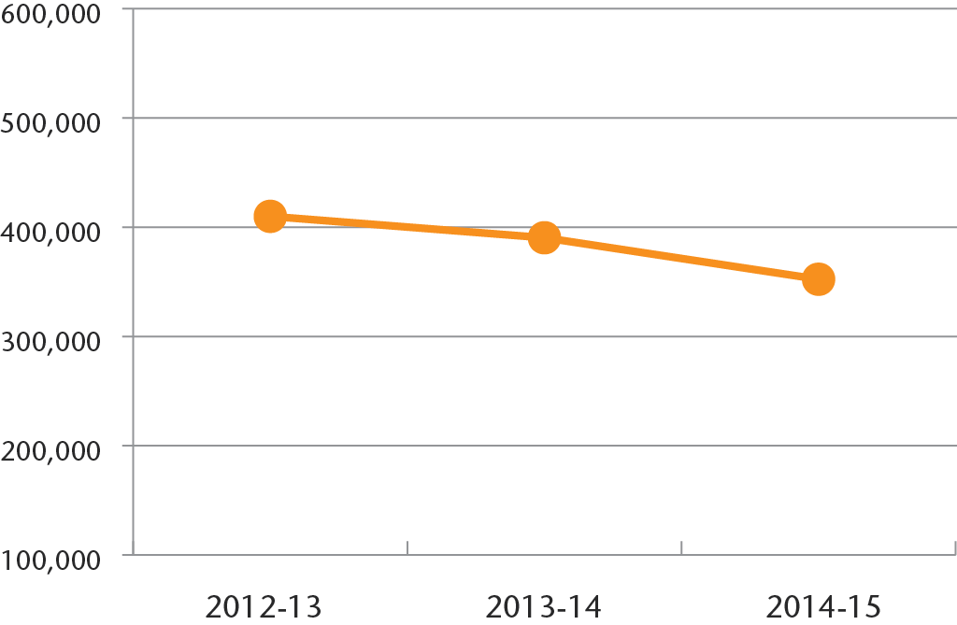
Website visits
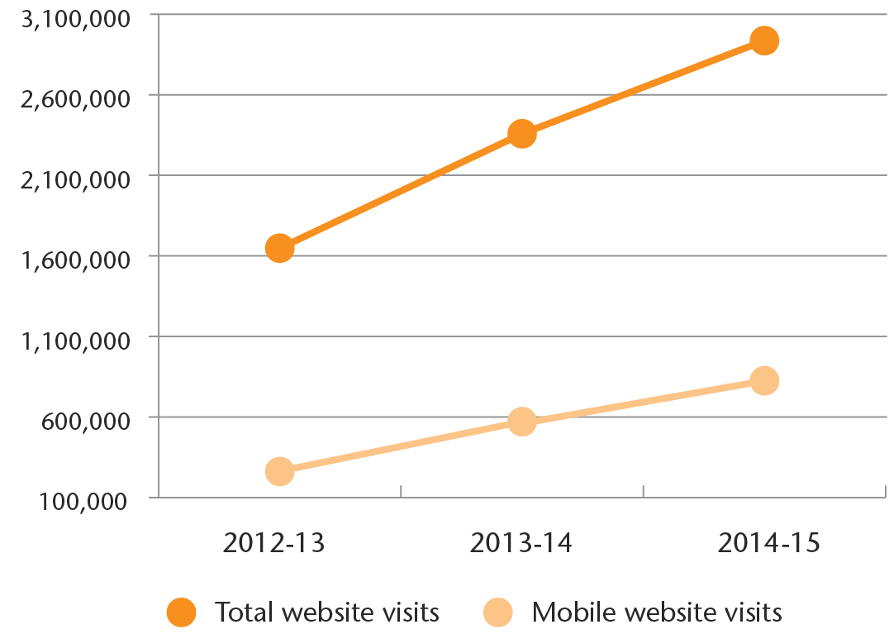
Letters emails and online contacts
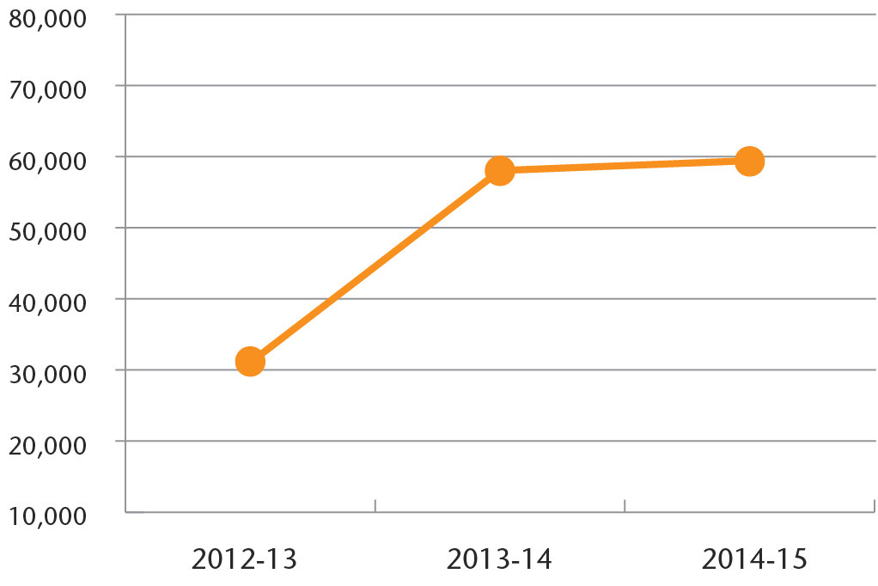

Supporting fair trading
Many contacts we receive for information and advice relate to fair trading matters, which are regulated by the ACL. The lists below highlight the top five reasons we were contacted in 2014-15 and are categorised by issue or by product. The term 'contacts' refers to the number of contacts from the public recorded in our case management system. This includes instances where we have been contacted for information and advice, as well as instances where a formal complaint has been lodged. The method of communication for each contact may be different, and includes telephone, face-to-face, or via written correspondence.

Top five shopping contacts for 2014-15

Issues
- Quality – such as defective goods, unsatisfactory services (14,866 contacts)
- Rights and responsibilities – such as refund and return rights, contract cancellation and warranty rights (11,054 contacts)
- Supply issues – such as non or partial supply, or delay in supply of goods and services (5,112 contacts)
- Charges, fees and pricing – such as disputed and unreasonable charges, billing problems (4,764 contacts)
- Conduct – such as misleading and deceptive conduct, misrepresentations (4,243 contacts)

Products
- Household goods – such as furniture, electrical appliances and whitegoods (9,364 contacts)
- Personal goods and services – such as clothing and footwear, jewellery, hair and beauty services (6,973 contacts)
- Electronics – such as computer hardware, audiovisual equipment (3,566 contacts)
- Automotive – such as servicing, maintenance, repairs and restoration (3,143 contacts)
- Recreational goods and services – such as gyms, sports and leisure goods (2,984 contacts)

A fair and competitive marketplace for all
We recognise the importance of providing specialised services to Victorians in need of more intensive support. We do this in some instances through partnerships with community agencies, which we fund to better target resources and reach a greater number of vulnerable and disadvantaged Victorians.

Support to Koori communities
We have a dedicated Koori Helpline to ensure that Koori consumers have access to our support services. In 2014-15 we answered 1,510 calls to our Koori consumer line, and participated in 45 events across Victoria designed for Koori audiences. These included radio presentations on Koori station 3KND about renting and buying a car, presentations at Koori Justice Gatherings, including in Bendigo, and stalls at events like the Koori Christmas barbecue in Epping, the Aboriginal Community Information Day in Collingwood and the Aboriginal and Torres Strait Islander Mental Health Awareness Day in Wangaratta. Our Financial Counselling and Tenancy Advice and Assistance Programs also provided support to over 1,100 Koori consumers.
We also contributed to the National Indigenous Consumer Strategy, working with other ACL regulators to:
- promote basic consumer rights recognised by the United Nations for Indigenous consumers in Australia
- improve market outcomes for Indigenous consumers
- ensure Indigenous consumers have equal access to our services.
We are part of a national working party developing a campaign to educate Indigenous consumers about various insurance products. Evidence suggests that many Indigenous consumers are not sure about the nature of funeral insurance contracts, and often don't know what they are signing up to. The goal of the campaign is to better inform these consumers, so they can make more informed decisions.

Culturally and linguistically diverse consumers
In 2014-15, we continued to tailor our information to suit the needs of culturally and linguistically diverse (CALD) communities, identified as particularly vulnerable in relation to some consumer issues.
Our analysis identified mobile phone contracts as a particular source of detriment to CALD consumers. To help address this vulnerability, we published tailored mobile phone contracts information in 23 languages on our website, helping non-English speakers to make an informed choice when deciding on a mobile phone provider and plan. By providing this information to those who need it most, we empower them to understand and assert their consumer rights.
In the lead-up to the launch of our new licensing and registrations system, myCAV, we established a partnership with the Ethnic Communities Council of Victoria to deliver multilingual information sessions for incorporated associations. This partnership ensures that CALD audiences involved in incorporated associations understand the new system and are supported in moving to digital transactions. Our funded services programs, including financial counselling, and advice and assistance to consumer and tenants, supported 4,653 clients for who speak a language other than English at home.

Financial counselling
We fund community agencies to deliver our Financial Counselling Program, which provides free, independent and confidential phone or face-to-face counselling sessions. In 2014-15, over 34,000 Victorians were assisted with financial counselling, 70 per cent via the telephone. The program funds the equivalent of 64 full-time counsellor positions across Victoria.
Funding is provided to 12 lead community agencies in partnership with another 13 agencies. The Consumer Action Law Centre (CALC) is funded to provide the state-wide phone financial counselling service MoneyHelp and the self-help MoneyHelp website <MoneyHelp.org.au>. In 2014-15, MoneyHelp assisted 12,142 Victorians with phone counselling, and visits to its website more than doubled to 878,029.

Specialist consumer support for vulnerable and disadvantaged
Our Consumer Advice and Assistance Program funds three community legal centres to help consumers prepare for and attend the Victorian Civil and Administrative Tribunal (VCAT). This year, the program supported 446 Victorians with consumer issues including defective goods, disputed and unreasonable charges and supply issues.
This funding also pays for legal advice and consumer legislation training for community workers through CALC. Through its funding, CALC serves as a state-wide peak organisation providing policy input from consumers’ perspectives.

Providing dispute resolution services to building consumers
We are responsible for administering the Domestic Building Contracts Act 1995 (DBCA) which specifically regulates domestic building contracts - how a contract should be entered into and managed and the specific warranties to be implied into every domestic building contract. This is in addition to the ACL, which applies across all industries, including building and building-related work such as cabinetry, kitchen installation and renovation services.
Working with the Victorian Building Authority (VBA), we jointly deliver the Building Advice and Conciliation Victoria (BACV) dispute resolution service, which provides a free domestic building dispute resolution service for Victorian consumers and builders.
Both parties must agree to participate in conciliation. The parties must have attempted to resolve the dispute themselves and must not have lodged the matter at VCAT or a court.
If there is evidence of defective building work, a technical inspection by an inspector provided by the VBA may be arranged to assist conciliation. If the parties cannot reach agreement through voluntary conciliation, the parties may be advised to take the dispute to VCAT.
In 2014-15, we finalised 1,318 disputes, of which 602 were conciliated onsite. Over 93 per cent of onsite conciliations were resolved. Overall conciliation resolution rates exceeded 86 per cent. We finalised 443 building disputes through our frontline resolution service, which aims to resolve disputes within 48 hours, by engaging both parties over the telephone to try to reach a mutually agreeable outcome.
We also provide information and advice in relation to the rights and obligations of consumers and builders under the DBCA and the ACL, and engage with builders to improve business practices and reduce disputes.

Retirement villages: making informed decisions
In July 2014, we launched a new campaign to help Victorians make informed decisions about retirement villages and understand changes to the Retirement Village Act 1996. The legislative amendments require retirement village operators to:
- provide an information factsheet (in an approved form) to prospective residents
- allow prospective residents to inspect particular documents they hold
- provide an expanded pre-contract disclosure statement (in the approved form) to those intending to sign a contract
- use standard content and layout in contracts to make them easier to understand and compare, including a basic set of mandatory rights and responsibilities of residents, managers and owners.
To support the campaign, Newspoll ran a survey on our behalf to obtain statistics about the retirement village industry. The results indicated that two thirds of those surveyed were unsure about what was involved in signing a retirement village contract.
The campaign targeted people aged 75-79 who were considering making the move, encouraging them to take advantage of legal changes which required villages to disclose certain information, making it easier to compare different villages.
The campaign was promoted widely, including across print outlets in Victoria and mainstream television.

Our retirement village campaign helped Victorians make informed decisions about retirement villages.

Working with Kidsafe to protect children
In September 2014, we joined our partner Kidsafe to launch the ‘Play it safe at home’ campaign, encouraging parents and carers to take steps to reduce risks to children. We highlighted the dangers of single and bunk beds, curtains and blinds, nursery furniture, trampolines, pools and spas. We also reminded parents about the risks of button batteries, which can cause life-threatening injuries if swallowed by a child, and are found in common household items like remote controls, car keys and watches.
We urge parents and carers to check their homes for common safety hazards that could injure their children.

We work in partnership with Kidsafe to protect children from unsafe products.

The game’s up for travelling con men
In January 2015, Consumer Affairs Minister Jane Garrett launched our campaign against travelling con men.
Travelling con men are dodgy tradesmen who knock on doors of homes, farms and small businesses, offering maintenance work with cheap ‘today only’ deals. Some also drop professional-looking flyers into letterboxes. They appear more frequently during warmer weather and after natural disasters such as floods, fires and storms, when people are cleaning up or repairing their properties. Travelling con men put people under pressure to say ‘yes’ immediately and to pay the full amount in cash, then often disappear. If they do any work, it is often unfinished or of a poor standard.
We work hard to educate Victorians to recognise and avoid travelling con men – this is the best way to stop them. We alert Victorians when travelling con men are active in a particular area. We work closely and strategically with organisations such as Victoria Police and other consumer protection agencies across the country to stop travelling con men.
Our partnership with Crime Stoppers Victoria has been targeting travelling con men since 2009. This year’s campaign focused on empowering Victorians to say no to these dodgy dealers through simple messaging:
- if you suspect a travelling con man is knocking, do not answer
- if you speak to them, ask them to leave
- if they refuse to leave, they are breaking the law.
Travelling con men often target vulnerable consumers and residents who speak little or no English. To these consumers, key messages of the campaign were translated into 23 other languages, including those of newly arrived communities such as Dari, Farsi, Karen and Somali.
We also collaborate with other ACL regulators to deliver a national Travelling Con Men Hotline and the ‘Stop Travelling Con Men’ Facebook page, both of which have been in operation for three years. Each regulator monitors the Facebook pages for reports of travelling con men in their state and uses the information to alert the community via social media. Our alerts about travelling con men usually include the suburb or town where the con man has been spotted and the type of services they are offering. We encourage the community to share these alerts with family and friends who live in those areas so that we reach a range of people, even those without access to social media.

Consumer Affairs Minister Jane Garrett with Doreen, who was targeted by travelling con men, at the media launch for our campaign.

Scams hurt. Talk helps
Scams pose a growing risk in our community, especially to older Victorians and those for whom English is a second language. According to the ACCC, reported scams losses in Australia totalled $81.8 million in 2014. Many scams also go unreported. Along with the financial pain involved in falling victim, there is also an emotional cost – highlighted in our education campaign, ‘Scams hurt. Talk helps’.
Our campaign was launched during Mental Health Week in October 2014, with the message that anyone can fall for a scam, and to promote the support services available. The campaign was supported by beyondblue, SANE Australia, headspace and the Victorian Men’s Shed Association.
The campaign encouraged people affected by a scam to talk about how they are feeling with friends and family, and to seek professional help if they are experiencing depression or anxiety as a result of being scammed.
The campaign featured videos educating consumers about tricks used to rip people off through romance, lottery, online selling, investment, rebates, rental and business scams. People affected by scams were encouraged to report them, and to share their story to help warn others.

Education is the key to protecting Victorians from being scammed.

Packing some peace of mind
Coinciding with the removal of travel agent licensing requirements in July 2014, we led a national campaign to educate consumers about the changes and how to protect themselves when booking their holidays. The ‘Pack some peace of mind’ campaign, an initiative of consumer protection agencies across Australia, reminded travellers of their rights, and the steps they could take to protect their travel bookings. The campaign’s key messages focused on helpful advice for consumers:
If you book through a travel agency:
- look for an agency that is accredited
- check that the business has a clearly stated refunds, complaints and cancellations policy
- seek referrals from friends and family.
If you book online:
- ensure the site has a good reputation and is secure
- look for contact details and information about refunds and dispute resolution
- remember that businesses based overseas may be more difficult to obtain a refund from.
We also reminded consumers that if they do not get what they paid for, they may be able to seek a chargeback from their bank if they have paid with a credit card, or by choosing 'credit' when using a MasterCard or Visa debit card.

We educated consumers about how to protect themselves when booking holidays.

Helping consumers understand property prices
We know that for many Victorians, buying a home is the biggest purchase they will make in their lives. When going through this process, it is critical that consumers understand property prices, how the property market operates, and key strategies for ensuring that they make the right choices. To provide this support, we partnered with the Real Estate Institute of Victoria (REIV) and Law Institute of Victoria to share property-buying tips at the free REIV Homebuyers Seminar in October 2014. We talked to consumers about the differences between buying at auction and private sale, inspecting properties before you buy, and our ‘due diligence’ checklist for buyers.
In that same month, we launched our video ‘Understanding property prices’, which shares some of our tips for those looking to buy property.

3 A fair and safe rental market for Victorians
As the Victorian regulator of residential tenancies, we work to achieve fair and safe rental housing in Victoria. Our priority is to ensure that the residential tenancy framework reflects the needs of the modern rental marketplace. Our focus includes effective collaboration with partners so that we can continue to improve our understanding of the needs of a modern market, and make positive changes across the sector.

Launch of Fairer Safer Housing
In June 2015, Consumer Affairs Minister Jane Garrett launched the Fairer Safer Housing website <fairersaferhousing.vic.gov.au>. Fairer Safer Housing is the Victorian Government’s work program for ensuring all Victorians have access to safe, affordable and secure housing.
This program includes work on housing affordability, planning reform, and a new integrated community care system to support the health and well-being of all Victorians. Over the next three years, the Fairer Safer Housing website will serve as a hub for the community to engage with the Government on housing-related initiatives.
We have an opportunity to play a critical role in the Government’s broader program for Fairer Safer Housing, through a review of the Residential Tenancies Act 1997. The rental market has changed significantly over the last 20 years, with growing numbers of Australians renting for longer. The purpose of the review is to ensure that regulation of Victoria’s rental sector is appropriate to meet the needs and expectations of tenants and landlords, now and into the future. The review will examine Victoria's rental laws within the modern rental market, and aim to balance the rights and responsibilities of tenants and landlords.
The first step of the review considers trends and behaviours in the rental market through an initial consultation paper, Laying the Groundwork, available on the Fairer Safer Housing website. Public submissions are being sought in response to the Laying the Groundwork paper. Over the second half of 2015, a series of papers are being released on housing-related issues, such as the Government's commitment to explore long-term leases and specific protections for residents of caravan parks and movable dwellings.
During 2016, an options paper outlining the outcomes of the public consultation will be released for discussion, with a view to developing reform proposals for introduction into the Victorian Parliament in 2017. It is anticipated that the review will be completed by mid-2018.
We are undertaking this review in a modern way, utilising the Fairer Safer Housing website to encourage community engagement throughout the review, through public submissions, polls, discussion papers, videos and social media.
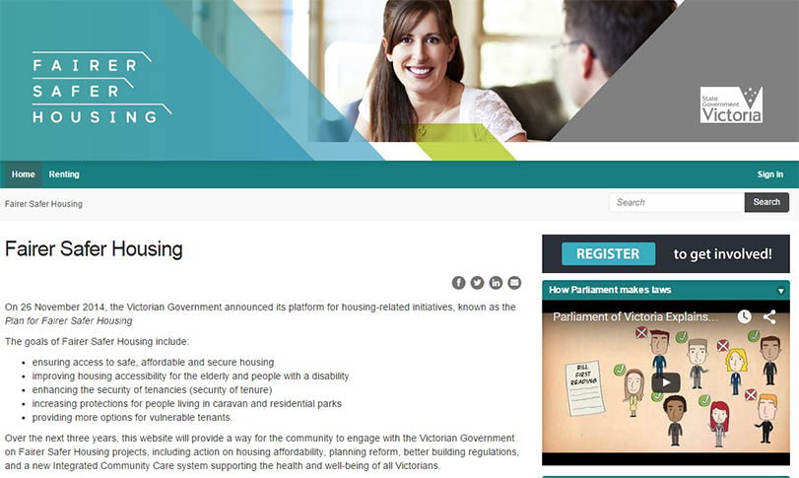
The Fairer Safer Housing website gives the community an opportunity to participate in discussions and stay informed about the review of the Residential Tenancies Act 1997.

Improved protections for rooming house residents
This year, we started work to implement the Government’s election commitment to legislate a ‘fit and proper person’ test for rooming house operators, to improve the protection of residents.
Rooming houses often attract vulnerable people unable to obtain any other form of accommodation. Residents include single people on low incomes, including a growing number of older women, tertiary students (including overseas students) and recently arrived migrants. Rooming houses are also increasingly being used by the long-term homeless and people in need of crisis housing.
The ‘fit and proper person test’ will be incorporated into a licensing scheme for rooming house operators, to be administered by the Business Licensing Authority. By implementing the scheme, we are addressing the issue of sub-standard operators, one of the key problems identified by the 2009 Rooming House Standards Taskforce. It is anticipated that the legislation will be introduced to the Parliament in late 2015.

The RentRight app: supporting tenants and landlords
In April 2015, we released a new version of our popular RentRight app, with new features designed to help property managers and landlords. Research indicates that over 60 per cent of landlords contact their tenants at least once every three months – so we took the opportunity to expand RentRight to make it easier for landlords to communicate with their tenants, and to learn more about renting rights and obligations. The latest version of RentRight provides:
- email templates to enable landlords and property managers to contact tenants about upcoming inspections, goods left behind and general property-related issues
- tools enabling landlords and property managers to generate and fill in condition reports, exit condition reports and inspection reports, which can be customised
- helpful information about managing a rental property.
More than a third of landlords own two to three properties, which can make it more difficult to remember important dates, such as inspections and when rent payments are due. RentRight provides help with this by allowing landlords to set up reminders, and the app has other tools to make it easier to manage properties.
RentRight was downloaded 16,591 times in 2014-15, bringing the total number of downloads to over 26,000 since we launched the app in 2013. The app was recently announced as the winner for ‘Most Accessible Mainstream App’ by the Australian Communications Consumer Action Network in its Apps for All Challenge.

Our award-winning RentRight app is a great support and information tool for both tenants and landlords.

A complete service for tenancy bonds
The Residential Tenancies Bond Authority (RTBA) is the Victorian Government statutory authority which holds all residential tenancy bonds for landlords and tenants, including long-term caravan park and rooming house residents. This requirement, part of the Residential Tenancies Act 1997, protects tenants from having their bond misused by unscrupulous landlords or agents.
The RTBA, run by CAV, performs numerous transactions, including bond lodgements, bond repayments and transfers. In 2014-15, it registered more than 228,900 bond lodgements and at 30 June 2015, held 567,550 bonds valued at $874 million. This represents an increase of nearly five per cent in the number of bonds lodged since 30 June 2014, and an eight per cent increase in value.
In 2014-15, the RTBA carried out more than 506,000 transactions and turned over $723 million. It processed 99 per cent of all transactions on the same day as receiving the form initiating the transaction.

Launch of the new RTBA website
A new RTBA website was launched in May 2015, offering considerable improvements for tenants, landlords and estate agents. The new website has a more modern look and feel, including a revised layout, compatibility with mobile devices and tablets, and improved security. In terms of functionality, the new website provides a more user-friendly experience and easier processes for sharing information with the RTBA and undertaking various transactions.

Specialist tenancy services for vulnerable and disadvantaged tenants
Through our Tenancy Advice and Assistance Program (TAAP), we fund nine community housing and legal centres to provide advice, negotiate or assist with matters at VCAT. In 2014-15, these agencies provided services to 6,267 Victorians. The majority of advice the agencies provide relates to Notices to Vacate.
Services for tenants include advice and advocacy at VCAT and outreach support for metropolitan rooming house residents. Housing support is also provided for older tenants, and tenancy legal advice and workshops for community sector workers.
We funded the Tenants Union of Victoria (TUV) and Peninsula Community Legal Centre to provide support for some of the most disadvantaged rooming house residents in metropolitan Melbourne.
We also provided funding to the Housing for the Aged Action Group, which provides advocacy advice and support to older tenants in Victoria. This group helps older Victorians transition into more affordable housing. In addition, we help community workers to improve their understanding of the Residential Tenancies Act 1997 by funding the TUV to provide tenancy legal advice and training.
A few examples of services provided through our funding are detailed below and demonstrate the important role our program plays in ensuring that vulnerable tenants have support in resolving their renting disputes.

Case study
A single mother to four young children in regional Victoria was served a Notice to Vacate for rental arrears. With her sole income being Centrelink payments, the tenant missed the payment date for a fortnight’s rent due to urgent car repairs. She contacted the real estate agent to arrange a repayment agreement, however the agent refused to negotiate with the tenant, and instead served a Notice to Vacate. The community agency worker funded through TAAP identified that the agent had not allowed for the requisite notice period in issuing the Notice to Vacate required by the Residential Tenancies Act 1997, effectively rendering the Notice invalid. Unable to reach an agreement with the agent, the worker attended VCAT with the tenant and challenged the validity of the Notice to Vacate. VCAT ruled in favour of the tenant on the grounds that the Notice was not valid.

Case study
A single man in Melbourne’s outer east with a drug and alcohol problem sought support from one of the community agencies funded through TAAP when the estate agent for the property he had rented alleged he was in arrears of rent after he left. The tenant advocate helped him prepare comprehensive calculations, which identified that he was in fact three weeks in advance - and was owed a rent refund. After rejecting numerous attempts to negotiate a settlement, the estate agent made an application to VCAT to claim part of the bond for the rent arrears. The advocate attended to represent the tenant, and VCAT agreed with the advocate’s submissions, and dismissed the landlord’s claim for the bond. The advocate also ensured that the landlord signed the bond release form and forwarded a cheque to the tenant for the overpaid rent.

4 A modern and effective consumer law framework
To be an effective regulator, our consumer law framework must continue to evolve with the changing market. We lead and participate in policy and legislative reviews, and work in partnership with other regulators and organisations, to ensure our consumer law framework supports a fair and competitive marketplace.

Working with other Australian Consumer Law regulators
The ACL operates under a ‘one law, multiple regulators’ model. CAV is the ACL regulator for Victoria and works with other jurisdictions to address important national issues. This approach fosters collaboration, reduces duplication and supports better outcomes for businesses and consumers nationally.
We play a significant leadership role in national projects and contribute to work led by other jurisdictions. We lead the Education and Information Advisory Committee (EIAC) and are members of the:
- Compliance and Dispute Resolution Advisory Committee (CDRAC)
- Policy and Research Advisory Committee (PRAC)
- Product Safety Consultative Committee (PSCC).
These national committees meet regularly to discuss issues, policies, ideas and innovations, identify and plan national work, and evaluate progress. Work is aligned across committees to deliver an integrated compliance approach.
Senior consumer affairs officials from each jurisdiction, as members of Consumer Affairs Australia and New Zealand (CAANZ), oversee these committees. Consumer Affairs Ministers oversee CAANZ in their roles as members of the Council of Australian Governments’ Legislative and Governance Forum on Consumer Affairs (CAF).
In leading and contributing to national projects aimed at improving regulator responses to a range of ACL matters, we can ensure a consistent approach across Australia, and share intelligence and expertise. ACL regulators continue to identify ways to prevent the duplication of work and to share information and resources, promoting efficient and economical regulation while achieving desired outcomes for consumers, and reducing compliance costs for national businesses. This year, a number of initiatives demonstrated benefits for regulators and consumers nationally. Some of our achievements are outlined below.

Taking the lead: Better Business Initiative
Several ACL regulators have adopted the Victorian model for engaging with businesses generating a relatively high number of contacts to regulators.
The Better Business Initiative (BBI) targets businesses with high or disproportionate contacts to us. The initiative focuses on reducing contact numbers by identifying common or thematic issues and possible underlying causes of those issues. BBI engages with businesses, seeking their commitment to implementing ongoing and sustainable improvements to business practices and to achieve compliance with consumer protection legislation. BBI promotes a fair and competitive marketplace by encouraging self-regulating business models which in turn, reduce consumer detriment and cost to government by lessening demand on the regulator’s resources.
When businesses refuse to engage and contact numbers remain high, we may take escalated action, including public naming and enforcement action in line with our Compliance and Enforcement Policy.
The BBI has this year resulted in a 39 per cent decrease in contacts to us about the businesses we have engaged with. It is a leading example to other ACL regulators about the benefits of positive engagement with business.

Enforceable undertakings: a national approach
We have piloted new protocols for national enforceable undertakings, enabling some actions against national businesses to be applied across Australia. This promotes consistency in compliance and enforcement approaches between jurisdictions.

Taking a national approach to Australia’s most complained about businesses
We are leading a national project to ensure a coordinated approach to Australia’s most complained about businesses. ACL regulators have found a significant number of contacts relate to a small number of national businesses. The majority identified are large organisations transacting with high numbers of consumers, with the complaints being only a small fraction of their transactions.
The common issues being raised with ACL regulators across the country result in an unnecessary demand on government services, when the business may be in a position to resolve the issues themselves, without regulator intervention.

Providing consumers for practical redress for disputes
We are leading the Credit Card Chargebacks National Project. Chargeback is a form of customer protection provided by the banks that issue credit cards, which allows cardholders to dispute transactions and obtain a reversal of a charge on their credit card, or debit card (when ‘credit’ is selected). A chargeback is often the only or the most practical means for consumers to obtain redress for disputed or incomplete transactions. With the growth of online shopping, chargeback has the potential to become a more common and appropriate remedy for consumer disputes.
There is currently no consistent understanding amongst ACL regulators about the use, framework, rules and conditions that govern chargeback. While ACL regulators currently advise consumers to seek chargeback in certain situations, this advice appears to be inconsistent across agencies.
The project, due to be completed in early 2016, seeks to establish a common understanding between ACL regulators of chargeback, and create a suite of tools to support ACL regulators and consumers in utilising chargeback as a means to address disputes. The project will increase the effective use of chargeback by providing nationally consistent information, guidance and tools to facilitate its application, and explore the possibility of making consumers self-sufficient in obtaining redress by increasing their awareness of chargeback as a means to resolving their dispute.

Protecting the community from illegal tactics of property spruikers
Through our role leading EIAC and contributing role in CDRAC and PRAC, we are working on a project with other ACL regulators to raise awareness among consumers about property spruikers and rent-to-buy schemes.
Property spruikers are in the business of promoting property investment schemes and selling their products to consumers wishing to invest or enter the property market, often using Self-Managed Super Funds. The claims they make entice consumers who generally have minimal knowledge of the investment or the property market. These claims are often extreme; for example, some spruikers claim that the consumer can purchase a property for one dollar.
Rent-to-buy schemes target lower income consumers or prospective property buyers who are unable to obtain mainstream finance. Under a rent-to-buy scheme, the buyer enters into a rental agreement with the vendor where they are charged high rent (well above market rate). At the end of the rental period they may buy the property but ownership of the property does not pass to the buyer until they exercise the ‘option to purchase’ after the rental period has expired, and buyers have limited legal rights if something goes wrong.
The purpose of this project is to educate consumers about property spruikers and rent-to-buy schemes, and particularly conduct that contravenes the ACL and targets vulnerable consumers. The project focuses on raising awareness for consumers about the risks of obtaining property investment advice from wealth-creation seminars, and the risks of entering a rent-to-buy contract when purchasing a home.
This project complements other national work undertaken including a compliance project to combat misleading behaviour by property spruikers, and research to identify legislative gaps and propose options for reform. The project is due to be completed in 2016.

Improving the consumer protection framework for building
In May 2015, the Victorian Auditor-General tabled a report in Parliament on Victoria’s Consumer Protection Framework for Building Construction. The audit examined the performance of CAV, the VBA, the Building Practitioners Board (BPB) and the Victorian Managed Insurance Authority (VMIA) as the key providers of building regulation and consumer protection in domestic building.
The audit found that the existing consumer protection framework for domestic building did not adequately protect consumers experiencing problems and that there was a pressing need to improve consumer awareness and understanding of the framework.
The report makes recommendations to CAV, the Department of Environment, Land, Water and Planning, VBA, BPB, Department of Treasury and Finance and VMIA, to improve the framework and its implementation.
Two of nine recommendations made relate to CAV. The Auditor-General recommended a review of our dispute resolution services, and that we work with the VBA to review our consumer education and awareness activities. We are committed to improving the consumer protection framework for domestic building construction and working closely with relevant agencies to implement the recommendations.

Protecting consumers from unscrupulous car park operators
A number of car park operators use a business model whereby customers are required to estimate the amount of time they will stay on entry to the car park, buy a ticket for the appropriate period, and then display it on their dashboard.
If a customer either fails to obtain a ticket, or parks for longer than the period they paid for, a notice may be placed on the vehicle's windscreen, which is similar to an infringement notice, but is actually a claim for liquidated damages. In practice, the amount claimed is commonly well in excess of any actual loss incurred by the car park operator. In 2014, VCAT rejected a private car park operator’s claim for fees, deeming it excessive as a penalty, and thus unenforceable.
When a customer does not pay the amount specified in the payment notice, the car park operator seeks a preliminary discovery in the Magistrates’ Court of Victoria that requires VicRoads to disclose the name and address of the registered owner of the vehicle in question. The car park operator will then write a series of letters of demand, demanding that the customer pays the amount owed, plus an additional late payment fee.
Additionally, it is common practice for the car park operators to onsell their debts to debt collection agencies that write similarly threatening letters of demand to the car park customers. These practices have given rise to significant public concern.
To address these issues, the Road Safety Amendment (Private Car Parks) Act 2015 was introduced into the Victorian Parliament, and passed in August 2015. This legislation removes the ability of private car park operators to obtain the names and addresses of vehicle owners from VicRoads to recover private car park fees, stopping the unfair and misleading conduct of these operators.

Considering the right approach to short stays in Victoria
In February this year, Consumer Affairs Minister Jane Garrett and Planning Minister Richard Wynne announced the appointment of an independent, seven-member expert panel to examine the conduct of short-stay occupants of city apartment buildings.
‘Short stay’ apartments can be let as serviced apartments, as part of a business, or on a one-off or intermittent basis. They can be let directly by the apartment owner or on their behalf by a management company. Bookings of short-stay accommodation are increasingly occurring through peer-to-peer websites, such as Airbnb and Stayz.
The panel was appointed to take a common sense and practical approach to options for minimising disruption. It considered reforms to better balance residents’ rights to quiet enjoyment of their apartments with the rights of other owners to lease their properties as short stay accommodation. It also looked at how other cities cope with the short stays issue, both around Australia and overseas, as well as the broader impact of short stay accommodation on tourism and investment in Victoria.
The panel considered the interests of stakeholders, including residents, investor-owners and the accommodation and tourism industries. It has reported to the Ministers on the issues, and provided options and recommendations to address them.

Reducing red tape

Changes to the Motor Car Traders Act 1986
Changes to the Motor Car Traders Act 1986 and the Motor Car Traders Regulations 2008 commenced in November 2014. These changes affect the obligations of licensed motor car traders. Importantly, they streamline the process for cooling-off on vehicle sales, and simplify the forms and notices motor car traders are required to use. Other changes include reduced record-keeping obligations for traders and removing the requirement for background checks for employees who are not directly involved in transactions. These changes have resulted in less paperwork for motor car traders and have made buying a car easier for consumers to understand. It is estimated this has resulted in annual red tape savings for the sector of close to $1 million.

Changes to the Sale of Land Act 1962
When a person sells a property they are required to disclose certain important information to a purchaser through what is known as a section 32 statement. A section 32 statement must be provided to the purchaser before any sale is completed. In the 30 years since the introduction of vendor disclosure, the disclosure requirements had become more onerous and complicated. Changes to the Sale of Land Act 1962 that came into effect in October 2014 clarify the information that sellers must provide to prospective home buyers. The changes were the result of a comprehensive policy review and were designed to make the existing disclosure regime more user friendly and remove unnecessary red tape. The reforms reduce the administrative and compliance burdens associated with preparing section 32 statements, while retaining the core elements of Victoria’s vendor disclosure system. These amendments reduce red tape for property sellers, buyers, and the lawyers and conveyancers who prepare and scrutinise section 32 statements on their behalf.

Statement of Expectations update
In 2014, the former Minister for Consumer Affairs issued a reducing red tape Statement of Expectations (SOE) to CAV, seeking reduced business costs through red tape reduction targets for some key compliance processes and licensing and registration activities. The red tape reduction program and implementation of the SOE is continuing under the Andrews Government.
The Statement encouraged us to continue with our risk-based approach to regulation and to identify key areas of governance and operational performance where there are opportunities to make improvements that reduce the cost of regulation for business, while maintaining a high level of consumer protection.
The projects identified as part of the Statement fall under four broad objectives:
- increased accountability and transparency
- improved timeliness
- clearer and more consistent regulation
- better compliance assistance and advice.
Our work to reduce red tape and meet the SOE is well underway and will be implemented by June 2016. An outline of each initiative is available on our website.

Enhancing consumer protections
In 2014-15, we advised on legislative changes to improve consumer protection and remake regulations due to expire, or that no longer met the needs of Victorian businesses and consumers.

Consumer Affairs Legislation Amendment Act 2014
The Consumer Affairs Legislation Amendment Act 2014 made various improvements to a number of Acts we administer, including the:
- Sex Work Act 1994
- Motor Car Traders Act 1986
- Australian Consumer Law and Fair Trading Act 2012
- Associations Incorporation Reform Act 2012
- Domestic Building Contracts Act 1995
- Estate Agents Act 1980
- Retirement Villages Act 1986
- Funerals Act 2006
- Fire Services Levy Monitor Act 2012.

Veterans and Other Acts Amendment Act 2015
The Veterans and Other Acts Amendment Act 2015 made various improvements to a number of Acts we administer, including the:
- Veterans Act 2005
- Sale of Land Act 1962
- Australian Consumer Law and Fair Trading Act 2012
- Residential Tenancies Act 1997
- Motor Car Traders Act 1986
- Associations Incorporation Reform Act 2012.
Detail about the changes to each Act is provided on our website.

Credit and credit administration regulations
In 2010, responsibility for the regulation of consumer credit was transferred from state governments to the Commonwealth. Although CAV no longer has primary responsibility for this sector, the Victorian Credit Act 1984 and the Credit (Administration) Act 1984 still exist to regulate continuing credit contracts entered into prior to the transition. The Credit Regulations 2014 and Credit (Administration) Regulations 2014 replace the previous Regulations, which were due to expire, and ensure the continued effective operation of these Acts. The regulations prescribed a number of technical matters including:
- methods of calculating statutory rebates and accrued credit charges
- descriptive terms to be used in certain documents
- requirements for print or type in documents
- certain forms required to be sent to mortgagors and guarantors.

Review of prescribed fees for owners corporations certificates
We conducted a review of the fees charged by owners corporations for various records, including certificates. Following extensive consultation with stakeholders and the release of a Regulatory Impact Statement for public consultation, regulations setting the new maximum fees that owners corporations managers can charge for issuing of certificates and other documents came into operation on 1 October 2014. The new fees are based on fee units, which are adjusted annually, and allow for urgent requests, and requests for additional certificates and copies of the owners corporations register and records.

5 A sustainable and innovative regulator
Efficient and effective internal operations are critical to our ability to be a modern and effective regulator. We continue working on new ways to foster better capability, better technology and better collaboration with our partner agencies.

Taking a long-term view
We have developed our four-year plan to drive our success as Victoria’s consumer affairs regulator and steer the organisation’s overall operations. The focus underpinning the implementation of our plan includes:
- risk-based monitoring and enforcement
- tools that enable business compliance
- business compliance through partners
- access to information on consumer rights
- digital first in all our work.
The plan was the result of several months of research and planning that included workshops, discussions and feedback with our Strategic Management Group to determine our long-term business model, goals, outcomes and strategies over the next four years.
Our staff had the opportunity to be involved in the plan’s development through an all-staff workshop held to identify and develop strategies, priority projects and actions that form the basis of this plan.

Staff participated in workshops to develop our long-term strategy.

Prioritising our work based on regulatory risks
This year, we developed Regulatory Risk Plans for a number of sectors that we regulate, identified as high priority, including building, estate agents, failure to supply, misleading and deceptive conduct, product safety, residential parks, residential tenancies and rooming houses. The plans articulate our approach to managing regulatory risk within that field or sector and draw on our organisational intelligence and expertise. Each plan was developed and finalised by a working group of expert staff to identify actions to mitigate each regulatory risk. We have developed a monitoring and evaluation framework for each risk plan to assess how our actions are impacting the market, and to enable us to respond to changes in the market.

Transforming our information and communications technology
We continued implementing our Information and Communications Technology transformation strategy, which is changing the way we deliver our services and how Victorians will interact with us.
Our strategy will enable transactions that are easier and less time-consuming for business. Information and self-help tools will be easily accessible through our website. Implementation of the strategy will improve our analysis and decision-making through better access to data.
The first project has been successfully completed, streamlining the registration processes for incorporated associations.
We also commenced a project to redesign our website and improve the end user experience. With close to three million views in 2014-15, our website is our primary point of engagement with the Victorian community. The redesign project recognises the need to ensure that our website is tailored to support businesses in complying with consumer laws, and empowers consumers to exercise their rights.
The website improvement project will improve the quality of our digital services by implementing tools to better support consumers in self-help, and provide access to all tools, features and support regardless of device or platform. Internally, the improved website will better allow us to capture data to identify emerging issues in the market.
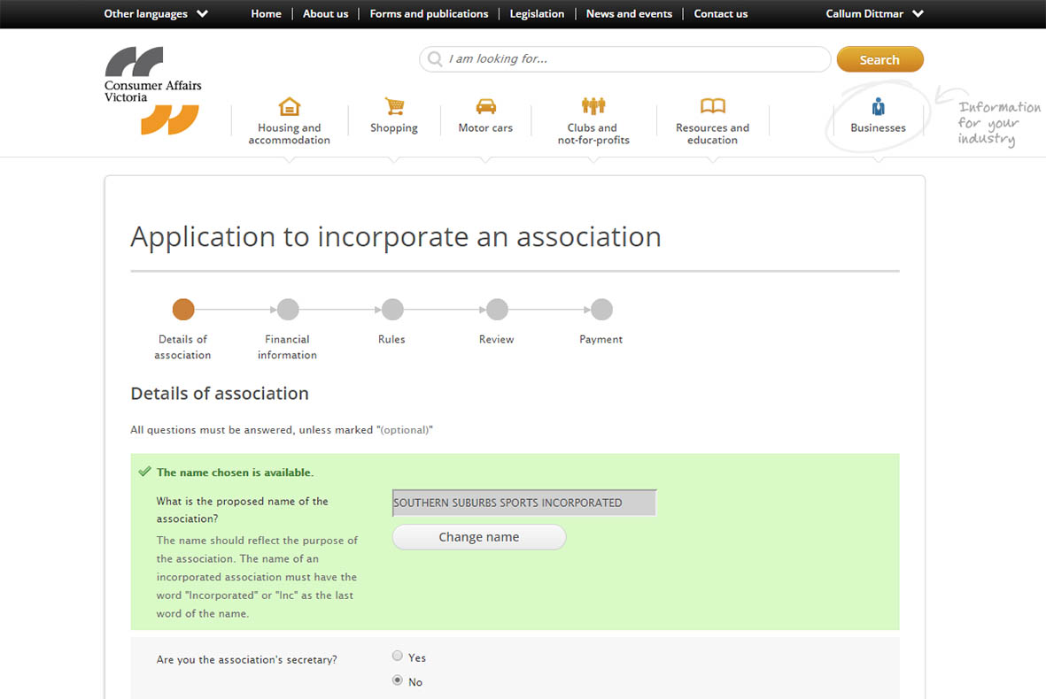
Launching our myCAV licensing and registrations system was an important milestone in our continuing transition to a digital organisation.

Growing the capabilities of our people
A critical element to achieving our vision of a fair and competitive marketplace in Victoria is the skills and capabilities of our staff. This year, we launched the CAV People Capability Framework, which outlines the people capabilities that will help achieve our vision. The framework complements the Department of Justice & Regulation values and capabilities and builds on the CAV values of innovation, collaboration, empowerment and trust.
The framework’s purpose is to give our people a common understanding of what success looks like in our roles, help identify our strengths and areas for further development, and enable all of us to work towards building our capability. The roll-out of the framework has included an increase in learning and development opportunities for staff, and events encouraging staff to think about and discuss each capability and how it applies to their role.
All staff had the opportunity to complete an online learning package, which we developed to help build understanding of:
- our role within the Victorian regulatory framework
- how we are implementing best practice regulation
- what it means for us to be a risk-based, intelligence-led regulator.
We also developed online learning content that explained how staff may access confidential information on the VicRoads system for enforcement purposes. About 50 staff attended training run by Dr George Argyrous on evidence-based decision making, and 30 others underwent training to gain customer insights in the creation of digital communication.
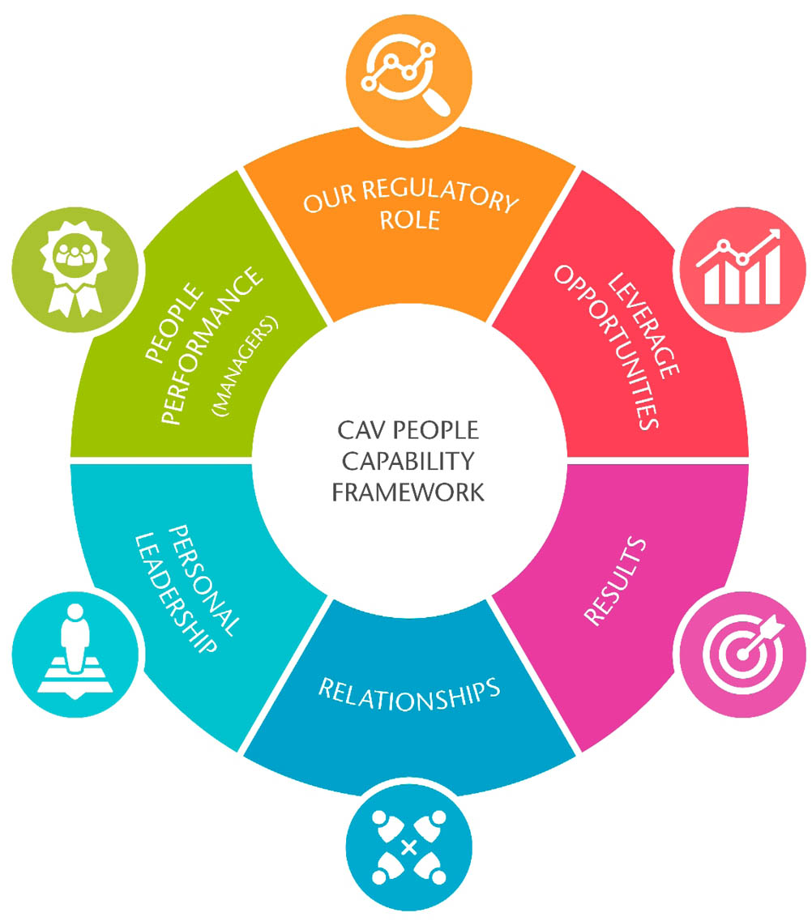
The CAV People Capability Framework describes the people capabilities and behaviours that will assist us to achieve our vision and meet our goals.

Our learning and development program supports staff to develop their capabilities.

Continuous improvement projects

Improving our operations to support business compliance
This year, we undertook a review of our compliance operating model, to assess it against our strategic goals and get a fresh perspective of regulatory best practice. The resulting design will enable staff to achieve business compliance through whole-of-CAV coordinated and structured compliance operations.
The new model aligns with our organisational strategy to increasingly be an outcome-focused, risk-based and intelligence-led regulator. The overarching component of this proposed model is a new compliance framework that aims to improve collaboration across the organisation in relation to compliance decision making. The framework does this by providing a coherent decision-making process, which recognises that there are different types of compliance decisions and different information requirements for making those decisions.
The new compliance operating model focuses on:
- broadening and improving the information and data we collect to understand consumer markets in Victoria
- improving our risk analysis to understand the risk of non-compliance and potential consumer harms
- improving the process of designing responses to risks to increase their effectiveness, based on experience and feedback.
We will roll out the model throughout 2015-16, ensuring that our systems can support it and our staff have the right tools and capabilities to apply the new model to their everyday work.

Consumer Help Program
One of the pillars of our long-term strategy is enabling digital service delivery for those capable of using it, and guided and managed help services for those who cannot self-help through technology. Our digital first approach enables businesses and consumers to get the information they need, whenever and wherever they want. By ensuring that Victorians have access to the right information, they will be empowered to assert their consumer rights and resolve their own problems.
Critical to achieving a genuine self-help model is clarity around what the best channels are for consumers and businesses to access our information and services. The Consumer Help Program has been established to ensure that we are best placed to deliver the right information to consumers and businesses through the right channels – whether digital self-help, guided support through telephone and face-to-face, or intensive support services through our funded advocacy and financial counselling programs. The program will map all of these approaches and outline any changes in our channel strategy that will improve access to information and support to the broader Victorian community.

CAV Specialist Services Program (SSP)
Our specialist services are those the community sector provide to vulnerable and disadvantaged consumers and tenants through funding provided by us. This includes face-to-face advice, dispute resolution and VCAT advocacy to help people resolve their problems, and advice to us on systemic issues affecting vulnerable and disadvantaged tenants.
The SSP will examine how we can further work with the community sector to achieve the best outcomes for vulnerable and disadvantaged consumers and tenants, and improve access for this group to consumer and tenant help services. Focus areas include identifying gaps in service delivery and pathways into service, and better integration and collaboration between community sector and CAV services. We are consulting and working closely with our funded agencies, as well as other community sector agencies to explore potential new partnerships, ideas and referral pathways.

Prudent management of our finances
We manage eight trust funds established by Acts of Parliament, which are administered within the Consumer Affairs portfolio. We have stringent governance and risk processes in place to ensure robust and effective management and oversight of these trust funds. Money held in trust funds can be spent on activities that are consistent with the expenditure purposes of the particular fund, and these requirements are set out in the legislation creating the trust fund.
In 2014-15, we undertook reviews to update our agreements with authorised financial institutions in relation to the management of real estate agent trust accounts. The review resulted in the implementation of standardised agreements across the banking sector, and improved interest rate returns being passed into the Victorian Property Fund. This provides for increased income from our investments, which can be used to support the provision of Government services.

Glossary
ACCC | Australian Competition and Consumer Commission
ACL | Australian Consumer Law
BACV | Building Advice and Conciliation Victoria
BBI | Better Business Initiative
BPB | Building Practitioners Board
CAANZ | Consumer Affairs Australia and New Zealand
CAF | Legislative and Governance Forum on Consumer Affairs
CALC | Consumer Action Law Centre
CALD | Culturally and linguistically diverse
CAV | Consumer Affairs Victoria
CDRAC | Compliance and Dispute Resolution Advisory Committee
DBCA | Domestic Building Contracts Act 1995
EIAC | Education and Information Advisory Committee
PRAC | Policy and Research Advisory Committee
PSCC | Product Safety Consultative Committee
REIV | Real Estate Institute of Victoria
RTBA | Residential Tenancies Bond Authority
SSP | Specialist Services Program
SOE | Statement of Expectations
TAAP | Tenancy Advice and Assistance Program
TUV | Tenants Union of Victoria
VBA | Victorian Building Authority
VCAT | Victorian Civil and Administrative Tribunal
VMIA | Victorian Managed Insurance Authority
VPF | Victorian Property Fund

Consumer Affairs Victoria
Consumer Affairs Victoria website <consumer.vic.gov.au
Facebook page of Consumer Affairs Victoria <facebook.com/ConsumerAffairsVictoria>
Twitter page of Consumer Affairs Victoria < twitter.com/consumervic>
YouTube page of Consumer Affairs Victoria <youtube.com/consumervic>
Consumer Affairs Victoria acknowledges Aboriginal and Torres Strait Islander people as the Traditional Custodians of the land. The department also acknowledges and pays respect to their Elders, past and present.
Authorised and published by the Victorian Government,
1 Treasury Place, Melbourne
October 2015
© State of Victoria
ISBN: 978-1-821079-67-2
This report is protected by copyright. Apart from any use permitted under the Copyright Act 1968, and those explicitly granted below, all other rights are reserved.
Accessibility
If you would like to receive this publication in an accessible format please visit the Consumer Affairs Victoria website <consumer.vic.gov.au> or call 1300 55 81 81.
Unless indicated otherwise, this work is made available under the terms of the Creative Commons Attribution 3.0 Australia licence.
To view a copy of this licence, visit the Creative Commons Australia website <http://creativecommons.org/licenses/by/3.0/au>.
It is a condition of this Creative Commons Attribution 3.0 Licence that you must give credit to the original author, who is the State of Victoria.

