Notice to Part 4A site owner
Residential Tenancies Act 1997 (the Act)

Note: Enter text in spaces provided only. This form will be invalid if you remove or change any questions or other text.
Use this form for giving notice to the site owner that:
- you have paid utility charges that are not your responsibility and you require reimbursement
- you or your visitor have caused damage to a site or facility in the park
- there is damage to or breakdown of communal facilities in the park
- you are terminating the site agreement before moving in
- you intend to vacate.

How to use this form

1. Identify your reason
Read the reasons for giving a notice on the back of this page and identify the correct reason for your circumstances.
The number beside each reason is the relevant section of the Act. You should consult the Act to make sure that you are entitled to give a notice.

2. Complete questions 1 to 7
You must complete all boxes.

3. Sign at 8 and write your name at 9

4. Write your reason in 10
In box 10, write the section number and the exact words given to you on the back of this page.

5. Attachments
For some reasons you must provide evidence or receipts. If you are providing them, attach them to the notice and tick the ‘yes’ box in 11.

6. When the form is complete
Send a copy of the form to the site owner. For more information, see ‘How to serve this notice’ on page 2.
Keep copies of the form for your records. If the notice requires compliance but the site owner does not comply, call Consumer Affairs Victoria. Depending on the circumstances you may need to send one of these copies to renting@dgs.vic.gov.au to arrange an inspection from Consumer Affairs Victoria, or to the Victorian Civil and Administrative Tribunal (VCAT) with an application to hear your case.

Telephone Interpreter Service
If you have difficulty understanding English, contact the Translating and Interpreting Service (TIS) on 131 450 (for the cost of a local call) and ask to be put through to an Information Officer at Consumer Affairs Victoria on
1300 55 81 81.
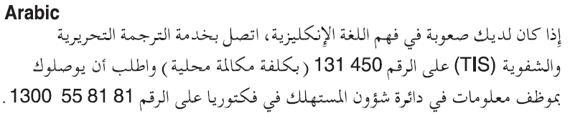
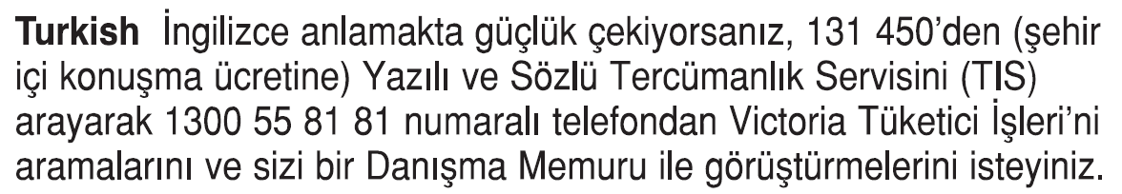


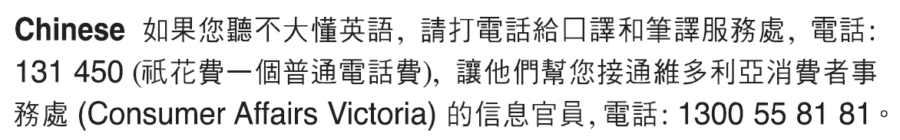
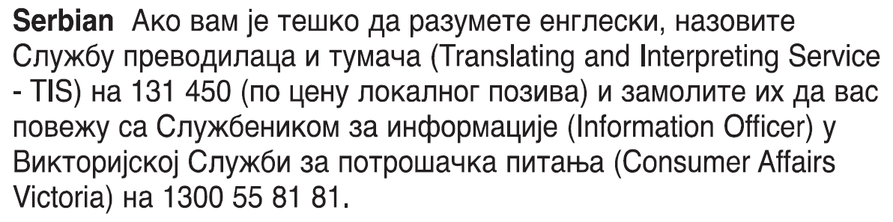

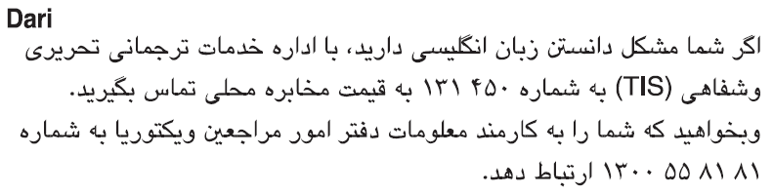

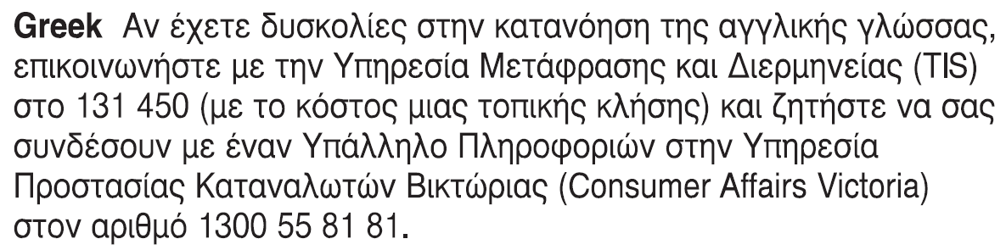
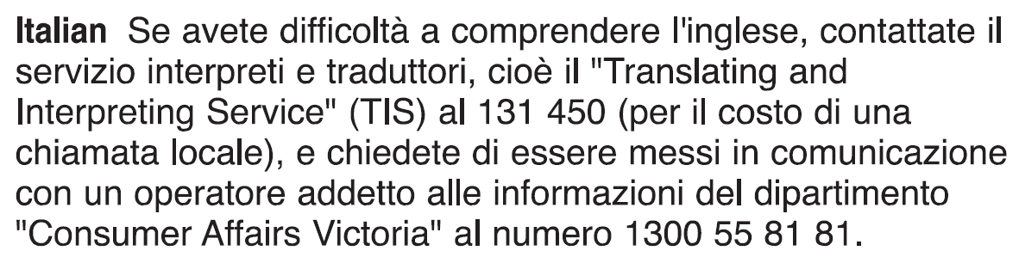

Notice to Part 4A site owner

Reasons to use in question 10

206ZG(2)–utility charges
- Refer to s206ZE and s206ZF of the Act to determine which utility charges are the responsibility of the site owner and which are the responsibility of the site tenant.
- Write the following and complete $ amount.
I have paid utility charges that are your responsibility.
I require you to reimburse me $ _ within 28 days.
- Attach details, receipts, and any other evidence.

206ZO(1)–damage by site tenant or visitor
- Write the following, specify whether damage is to a Part 4A site or to a facility in the Part 4A park, and complete damage description.
I, or my visitor, have damaged the site/park facility. I have not repaired the damage, so I must notify you of the damage and I must pay compensation.
The damage is _

206ZO(2)–notice of damage
- Write the following and complete damage description.
I am notifying you of damage to, or breakdown of, communal facilities in the park.
The damage/breakdown is _

317J–termination before moving in
- Write the following, selecting one of the reasons for termination.
I am terminating the site agreement before I move in or use the Part 4A site, because the site:
- is unsafe, or
- is not legally available for use as a Part 4A site, or
- is unavailable for occupation for the following reason _

317R(1)–intention to vacate (no specified reason)
- Write the following and complete the date (note: for a fixed term site agreement, the date cannot be earlier than the end of the term of the site agreement).
I am giving you at least 28 days notice that I intend to vacate the site on _ / _ / _

317T(2)&(3)–intention to vacate (reduced notice period in certain circumstances)
- Write the following and complete the date (note: for a fixed term site agreement, the date cannot be earlier than the end of the term of the site agreement), selecting one of the reasons.
I am giving you at least 14 days notice that I intend to vacate the site on _ / _ / _ because:
- you have given me a notice to vacate under section 317ZF, or
- I require special or personal care and need to vacate the site to obtain that care, or
- I have received an offer of public housing, or
- I require temporary crisis accommodation and need to vacate the site to obtain that accommodation.

317U(1)–intention to vacate (non-compliance with Tribunal order)
- Write the following and complete the date.
I am giving you at least 14 days notice that I intend to vacate the site on _ / _ / _ because you have failed to comply with a compensation or compliance order of the Victorian Civil and Administrative Tribunal under section 212 of the Act.

317V(1)–intention to vacate (successive breaches by site owner)
- Write the following and complete the date.
I am giving you at least 14 days notice that I intend to vacate the site on _ / _ / _ because you have breached a duty owed under a duty provision within Part 5 of the Act for the third time. You have been given notice twice before to remedy the breach.

How to serve this notice
You can serve this notice by hand, by post, or by email (with consent).
If you send this notice by post, you must take into account the extra days it takes for the notice to be delivered. Australia Post has three different speeds for ordinary mail delivery – express, priority and regular mail, which may take up to six days. Priority and regular delivery speeds also apply for registered post. You may wish to keep evidence of the mail delivery method you relied on to send this notice.
For more information about Australia Post’s mail delivery options and times, visit the Australia Post website (auspost.com.au).
You can only send this notice by email if you already have the site owner’s written consent to receive notices and other documents this way. The site owner may have given consent in the site agreement or separately in writing. A consent form is available from the Forms and publications section – Consumer Affairs Victoria website (consumer.vic.gov.au/forms).
If you send this notice by email, the provisions of the Electronic Transactions (Victoria) Act 2000 apply. For legal purposes,
the time when a notice is received is when it can be retrieved from the email address the recipient nominated.
To help calculate the total minimum days to allow, depending on the notice period required and the method of delivery,
visit the Giving notices – Residential Tenancies List page – Victorian Civil and Administrative Tribunal website (www.vcat.vic.gov.au/resources/giving-notices-residential-tenancies-list).
If you need help with this notice, visit the Renting section – Consumer Affairs Victoria website (consumer.vic.gov.au/renting)
or call the Consumer Affairs Victoria Helpline on 1300 55 81 81.

Notice to Part 4A site owner
From the site tenant Site owner’s copy

Site owner details
- This notice is given to: (site owner/s name/s)
- Owner’s address: (can be an agent’s)

Site tenant details
- Site tenant/s name/s:
- Regarding the Part 4A site at:
(insert address of Part 4A site)
- Address for serving documents:
(if same address as 4, write ‘as above’)
- Contact telephone numbers:
Business hours:
After hours:

Service details
- This notice is given: (mark one method only and if posted note the delivery speed)
by hand:
by registered post:
by ordinary post:
by email:
Insert email address:
(if applicable)
on (date): | / /
- Signature of site tenant:
- Name of site tenant signing this notice:

Reason for notice
- (write the section number and reason, using the words from the ‘Reasons to use in question 10’)
- Details are attached to this notice:
(e.g. receipts, other evidence)
yes:
no:

Site owner please note
If you need help with this notice, call the Consumer Affairs Victoria Helpline on 1300 55 81 81 or visit consumer.vic.gov.au/renting

Notice to Part 4A site owner
From the site tenant Site tenant’s copy

Site owner details
- This notice is given to: (site owner/s name/s)
- Owner’s address: (can be an agent’s)

Site tenant details
- Site tenant/s name/s:
- Regarding the Part 4A site at:
(insert address of Part 4A site)
- Address for serving documents:
(if same address as 4, write ‘as above’)
- Contact telephone numbers:
Business hours:
After hours:

Service details
- This notice is given: (mark one method only and if posted note the delivery speed)
by hand:
by registered post:
by ordinary post:
by email:
Insert email address:
(if applicable)
on (date): | / /
- Signature of site tenant:
- Name of site tenant signing this notice:

Reason for notice
- (write the section number and reason, using the words from the ‘Reasons to use in question 10’)
- Details are attached to this notice:
(e.g. receipts, other evidence)
yes:
no:

Site owner please note
If you need help with this notice, call the Consumer Affairs Victoria Helpline on 1300 55 81 81 or visit consumer.vic.gov.au/renting

Notice to Part 4A site owner
From the site tenant Site tenant’s copy

Site owner details
- This notice is given to: (site owner/s name/s)
- Owner’s address: (can be an agent’s)

Site tenant details
- Site tenant/s name/s:
- Regarding the Part 4A site at:
(insert address of Part 4A site)
- Address for serving documents:
(if same address as 4, write ‘as above’)
- Contact telephone numbers:
Business hours:
After hours:

Service details
- This notice is given: (mark one method only and if posted note the delivery speed)
by hand:
by registered post:
by ordinary post:
by email:
Insert email address:
(if applicable)
on (date): | / /
- Signature of site tenant:
- Name of site tenant signing this notice:

Reason for notice
- (write the section number and reason, using the words from the ‘Reasons to use in question 10’)
- Details are attached to this notice:
(e.g. receipts, other evidence)
yes:
no:

Site owner please note
If you need help with this notice, call the Consumer Affairs Victoria Helpline on 1300 55 81 81 or visit consumer.vic.gov.au/renting

