Residential accommodation complaint form

Consumer Affairs Victoria (CAV) may conciliate disputes which arise from tenancies, including residential parks, caravan parks and rooming houses. CAV also provides information and advice on disputes in owners corporations and retirement villages.
Before lodging this form, please attempt settlement of your issue by reading the information relevant to your tenancy type:
- resolving renting disputes (consumer.vic.gov.au/rtdisputes)
- resolving owners corporation disputes (consumer.vic.gov.au/ocdisputes)
- resolving retirement village disputes (consumer.vic.gov.au/rvdisputes).
CAV can accept written complaints when:
- the consumer has made a reasonable attempt to resolve the dispute with the landlord, owners corporation manager or retirement village manager
- the subject matter is within our jurisdiction and is not more appropriately handled by another body
- consumer legislation or the consumer’s contractual rights appear to have been breached
- the complaint has a reasonable chance of being settled
- the Victorian Civil and Administrative Tribunal (VCAT) or the courts have not already ruled on the matter and there is no case pending.

How to lodge this complaint
If you cannot resolve the problem, please complete both sides of the complaint form and lodge it with CAV.
Scan and email the form and supporting documentation to consumer@dgs.vic.gov.au
or post to:
Consumer Affairs Victoria
GPO Box 4567
Melbourne VIC 3001
or fax to: 03 8684 6295.

What happens next?
Consumer Affairs Victoria will contact you regarding this complaint.
If your complaint is about an owners corporation or retirement village, we may also refer you to the Dispute Settlement Centre of Victoria for further advice and assistance.

Privacy
Consumer Affairs Victoria collects and handles your personal information consistent with the requirements of the Privacy and Data Protection Act 2014. Where you do not provide the information required by this form, we may refuse or be unable to process this transaction. We may need to disclose your personal information to other State and Commonwealth Agencies. For more information, go to our Privacy statement (consumer.vic.gov.au/privacy).

Telephone Interpreter Service
If you have difficulty understanding English, contact the Translating and Interpreting Service (TIS) on 131 450 (for the cost of a local call) and ask to be put through to an Information Officer at Consumer Affairs Victoria on 1300 55 81 81.
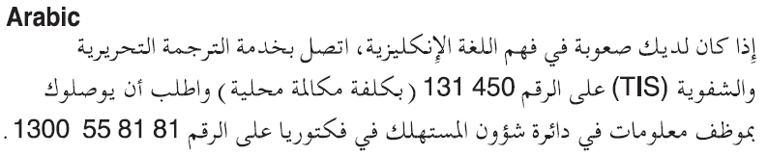

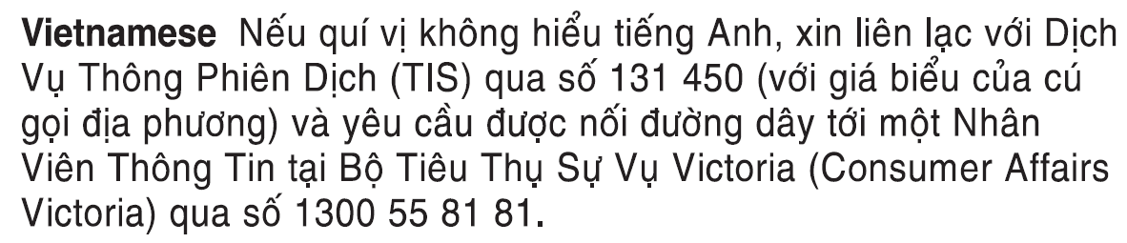

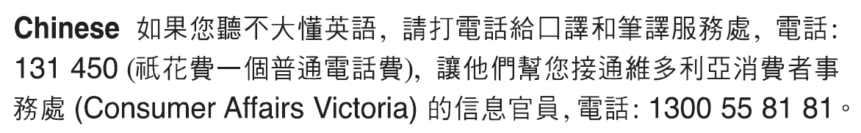
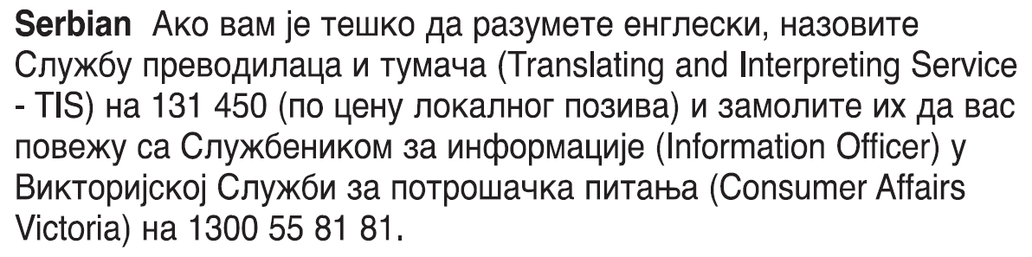



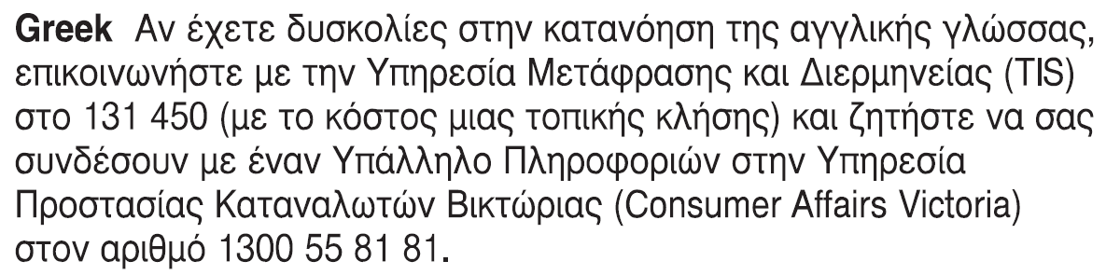
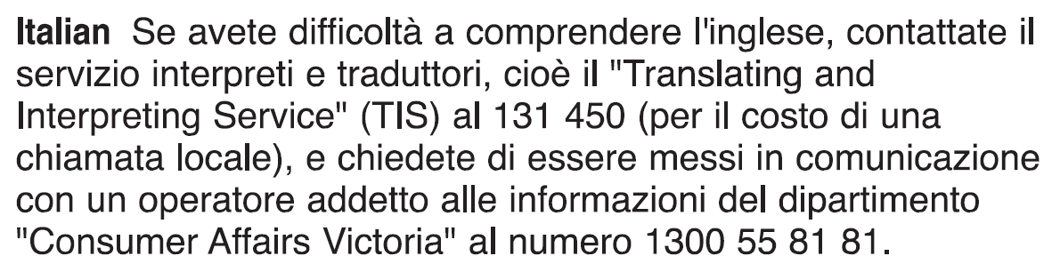

1. Details of residential accommodation
(please tick)
Caravan park:
Rooming house:
Site agreement:

Private:
Public:

Weekly rent: ($)
Bond amount: ($)
Bond No. (if known):

Retirement Village
(please tick)
Strata title:
Lease/licence:

Owners Corporation
(please tick)
Private:
Commercial:

2. Your details
Title:
Family name:
Given names:
Street address:
Suburb:
Postcode:
Daytime telephone number:
Mobile:
Email address:
Gender
Male: |  | Female:

3. Name of landlord/agent or owners corporation manager/retirement village manager
Name:
Street address:
Suburb:
Postcode:
Daytime telephone number:
Mobile:
Email address:

4. Address of property in dispute if different from address in question 2
Street address:
Suburb:
Postcode:

5. Details of any other party/parties involved
Name:
Street address:
Suburb:
Postcode:
Daytime telephone number:
Mobile:
Email address:

6. Details of dispute
Date of transaction/dispute: | / /
Monetary value of dispute (if any): ($)
Have you approached the internal dispute resolution process? (applicable to owners corporations and retirement villages only)
Yes: |  | No:

7. Please explain your complaint
(include dates – if you need more space, please attach a separate sheet)

8. Have you lodged this complaint with another organisation/court/tribunal?
Yes: |  | No:
If yes, with whom?

9. What was the response you received when you alerted the other party to the issues in your complaint?
Name of person you have spoken to:

10. What remedy are you seeking – how do you want your problem to be solved?
(if you need more space, please attach a separate sheet)

11. Do you require an interpreter?
Yes: |  | No:
If yes, specify language:

12. Do you have any written documents to support your complaint?
(eg: receipts, quotes, contracts, invoices or any documents you have served on the landlord/agent/manager or they have served on you)
No: |  | Yes:
If Yes, please attach copies of all documents to this complaint form.

13. Signature
I declare that the above information is true and correct to the best of my knowledge. I agree that the information I have given in this form may be used or disclosed by Consumer Affairs Victoria to process this complaint.
Signature:

Date: | / /

