

Small business
self assessment checklist

This checklist is designed to help you and your business to become aware of your rights and comply with your obligations under the Australian Consumer Law (ACL). It will help you identify which parts of the ACL are relevant to your business and how you can get more information.

This checklist is not a comprehensive statement of the law.

About the ACL

The ACL aims to ensure fair trading in Australia, protecting consumers while also reducing compliance costs to businesses. It is a national law, jointly administered by Australian, state and territory governments and came into effect on 1 January 2011.

Under the ACL, consumers have the same protections, and businesses have the same obligations, throughout Australia.

For more information about the ACL visit www.consumerlaw.gov.au
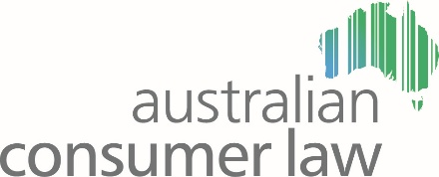
Setting up your business to sell goods or services

Your contracts
Q1 Do you enter into written contracts with customers? Y N

Q2 Are your written contracts prepared without negotiation with your customers? Y N

Q3 Are customers acquiring your goods or services mainly for personal, household or domestic use? Y N

If you have ticked ‘yes’ to all of Questions 1, 2 and 3 your contracts will most likely be covered by the unfair contract terms provisions of the ACL.

If a term of your contract:

- causes a significant imbalance in the parties’ rights and obligations arising under the contract and
- is not reasonably necessary to protect your legitimate interests and
- it would cause detriment (whether financial or otherwise) if it were to be applied or relied on

then it may be an unfair term.

For more information refer to A guide to the unfair contract terms law available from www.consumerlaw.gov.au

Displaying prices

A price is considered ‘displayed’ in a variety of ways including if it is on a label or a sign attached to or near the goods or services, in a barcode, in a catalogue or any other way that can be reasonably taken to be a representation of price.

Q4 Do you display prices for goods or services in more than one place?
Y N

Q5 If you have different prices displayed do you sometimes sell the goods or
services for the higher price? Y N

If you ticked ‘yes’ to Question 5 you may be breaching the multiple pricing laws of the ACL.

For more information about what is a displayed price and how to retract pricing discrepancies refer to Chapter 4 in the Sales practices guide available from www.consumerlaw.gov.au

Q6 Do you show a price for goods or services that is only part of the full price?
Y N

Q7 If so, do you also display the full price? Y N

Did you answer ‘no’ to Question 7? It is unlawful to display part of the price for goods or services without also displaying the full price consumers must pay as prominently as the part price.

For more information about component pricing refer to Chapter 4 in the Sales practices guide available from www.consumerlaw.gov.au

Selling safe goods or services

The ACL has provisions that make product safety a matter all businesses must consider.

Q8 Do you know how to find out whether goods you supply have been banned? Y N

Q9 Do you know how to find out whether your goods or services are covered by mandatory safety standards? Y N

Q10 Do you know how to find out whether your goods or services are covered by mandatory information standards? Y N

If you answered ‘no’ to any of Questions 8, 9 or 10 you should go to the Product Safety Australia website www.productsafety.gov.au to view a comprehensive list of products covered by interim and permanent bans as well as mandatory safety and information standards.

Q11 Do you know what to do in relation to the recall of products? Y N

For more information about product recalls refer to the publication Consumer Product Safety Recall Guidelines available from www.consumerlaw.gov.au

Q12 Do you have processes in place to manage your obligations if you are told a product or service you supply has hurt someone? Y N

If you become aware that your goods or services have, or may have, caused death, serious injury or illness you must report this to the Commonwealth Minister within two days. You should ensure your business has a procedure in place for such notifications and all staff should be aware of that procedure. To notify the Minister, complete the online mandatory reporting form on the Product Safety Australia website www.productsafety.gov.au

For more information please refer to the Product safety guide available from
www.consumerlaw.gov.au

Unsolicited selling

Q13 Do you engage in marketing practices such as cold calling, telemarketing or door knocking? Y N

If you answered ‘yes’ then you should be aware that these practices are covered by the unsolicited consumer agreement provisions of the ACL. These provisions cover such things as:

- when you can telephone or visit consumers
- what you must disclose to your customers
- what your sales contracts must include
- when you can supply services
- when you can supply goods above a certain value
- when you can request or accept payment from your customers.

Cooling off periods

Consumers have 10 business days to change their mind and cancel sales (cool off) that result from unsolicited selling. They can also cancel the contract within three or six months if the supplier has not met certain obligations.

For further information about calling times, disclosure requirements and cooling off periods refer to Chapter 2, in the Sales practices guide available from www.consumerlaw.gov.au and visit your local consumer protection regulator’s website.

Selling your goods or services

Advertising your goods and services

Q14 Do you understand concepts such as puffery, bait advertising and fine print? Y N

There are principles that apply to what you say in your advertising and how you say it. To make sure your advertising complies refer to the Avoiding unfair business practices guide available from www.consumerlaw.gov.au

The publication Advertising and selling available on the Australian Competition and Consumer Commission (ACCC) website www.accc.gov.au may also be useful when undertaking or assessing your advertising and selling activities.

Itemised billing

Q15 Do you supply itemised bills for every transaction? Y N

If you provide goods or services valued over $75 (excluding GST) you have to give a proof of transaction. If the value is under $75 a consumer can still request a proof of transaction and you have seven days to provide it to them.

Q16 Do you provide itemised bills on request? Y N

Q17 Do you provide this bill free of charge? Y N

If you answered no to Question 16 or 17, you should be aware that bills must be provided on request and this must be done free of charge. If your business provides services you should familiarise yourself with the provisions of the ACL relating to itemised billing.

For more information about itemised bills refer to Chapter 8 in the Sales practices guide available from www.consumerlaw.gov.au

Giving receipts (Proof of transaction)

Q18 Does your proof of transaction do the following? Y N

- Identify you (the supplier); state your ABN and/or ACN (if any); state what was supplied, the date of supply and the price?

If a proof of transaction does not meet those criteria it may not comply with the ACL.

For more information about requirements relating to proof of transaction refer to Chapter 8 in the Sales practices guide available from www.consumerlaw.gov.au

Providing lay-by facilities

Q19 Do you have agreements that allow consumers to pay off goods in instalments? Y N
If you answered ‘yes’ and:

- you call such agreements lay-bys OR
- you allow the consumers to make three or more instalments to pay for the goods

then the agreements are considered lay-bys under the ACL. There are certain requirements for lay-by agreements, such as that the agreement must be in writing and a copy given to the consumer.

For more information about lay-bys refer to Chapter 5 in the Sales practices guide available from www.consumerlaw.gov.au

Consumer guarantees and warranties against defects
A warranty against defects is a representation made at or about the time of supply that states:

- if goods are defective they will be repaired or replaced or compensation will be provided
- if services are defective they will be replaced or rectified or compensation will be provided.

These are sometimes known as a manufacturer’s warranty or an extended warranty.

Q20 Do you refer consumers straight to manufacturers when they have problems? Y N

Q21 Do you tell consumers that your goods or services come with a warranty
against defects? Y N

If you answered ‘yes’ to either of the above questions, you should be aware a warranty is not the only remedy a consumer has if something goes wrong. Consumers also have statutory rights, known as consumer guarantees.

For more information about warranties against defects refer to Chapter 4 in the Consumer guarantees guide available from www.consumerlaw.gov.au

For more information about what must be included in a warranty against defects go to the ACCC website www.accc.gov.au

Solving your customer problems

Dealing with refunds

Q22 Do you have a refund policy? Y N

Q23 Does your refund policy or signage include words like ‘no refunds’?
Y N

Whether you answered ‘yes’ or ‘no’ to Questions 22 and 23 you should be aware that when a problem arises in relation to goods or services, consumers have the right to seek remedies from the business they purchased from, regardless of that business’ policies or signage.

These remedies include a full refund if any consumer guarantees are not met. It is a breach of the ACL to tell a consumer unconditionally that there are ‘no refunds’.

For more information about refund policies, consumer guarantees and what they cover, refer to the Consumer guarantees guide available from www.consumerlaw.gov.au

Dealing with repairs

Q24 Do you supply refurbished goods as an alternative to repairing a consumer’s defective goods or use refurbished parts in the repair of a consumer’s defective goods? Y N

Q25 Do you repair goods that are capable of retaining user-generated data such as flash drives, MP3 players, computers or phones? Y N

If you answered ‘yes’ to either Question 24 or 25 you should be aware that certain information must be disclosed to consumers before accepting the goods for repair.

For more information on repair notices refer to the ACCC website www.accc.gov.au or Chapter 7 in the Consumer guarantees guide available from www.consumerlaw.gov.au

Contacts




South Australia
Consumer and Business
Services
T. 13 18 82
cbs.sa.gov.au

Australian Competition and
Consumer Commission
T. 1300 302 021
accc.gov.au




Queensland
Office of Fair Trading
T. 13 QGOV (13 74 68)
fairtrading.qld.gov.au

Australian Capital Territory
Office of Regulatory Services
T. 02 6207 3000
ors.act.gov.au


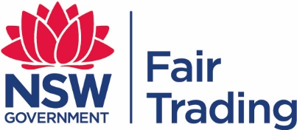

Tasmania
Office of Consumer
Affairs and Fair Trading
T. 1300 654 499
consumer.tas.gov.au

New South Wales
NSW Fair Trading
T. 13 32 20
fairtrading.nsw.gov.au

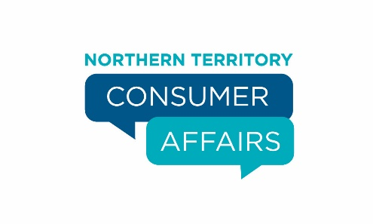

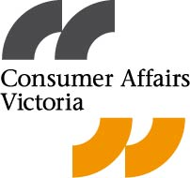

Northern Territory
Victoria
Consumer Affairs Victoria
T. 1300 55 81 81
consumer.vic.gov.au

Consumer Affairs
T. 1800 019 319
consumeraffairs.nt.gov.au



Western Australia
Department of Commerce
T. 1300 30 40 54
commerce.wa.gov.au

A joint initiative of Australian, state and territory governments.

